Automated report for MONS-Pelagic-Fish survey

# Introduction

This automated report provides a detailed overview of Plankton Imager data collected during the MONS-Pelagic-Fish cruise between 2024-01-10 16:00:00 to 2024-01-18 18:00:00. In total, 16,968,754 images were collected in the region from approximately 3.86°E to 6.26°E longitude and 52.13°N to 53.97°N latitude.  
  
This automated report provides an overview of the data processed using the ResNet50 model developed by van Walraven et al. (in prep), see method section. The report contains information on the number of images per class, density statistics (N/L), and the model confidence in predicting the class. Moreover, figures are created on the 10-minute bins of detected objects visualized in density and spatio-temporal plots. A first attempt at deriving an index of patchiness is provided as well, through dividing the number of images by 340, corresponding to the volume of water (in L) flowing through the Plankton Imager in 10 minutes.

# Methodology

The analysis was conducted using the ResNet50 developed in Van Walraven et al. (in prep) which predicts 49 different plankton and non-plankton classes. Detailed information on the code, weights, and datasets can be found at: https://git.wur.nl/marine-vision-and-robotics/mons. The density calculations are created by dividing the estimated volume of water that passes through the flow cell 34 L/min, for a total of 340 L per 10 minutes. Therefore, the number of predictions can be binned per 10 minutes and divided to get the density per L, which we report as N/L. Afterwards, we process this dataset to compute descriptive statistics on the entire dataset, and class-specific derived information. Density graphs and maps are created to illustrate the distribution of each predicted class over time and geographic locations.  
  
Moreover, to provide an estimate of the model's confidence in predicting specific classes, we generate descriptive statistics and a violin plot illustrating the confidence distribution. This visualization helps in understanding the variability and uncertainty in the model's predictions.We focus on the top five classes most related to the actual target by computing the mean confidence values for all non-target classes and selecting the five with the highest mean confidence. These classes are considered the most related to the target and represent areas where the model might struggle to differentiate between the actual target and similar classes. For example, the model might show lower certainty in predictions for the class 'Crustacea Amphipoda', particularly when differentiating it from other closely related Crustacea targets. This adds a layer of nuance to the model, and shows potential areas for improvements.

# General statistics

During the MONS-Pelagic-Fish survey, a total of 16,968,754 images were collected along the transect. The table below shows the amount of images predicted for each class and as percentage of the total images collected. Also shown is the minimum, mean, and maximum density (n/L) for each class.

General statistics on the predictions made using the model, such as the number of images predicted as each class, the density (N/L), and the confidence for each class.

|  |  |  |  |  |
| --- | --- | --- | --- | --- |
| ID | Class | # of Images | Density | Confidence |
| 26 | Detritus | 10,047,147 59.21% | Min: 3.89 Mean: 50.09 Max: 250.97 | Min: 0.10 Mean: 0.80 Max: 1.00 |
| 35 | Heterokontophyta Bacillariophyceae | 3,706,222 21.84% | Min: 0.46 Mean: 18.48 Max: 64.45 | Min: 0.13 Mean: 0.80 Max: 1.00 |
| 32 | Gastropoda | 1,022,505 6.03% | Min: 0.02 Mean: 5.10 Max: 31.51 | Min: 0.12 Mean: 0.77 Max: 1.00 |
| 48 | bubbles | 886,260 5.22% | Min: 0.03 Mean: 4.42 Max: 24.43 | Min: 0.14 Mean: 0.89 Max: 1.00 |
| 41 | Myzozoa Dinophyceae | 554,713 3.27% | Min: 0.07 Mean: 2.77 Max: 19.79 | Min: 0.13 Mean: 0.72 Max: 1.00 |
| 15 | Crustacea Copepoda nauplii | 288,129 1.70% | Min: 0.02 Mean: 1.44 Max: 4.21 | Min: 0.13 Mean: 0.76 Max: 1.00 |
| 37 | Larvacea | 112,512 0.66% | Min: 0.00 Mean: 0.56 Max: 2.29 | Min: 0.13 Mean: 0.78 Max: 1.00 |
| 16 | Crustacea Copepoda Calanoida | 63,970 0.38% | Min: 0.01 Mean: 0.32 Max: 2.14 | Min: 0.12 Mean: 0.68 Max: 1.00 |
| 43 | Phoronida larvae | 58,141 0.34% | Min: 0.00 Mean: 0.29 Max: 2.95 | Min: 0.13 Mean: 0.59 Max: 1.00 |
| 13 | Crustacea Cirripedia larvae | 48,192 0.28% | Min: 0.00 Mean: 0.24 Max: 2.65 | Min: 0.10 Mean: 0.57 Max: 1.00 |
| 14 | Crustacea Cladocera | 28,906 0.17% | Min: 0.00 Mean: 0.14 Max: 0.60 | Min: 0.12 Mean: 0.59 Max: 1.00 |
| 33 | Haptophyta Phaeocystales | 26,281 0.15% | Min: 0.00 Mean: 0.14 Max: 31.06 | Min: 0.14 Mean: 0.69 Max: 1.00 |
| 4 | Bryozoa larvae | 19,249 0.11% | Min: 0.00 Mean: 0.10 Max: 2.29 | Min: 0.12 Mean: 0.61 Max: 1.00 |
| 0 | Annelida Polychaeta larvae | 17,662 0.10% | Min: 0.00 Mean: 0.09 Max: 1.20 | Min: 0.12 Mean: 0.53 Max: 1.00 |
| 17 | Crustacea Copepoda Cyclopoida | 17,220 0.10% | Min: 0.00 Mean: 0.09 Max: 0.29 | Min: 0.12 Mean: 0.63 Max: 1.00 |
| 44 | Platyhelminthes | 9,004 0.05% | Min: 0.00 Mean: 0.05 Max: 1.08 | Min: 0.14 Mean: 0.68 Max: 1.00 |
| 45 | Radiozoa | 8,399 0.05% | Min: 0.00 Mean: 0.05 Max: 2.36 | Min: 0.13 Mean: 0.61 Max: 1.00 |
| 47 | artefacts | 7,497 0.04% | Min: 0.00 Mean: 0.04 Max: 1.81 | Min: 0.20 Mean: 0.71 Max: 1.00 |
| 22 | Crustacea Euphausidae | 6,342 0.04% | Min: 0.00 Mean: 0.03 Max: 0.23 | Min: 0.12 Mean: 0.53 Max: 1.00 |
| 6 | Ciliophora | 4,276 0.03% | Min: 0.00 Mean: 0.02 Max: 0.09 | Min: 0.12 Mean: 0.61 Max: 1.00 |
| 5 | Chaetognatha | 3,269 0.02% | Min: 0.00 Mean: 0.02 Max: 0.14 | Min: 0.15 Mean: 0.88 Max: 1.00 |
| 30 | Fish eggs | 3,114 0.02% | Min: 0.00 Mean: 0.02 Max: 0.28 | Min: 0.10 Mean: 0.68 Max: 1.00 |
| 11 | Crustacea exuvia | 3,095 0.02% | Min: 0.00 Mean: 0.02 Max: 0.12 | Min: 0.15 Mean: 0.73 Max: 1.00 |
| 34 | Hemichordata Enteropneusta larvae | 3,085 0.02% | Min: 0.00 Mean: 0.02 Max: 0.15 | Min: 0.11 Mean: 0.59 Max: 1.00 |
| 36 | Invertebrata eggs | 2,803 0.02% | Min: 0.00 Mean: 0.02 Max: 0.48 | Min: 0.18 Mean: 0.54 Max: 1.00 |
| 24 | Ctenophora | 2,681 0.02% | Min: 0.00 Mean: 0.01 Max: 0.09 | Min: 0.10 Mean: 0.55 Max: 1.00 |
| 21 | Crustacea Decapoda larvae | 2,250 0.01% | Min: 0.00 Mean: 0.01 Max: 0.06 | Min: 0.13 Mean: 0.59 Max: 1.00 |
| 29 | Echinodermata Ophiuroidea larvae | 2,048 0.01% | Min: 0.00 Mean: 0.01 Max: 0.06 | Min: 0.11 Mean: 0.57 Max: 1.00 |
| 27 | Echinodermata Asteroida larvae | 1,636 0.01% | Min: 0.00 Mean: 0.01 Max: 0.06 | Min: 0.12 Mean: 0.61 Max: 1.00 |
| 46 | Tunicata Doliolida | 1,500 0.01% | Min: 0.00 Mean: 0.01 Max: 0.10 | Min: 0.15 Mean: 0.50 Max: 0.99 |
| 42 | Nemetrea larvae | 1,401 0.01% | Min: 0.00 Mean: 0.01 Max: 0.04 | Min: 0.12 Mean: 0.67 Max: 1.00 |
| 23 | Crustacea Mysidacea | 1,212 0.01% | Min: 0.00 Mean: 0.01 Max: 0.20 | Min: 0.13 Mean: 0.76 Max: 1.00 |
| 18 | Crustacea Copepoda Harpacticoida | 1,095 0.01% | Min: 0.00 Mean: 0.01 Max: 0.03 | Min: 0.13 Mean: 0.36 Max: 0.85 |
| 9 | Cnidaria Hydrozoa Siphonophora | 1,042 0.01% | Min: 0.00 Mean: 0.01 Max: 0.04 | Min: 0.11 Mean: 0.59 Max: 1.00 |
| 7 | Cnidaria Hydrozoa medusa | 979 0.01% | Min: 0.00 Mean: 0.01 Max: 0.04 | Min: 0.17 Mean: 0.83 Max: 1.00 |
| 3 | Branchiostomatidae | 904 0.01% | Min: 0.00 Mean: 0.01 Max: 0.03 | Min: 0.12 Mean: 0.55 Max: 1.00 |
| 28 | Echinodermata Echinoidea larvae | 802 0.00% | Min: 0.00 Mean: 0.01 Max: 0.02 | Min: 0.16 Mean: 0.53 Max: 0.99 |
| 31 | Fish larvae | 672 0.00% | Min: 0.00 Mean: 0.01 Max: 0.03 | Min: 0.08 Mean: 0.56 Max: 1.00 |
| 1 | Annelida Polychaeta Tomopteris | 601 0.00% | Min: 0.00 Mean: 0.01 Max: 0.04 | Min: 0.17 Mean: 0.56 Max: 1.00 |
| 12 | Crustacea Amphipoda | 521 0.00% | Min: 0.00 Mean: 0.01 Max: 0.02 | Min: 0.15 Mean: 0.59 Max: 1.00 |
| 8 | Cnidaria Hydrozoa polyp | 281 0.00% | Min: 0.00 Mean: 0.00 Max: 0.01 | Min: 0.17 Mean: 0.67 Max: 1.00 |
| 39 | Mollusca Gastropoda | 217 0.00% | Min: 0.00 Mean: 0.00 Max: 0.01 | Min: 0.14 Mean: 0.34 Max: 0.91 |
| 2 | Brachiopoda larvae | 197 0.00% | Min: 0.00 Mean: 0.00 Max: 0.01 | Min: 0.18 Mean: 0.47 Max: 0.89 |
| 20 | Crustacea Cumacea | 73 0.00% | Min: 0.00 Mean: 0.00 Max: 0.01 | Min: 0.20 Mean: 0.72 Max: 1.00 |
| 10 | Cnidaria Scyphozoa ephyrae | 35 0.00% | Min: 0.00 Mean: 0.00 Max: 0.01 | Min: 0.24 Mean: 0.87 Max: 1.00 |
| 25 | Cyanobacteria | 12 0.00% | Min: 0.00 Mean: 0.00 Max: 0.00 | Min: 0.34 Mean: 0.55 Max: 0.97 |
| 19 | Crustacea Copepoda Monstrilloidae | 6 0.00% | Min: 0.00 Mean: 0.00 Max: 0.00 | Min: 0.22 Mean: 0.40 Max: 0.63 |
| 40 | Mollusca Gastropoda larvae | 4 0.00% | Min: 0.00 Mean: 0.00 Max: 0.01 | Min: 0.18 Mean: 0.24 Max: 0.31 |
| 38 | Mollusca Bivalvia larvae | 2 0.00% | Min: 0.00 Mean: 0.00 Max: 0.00 | Min: 0.28 Mean: 0.38 Max: 0.48 |

# Class: Detritus

## Statistics

|  |  |
| --- | --- |
| Metric | Value |
| Class ID | 26 |
| Class | Detritus |
| Number of predictions | 10,047,147 |
| Percentage of total images | 59.21 % |
| Min confidence | 0.10 % |
| Max confidence | 1.00 % |
| Average confidence | 0.80 % |
| Min density | 3.89 n/L |
| Max density | 250.97 n/L |
| Average density | 50.09 n/L |

## Model confidence

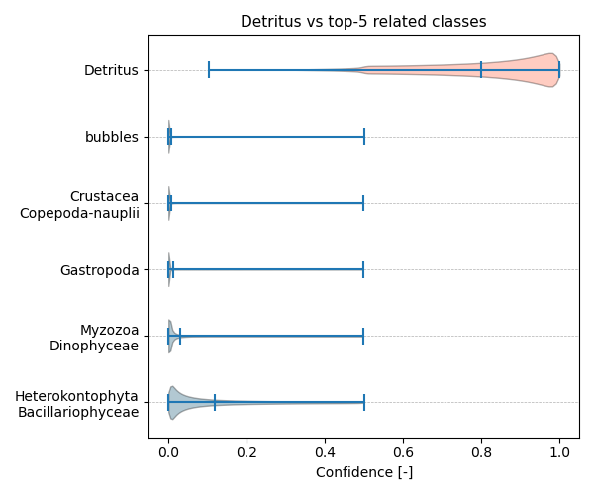

Figure showcasing the confidence distribution of the top-5 most related classes, which are determined by computing the mean confidence value of all non-target classes and selecting the five with the highest means, compared to Detritus.

## Temporal density

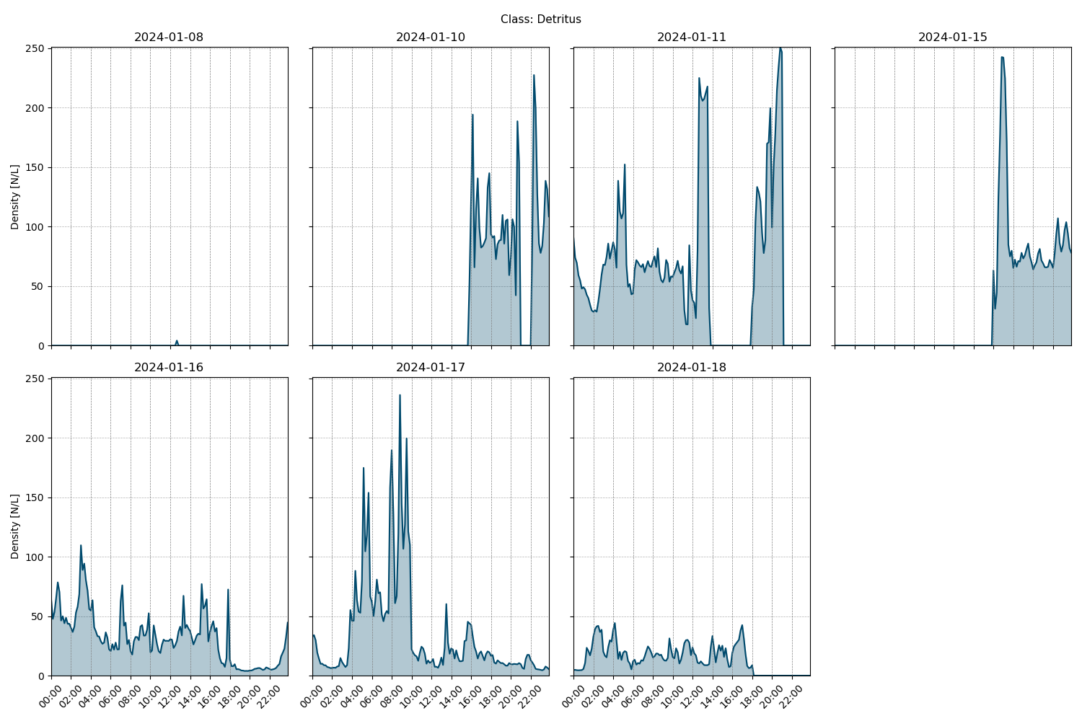

Figure showcasing the daily density estimates for Detritus per 10 minutes.

## Spatio-temporal density

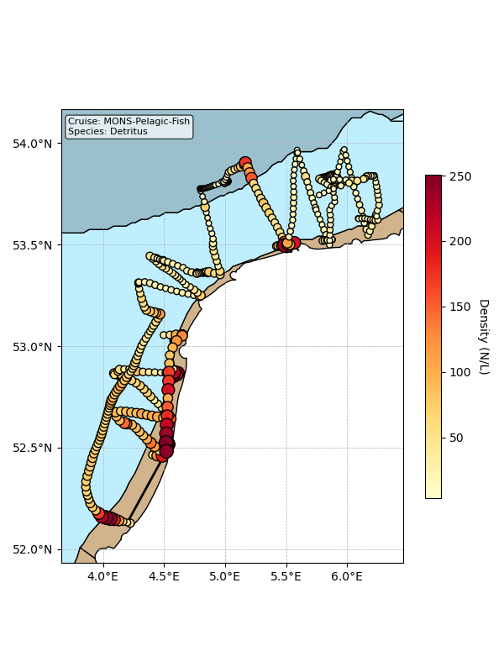

Map showing mean density estimates for Detritus along the cruise transect. OSPAR eutrophication areas are plotted in the background with different colours.

## Classification examples

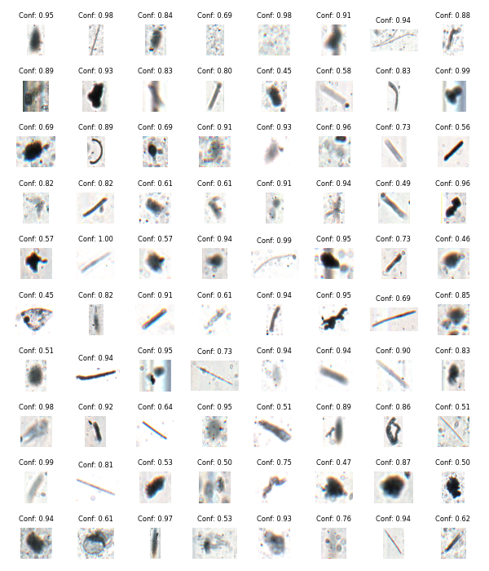

Figure showing several images classified as Detritus with model confidence.

# Class: Heterokontophyta_Bacillariophyceae

## Statistics

|  |  |
| --- | --- |
| Metric | Value |
| Class ID | 35 |
| Class | Heterokontophyta Bacillariophyceae |
| Number of predictions | 3,706,222 |
| Percentage of total images | 21.84 % |
| Min confidence | 0.13 % |
| Max confidence | 1.00 % |
| Average confidence | 0.80 % |
| Min density | 0.46 n/L |
| Max density | 64.45 n/L |
| Average density | 18.48 n/L |

## Model confidence

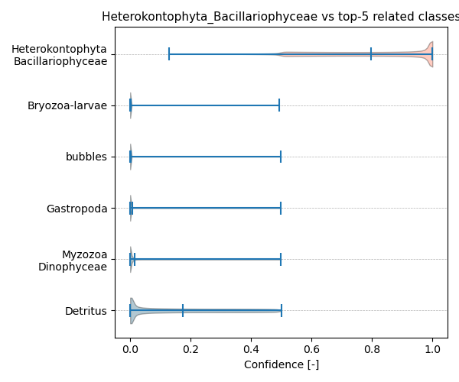

Figure showcasing the confidence distribution of the top-5 most related classes, which are determined by computing the mean confidence value of all non-target classes and selecting the five with the highest means, compared to Heterokontophyta_Bacillariophyceae.

## Temporal density

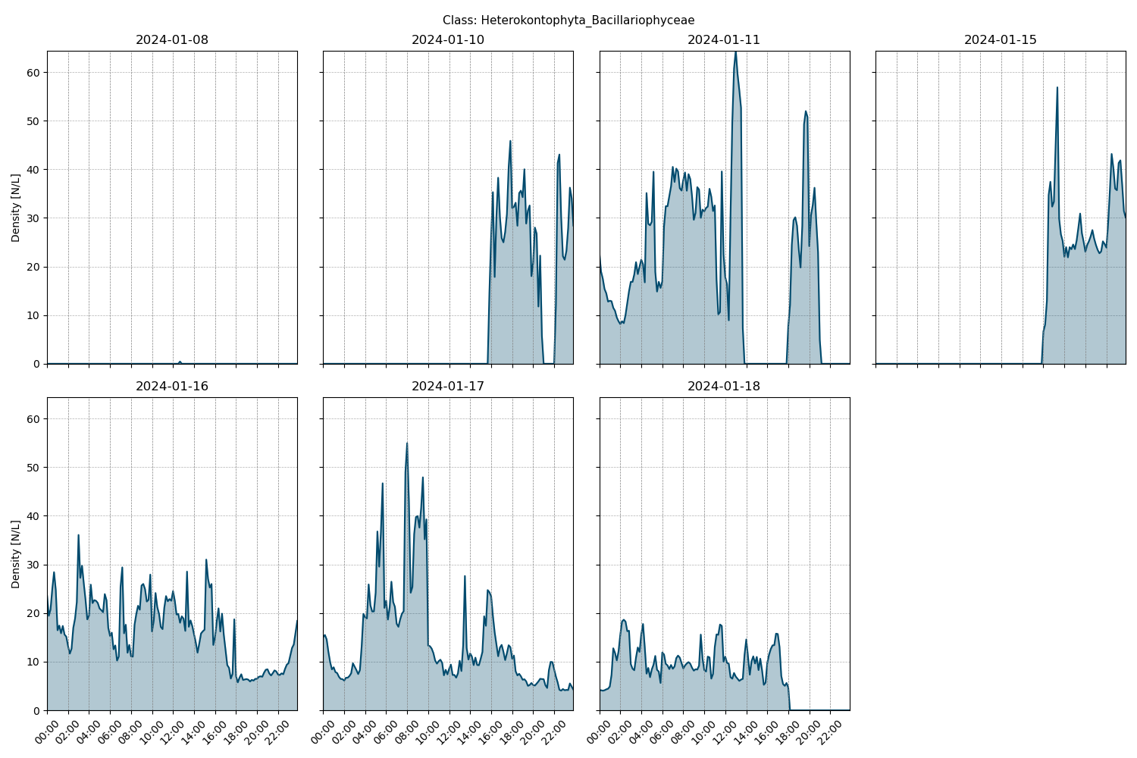

Figure showcasing the daily density estimates for Heterokontophyta_Bacillariophyceae per 10 minutes.

## Spatio-temporal density

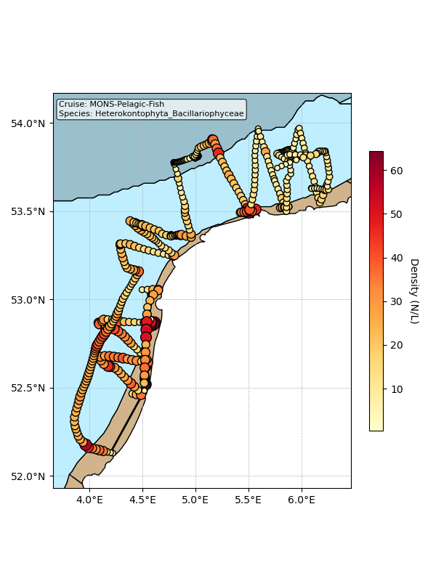

Map showing mean density estimates for Heterokontophyta_Bacillariophyceae along the cruise transect. OSPAR eutrophication areas are plotted in the background with different colours.

## Classification examples

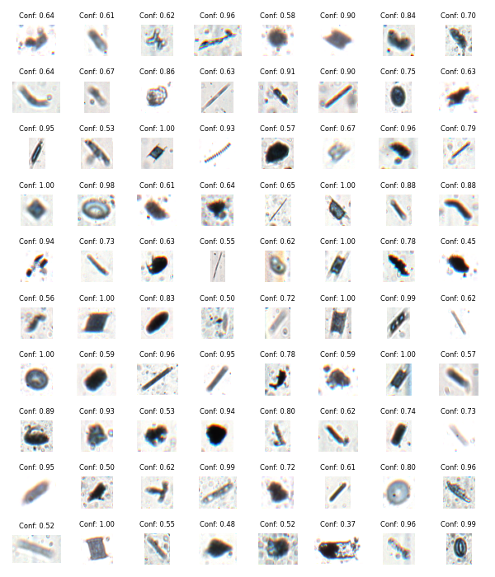

Figure showing several images classified as Heterokontophyta_Bacillariophyceae with model confidence.

# Class: Gastropoda

## Statistics

|  |  |
| --- | --- |
| Metric | Value |
| Class ID | 32 |
| Class | Gastropoda |
| Number of predictions | 1,022,505 |
| Percentage of total images | 6.03 % |
| Min confidence | 0.12 % |
| Max confidence | 1.00 % |
| Average confidence | 0.77 % |
| Min density | 0.02 n/L |
| Max density | 31.51 n/L |
| Average density | 5.10 n/L |

## Model confidence

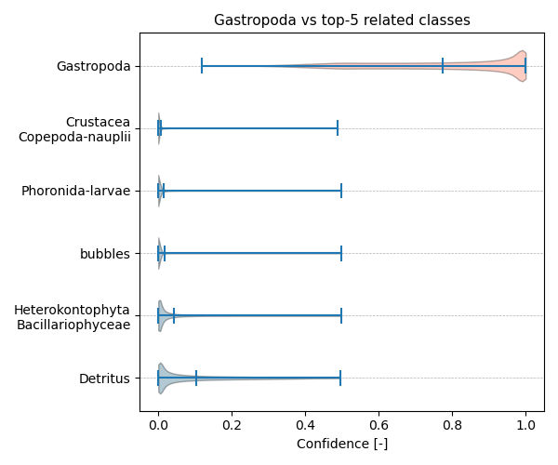

Figure showcasing the confidence distribution of the top-5 most related classes, which are determined by computing the mean confidence value of all non-target classes and selecting the five with the highest means, compared to Gastropoda.

## Temporal density

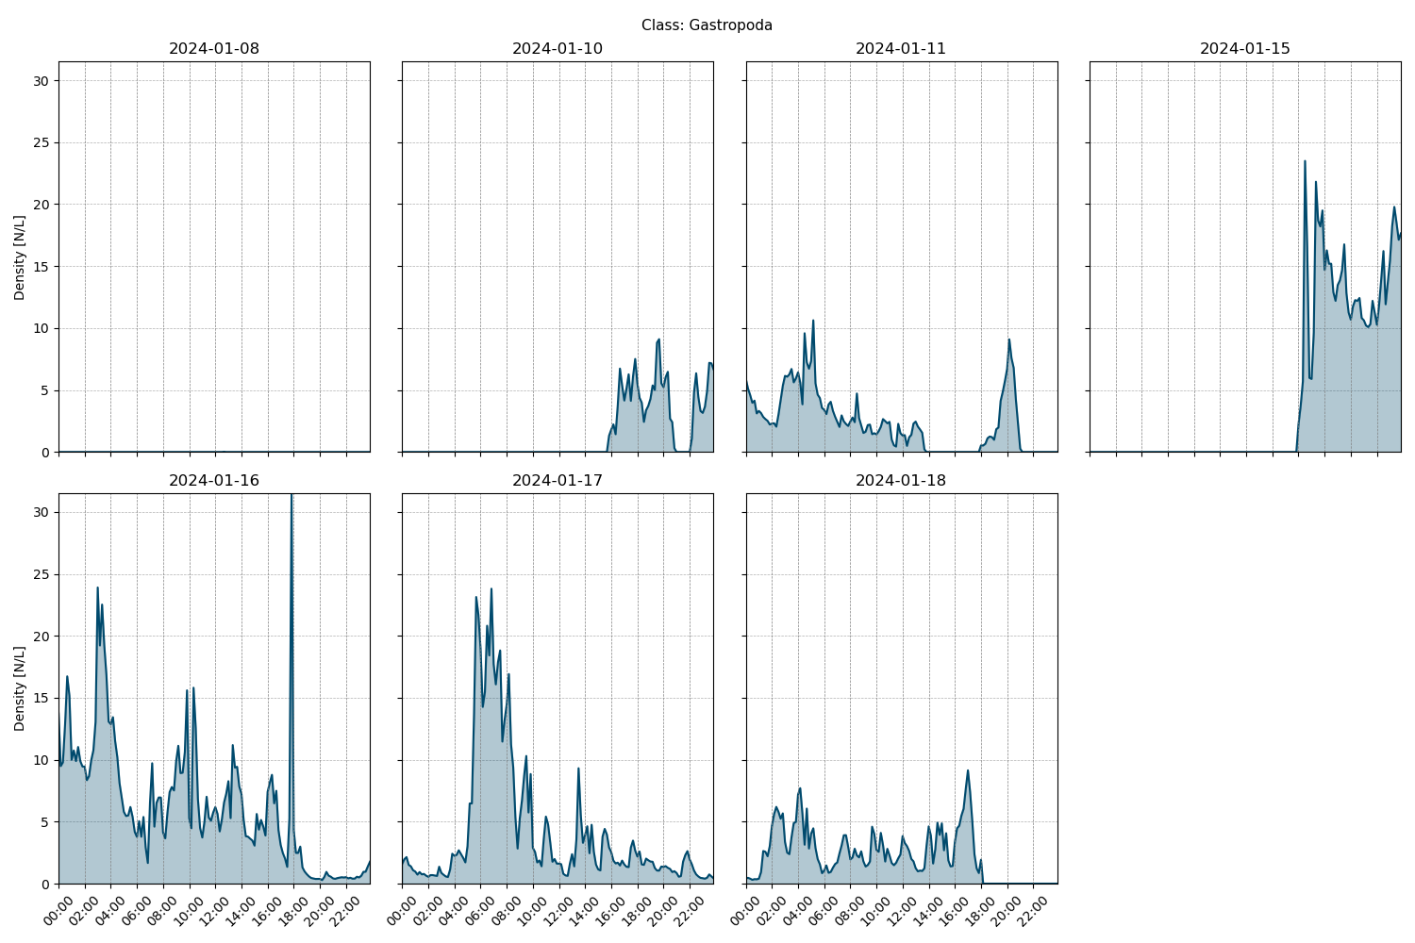

Figure showcasing the daily density estimates for Gastropoda per 10 minutes.

## Spatio-temporal density

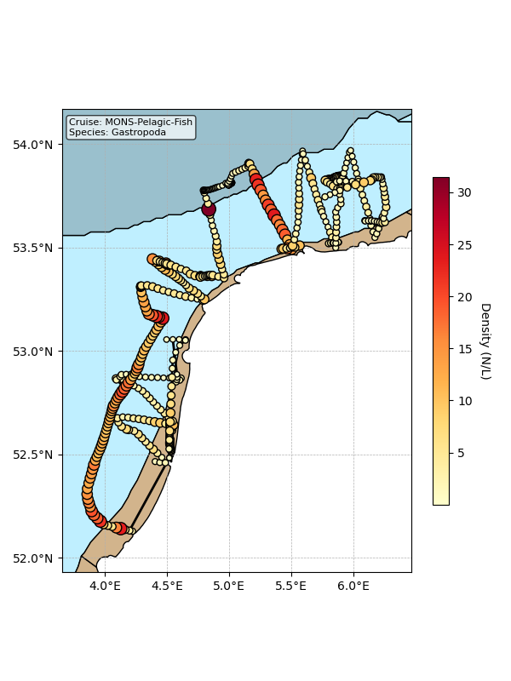

Map showing mean density estimates for Gastropoda along the cruise transect. OSPAR eutrophication areas are plotted in the background with different colours.

## Classification examples

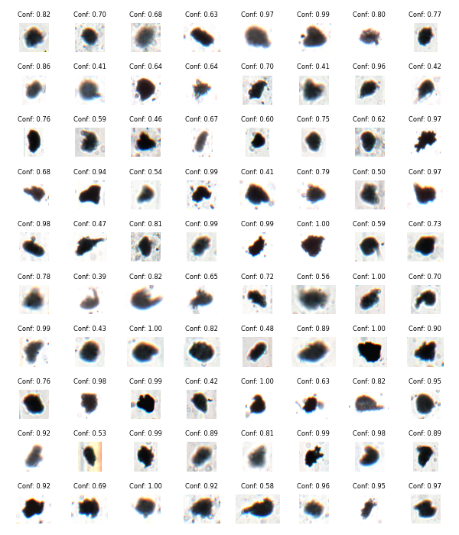

Figure showing several images classified as Gastropoda with model confidence.

# Class: bubbles

## Statistics

|  |  |
| --- | --- |
| Metric | Value |
| Class ID | 48 |
| Class | bubbles |
| Number of predictions | 886,260 |
| Percentage of total images | 5.22 % |
| Min confidence | 0.14 % |
| Max confidence | 1.00 % |
| Average confidence | 0.89 % |
| Min density | 0.03 n/L |
| Max density | 24.43 n/L |
| Average density | 4.42 n/L |

## Model confidence

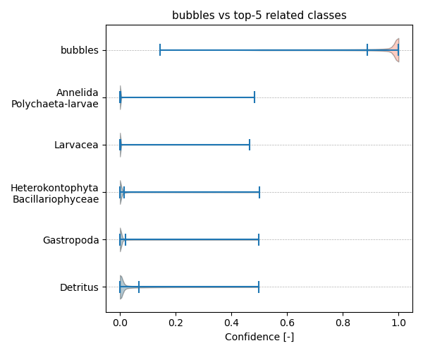

Figure showcasing the confidence distribution of the top-5 most related classes, which are determined by computing the mean confidence value of all non-target classes and selecting the five with the highest means, compared to bubbles.

## Temporal density

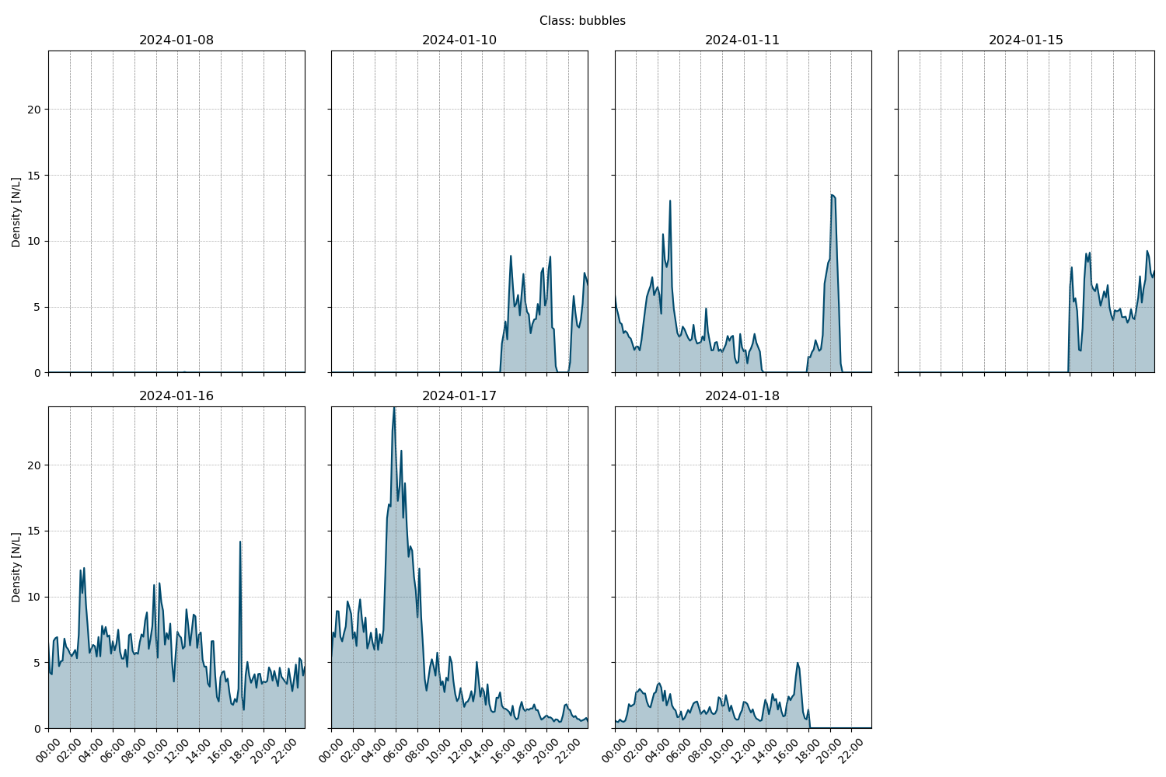

Figure showcasing the daily density estimates for bubbles per 10 minutes.

## Spatio-temporal density

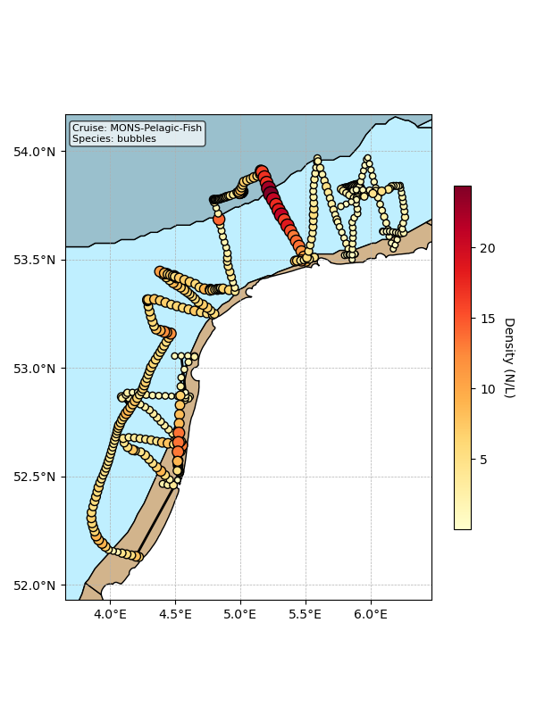

Map showing mean density estimates for bubbles along the cruise transect. OSPAR eutrophication areas are plotted in the background with different colours.

## Classification examples

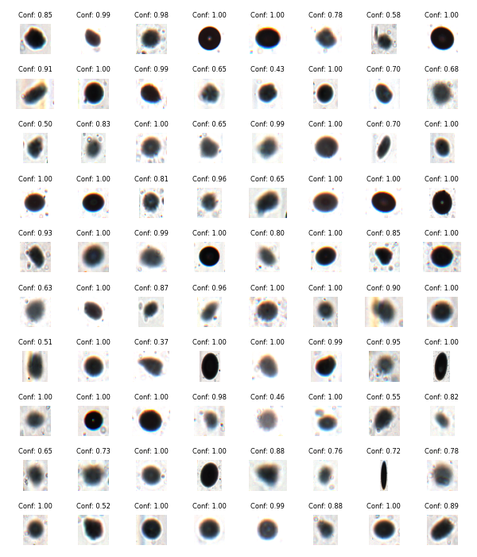

Figure showing several images classified as bubbles with model confidence.

# Class: Myzozoa_Dinophyceae

## Statistics

|  |  |
| --- | --- |
| Metric | Value |
| Class ID | 41 |
| Class | Myzozoa Dinophyceae |
| Number of predictions | 554,713 |
| Percentage of total images | 3.27 % |
| Min confidence | 0.13 % |
| Max confidence | 1.00 % |
| Average confidence | 0.72 % |
| Min density | 0.07 n/L |
| Max density | 19.79 n/L |
| Average density | 2.77 n/L |

## Model confidence

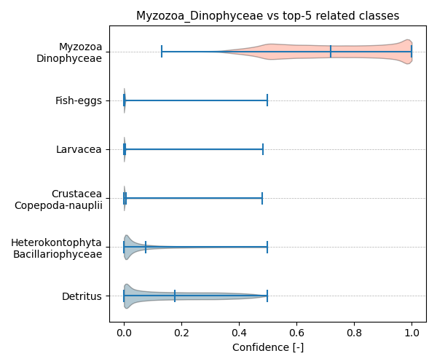

Figure showcasing the confidence distribution of the top-5 most related classes, which are determined by computing the mean confidence value of all non-target classes and selecting the five with the highest means, compared to Myzozoa_Dinophyceae.

## Temporal density

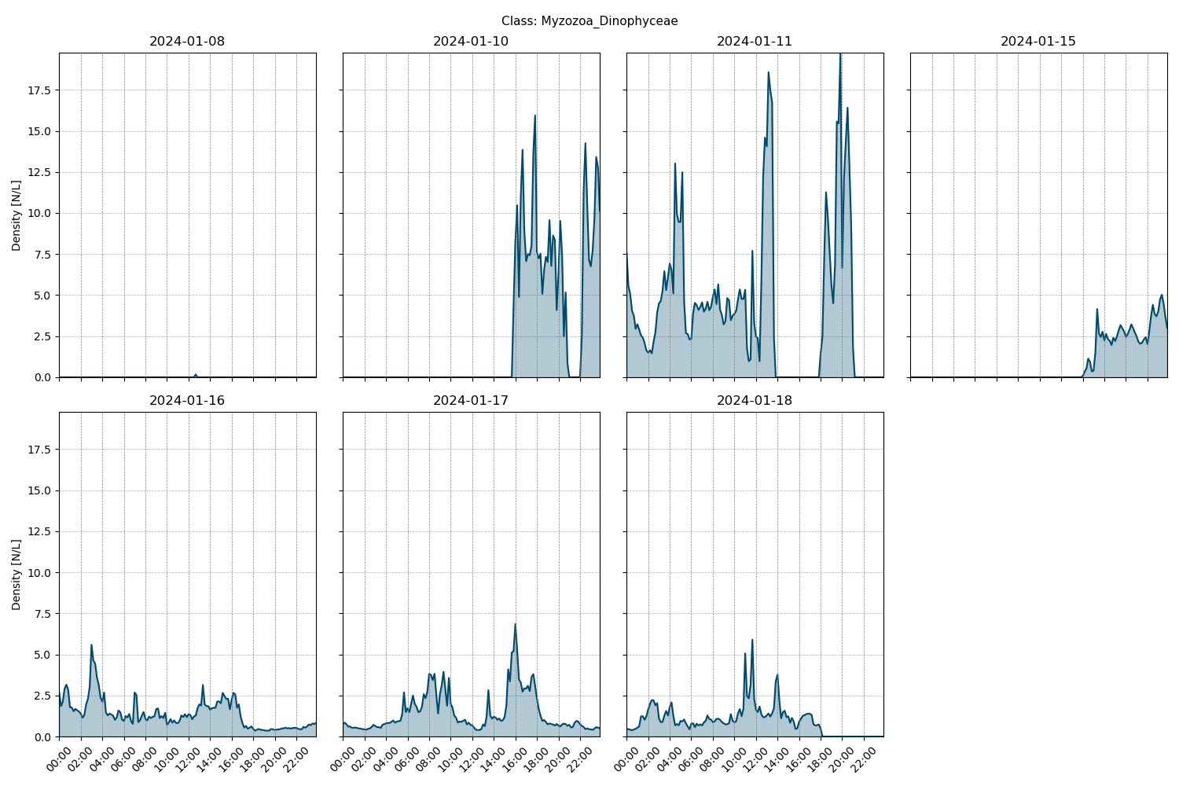

Figure showcasing the daily density estimates for Myzozoa_Dinophyceae per 10 minutes.

## Spatio-temporal density

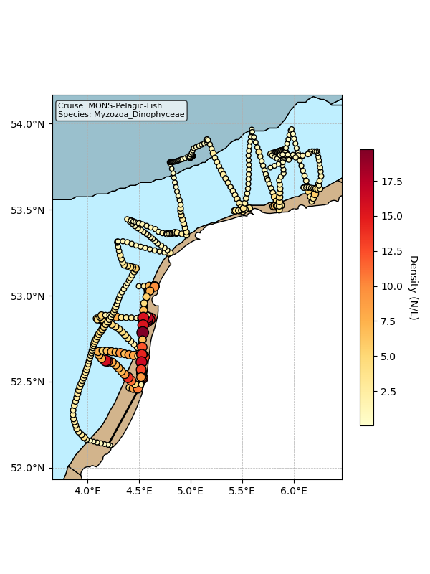

Map showing mean density estimates for Myzozoa_Dinophyceae along the cruise transect. OSPAR eutrophication areas are plotted in the background with different colours.

## Classification examples

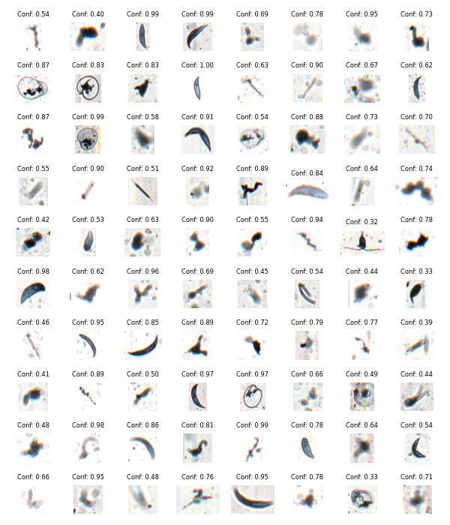

Figure showing several images classified as Myzozoa_Dinophyceae with model confidence.

# Class: Crustacea_Copepoda-nauplii

## Statistics

|  |  |
| --- | --- |
| Metric | Value |
| Class ID | 15 |
| Class | Crustacea Copepoda nauplii |
| Number of predictions | 288,129 |
| Percentage of total images | 1.70 % |
| Min confidence | 0.13 % |
| Max confidence | 1.00 % |
| Average confidence | 0.76 % |
| Min density | 0.02 n/L |
| Max density | 4.21 n/L |
| Average density | 1.44 n/L |

## Model confidence

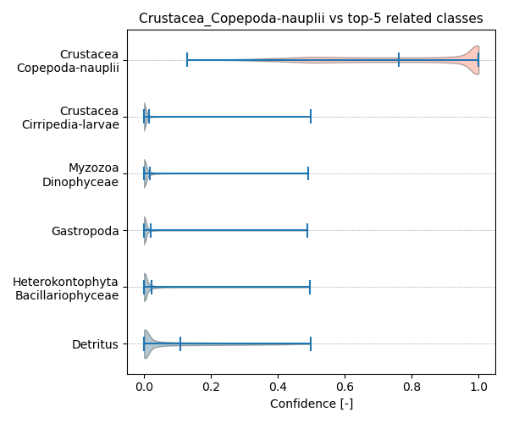

Figure showcasing the confidence distribution of the top-5 most related classes, which are determined by computing the mean confidence value of all non-target classes and selecting the five with the highest means, compared to Crustacea_Copepoda-nauplii.

## Temporal density

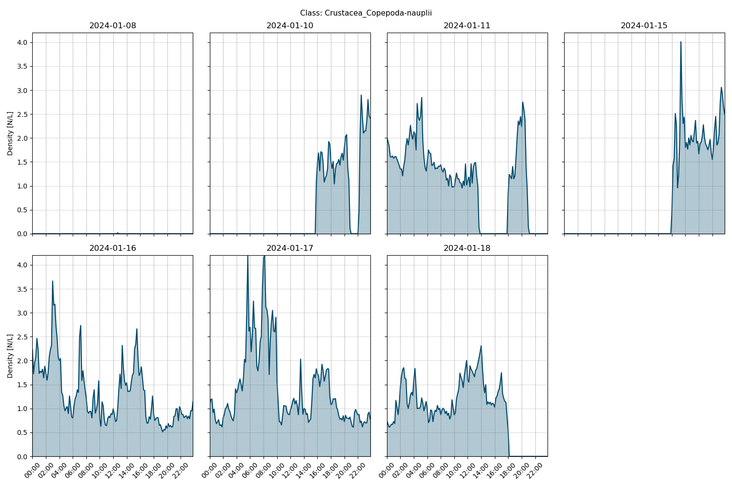

Figure showcasing the daily density estimates for Crustacea_Copepoda-nauplii per 10 minutes.

## Spatio-temporal density

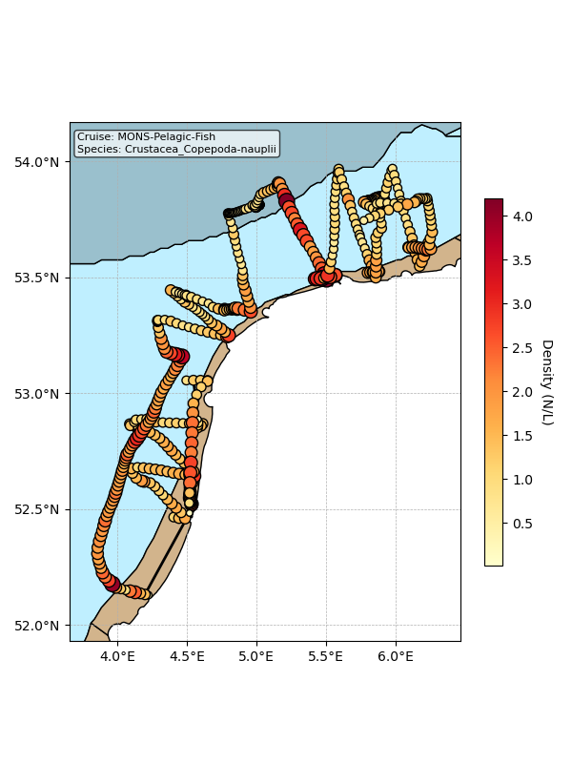

Map showing mean density estimates for Crustacea_Copepoda-nauplii along the cruise transect. OSPAR eutrophication areas are plotted in the background with different colours.

## Classification examples

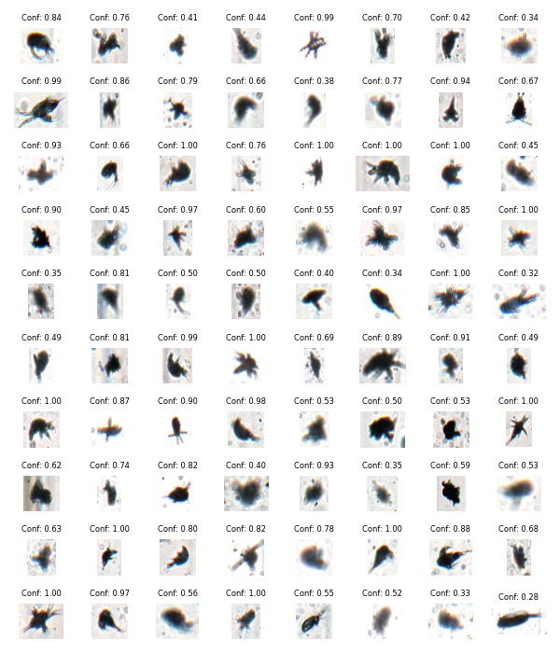

Figure showing several images classified as Crustacea_Copepoda-nauplii with model confidence.

# Class: Larvacea

## Statistics

|  |  |
| --- | --- |
| Metric | Value |
| Class ID | 37 |
| Class | Larvacea |
| Number of predictions | 112,512 |
| Percentage of total images | 0.66 % |
| Min confidence | 0.13 % |
| Max confidence | 1.00 % |
| Average confidence | 0.78 % |
| Min density | 0.00 n/L |
| Max density | 2.29 n/L |
| Average density | 0.56 n/L |

## Model confidence

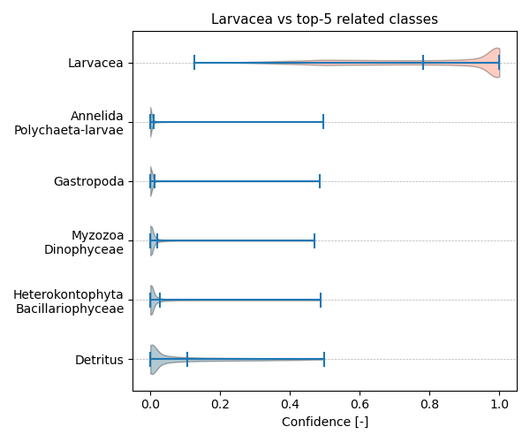

Figure showcasing the confidence distribution of the top-5 most related classes, which are determined by computing the mean confidence value of all non-target classes and selecting the five with the highest means, compared to Larvacea.

## Temporal density

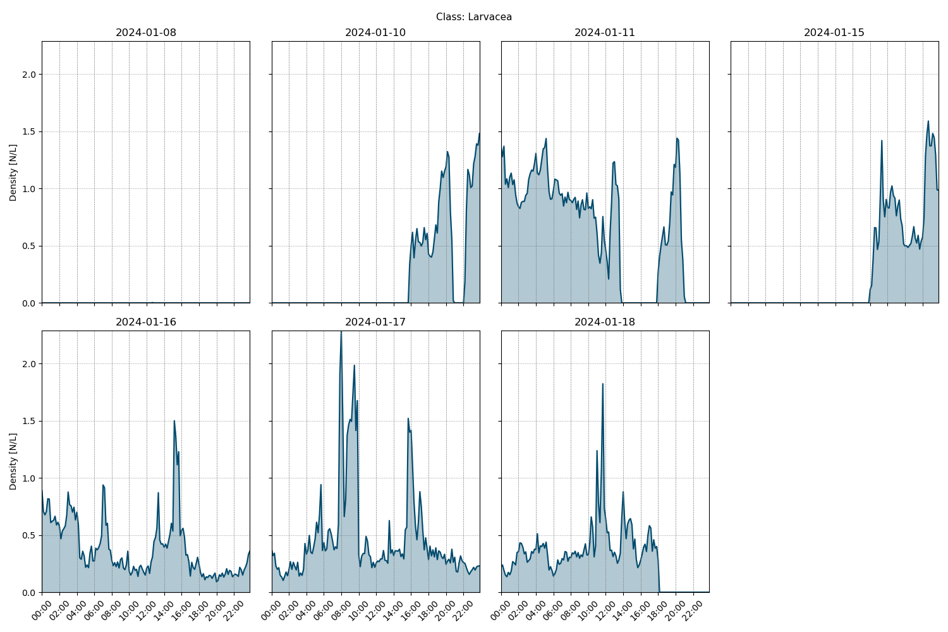

Figure showcasing the daily density estimates for Larvacea per 10 minutes.

## Spatio-temporal density

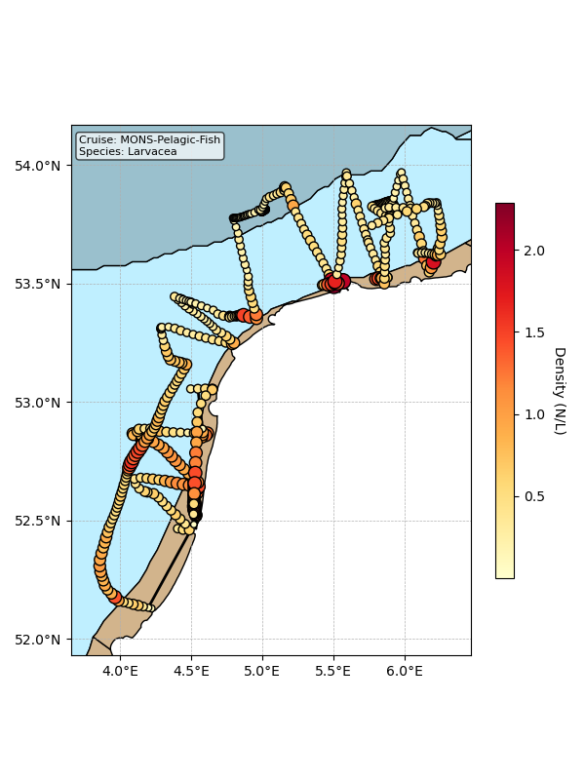

Map showing mean density estimates for Larvacea along the cruise transect. OSPAR eutrophication areas are plotted in the background with different colours.

## Classification examples

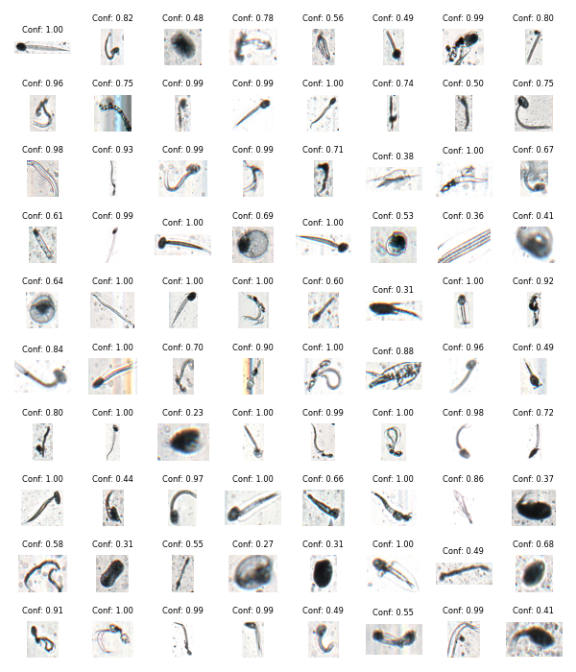

Figure showing several images classified as Larvacea with model confidence.

# Class: Crustacea_Copepoda_Calanoida

## Statistics

|  |  |
| --- | --- |
| Metric | Value |
| Class ID | 16 |
| Class | Crustacea Copepoda Calanoida |
| Number of predictions | 63,970 |
| Percentage of total images | 0.38 % |
| Min confidence | 0.12 % |
| Max confidence | 1.00 % |
| Average confidence | 0.68 % |
| Min density | 0.01 n/L |
| Max density | 2.14 n/L |
| Average density | 0.32 n/L |

## Model confidence

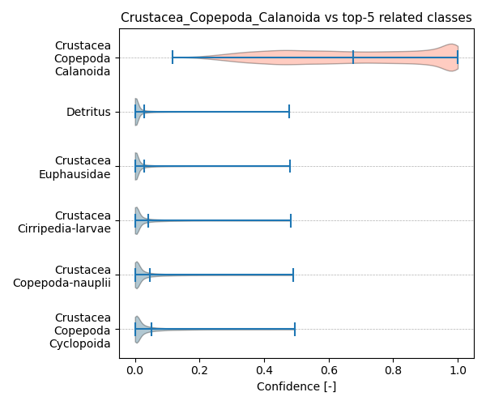

Figure showcasing the confidence distribution of the top-5 most related classes, which are determined by computing the mean confidence value of all non-target classes and selecting the five with the highest means, compared to Crustacea_Copepoda_Calanoida.

## Temporal density

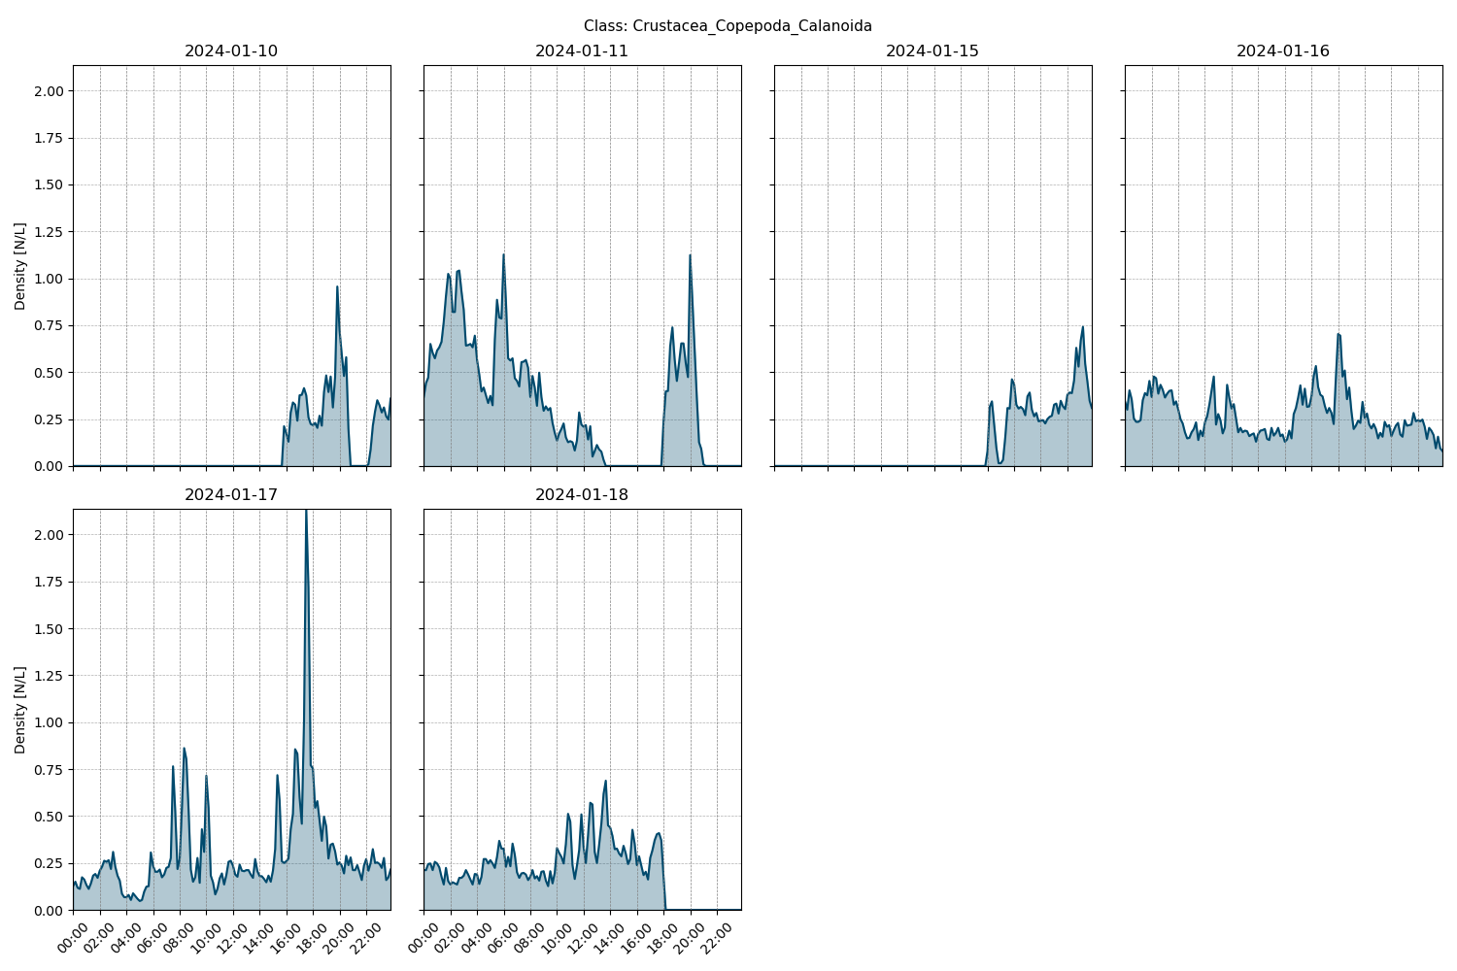

Figure showcasing the daily density estimates for Crustacea_Copepoda_Calanoida per 10 minutes.

## Spatio-temporal density

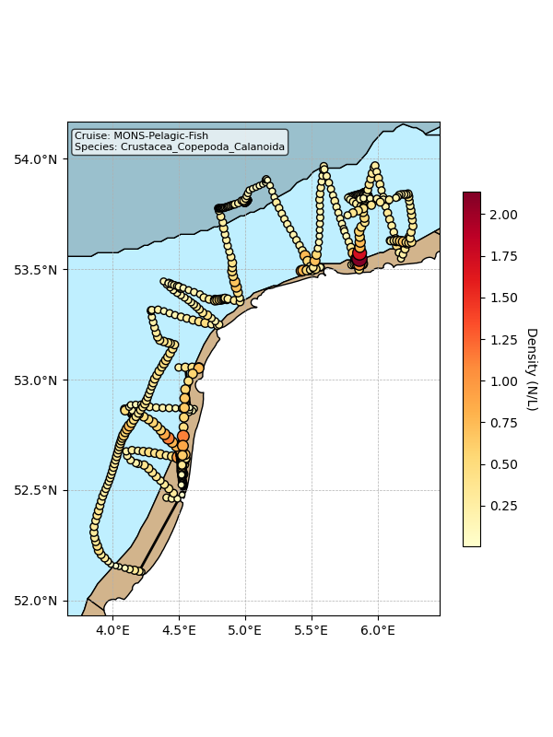

Map showing mean density estimates for Crustacea_Copepoda_Calanoida along the cruise transect. OSPAR eutrophication areas are plotted in the background with different colours.

## Classification examples

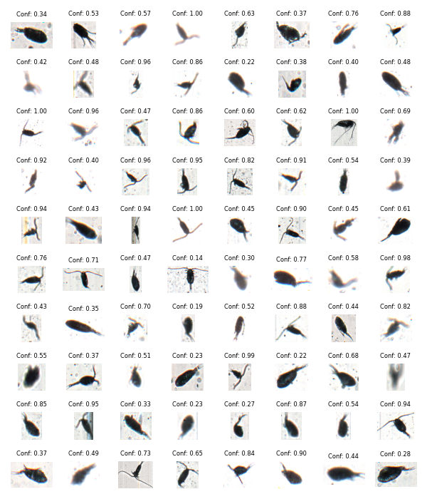

Figure showing several images classified as Crustacea_Copepoda_Calanoida with model confidence.

# Class: Phoronida-larvae

## Statistics

|  |  |
| --- | --- |
| Metric | Value |
| Class ID | 43 |
| Class | Phoronida larvae |
| Number of predictions | 58,141 |
| Percentage of total images | 0.34 % |
| Min confidence | 0.13 % |
| Max confidence | 1.00 % |
| Average confidence | 0.59 % |
| Min density | 0.00 n/L |
| Max density | 2.95 n/L |
| Average density | 0.29 n/L |

## Model confidence

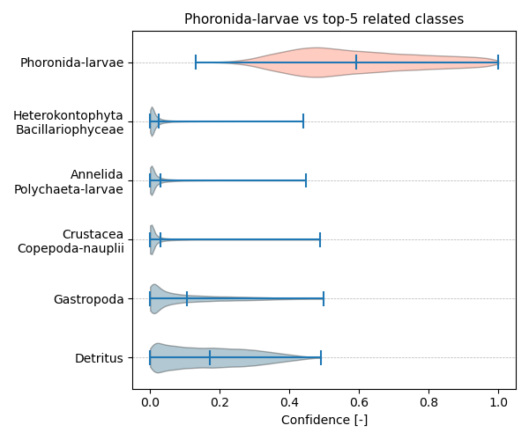

Figure showcasing the confidence distribution of the top-5 most related classes, which are determined by computing the mean confidence value of all non-target classes and selecting the five with the highest means, compared to Phoronida-larvae.

## Temporal density

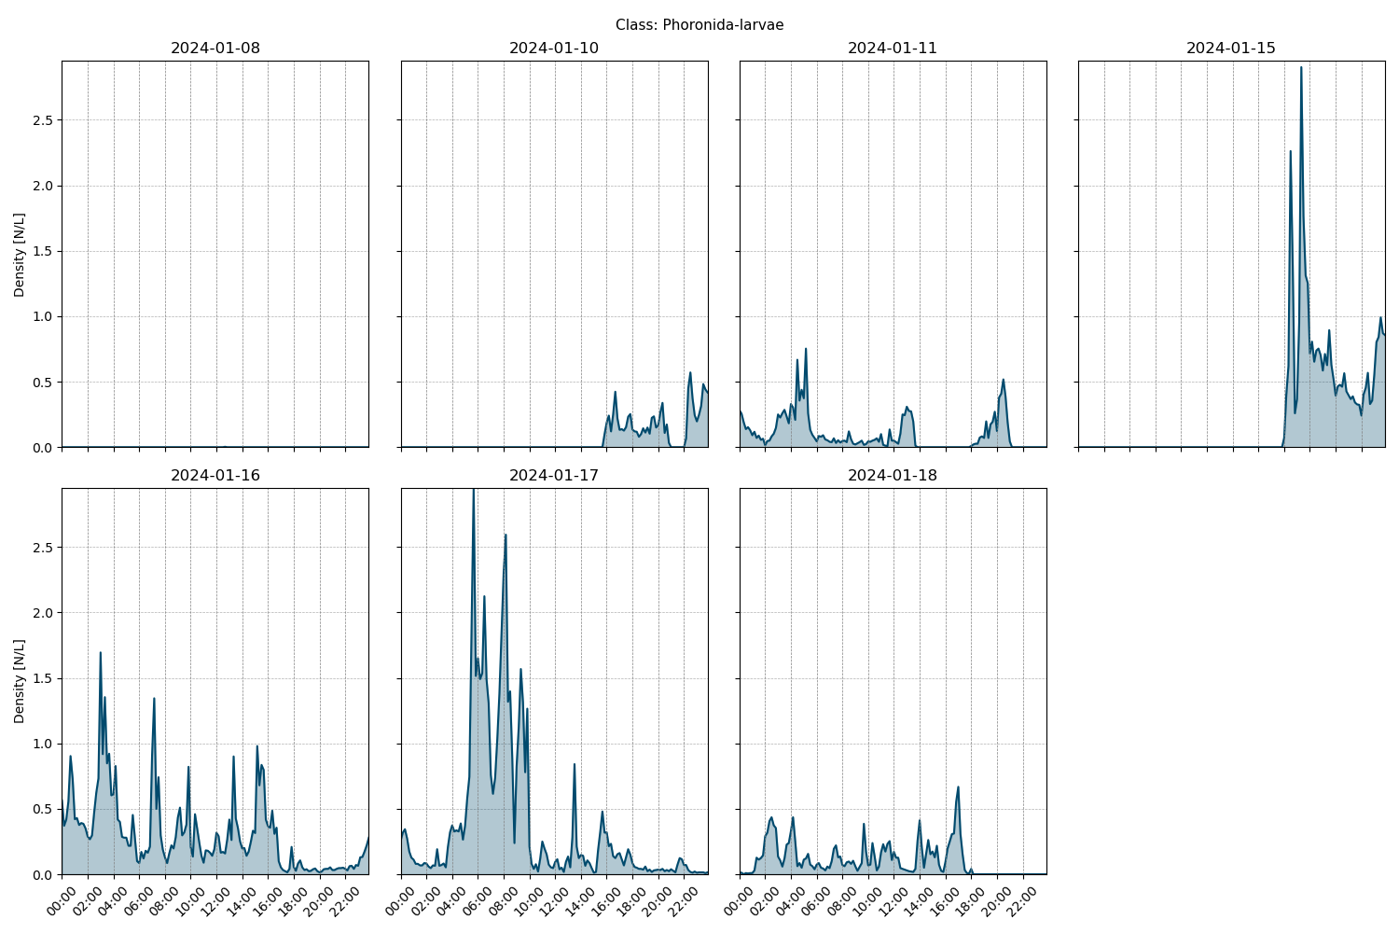

Figure showcasing the daily density estimates for Phoronida-larvae per 10 minutes.

## Spatio-temporal density

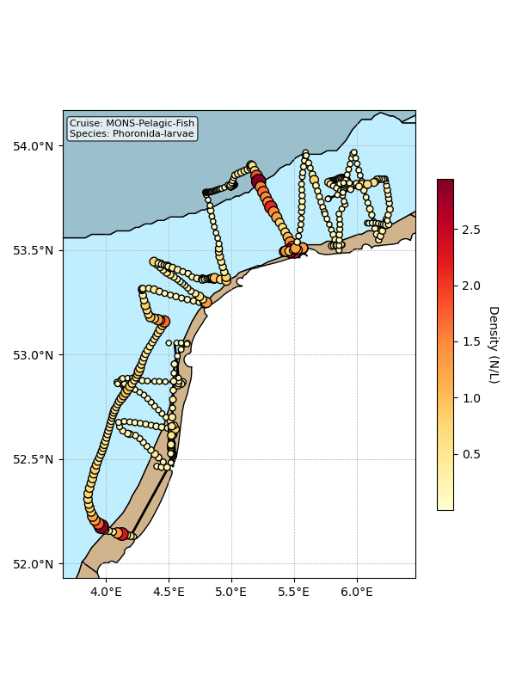

Map showing mean density estimates for Phoronida-larvae along the cruise transect. OSPAR eutrophication areas are plotted in the background with different colours.

## Classification examples

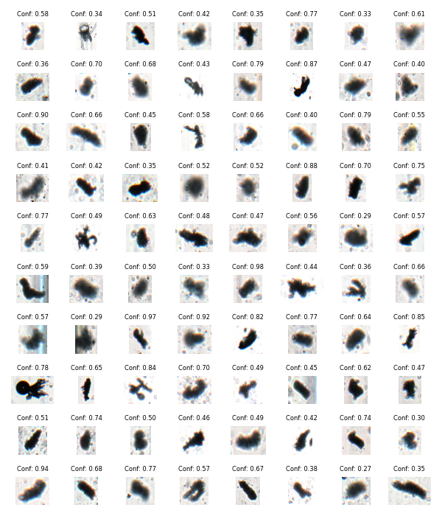

Figure showing several images classified as Phoronida-larvae with model confidence.

# Class: Crustacea_Cirripedia-larvae

## Statistics

|  |  |
| --- | --- |
| Metric | Value |
| Class ID | 13 |
| Class | Crustacea Cirripedia larvae |
| Number of predictions | 48,192 |
| Percentage of total images | 0.28 % |
| Min confidence | 0.10 % |
| Max confidence | 1.00 % |
| Average confidence | 0.57 % |
| Min density | 0.00 n/L |
| Max density | 2.65 n/L |
| Average density | 0.24 n/L |

## Model confidence

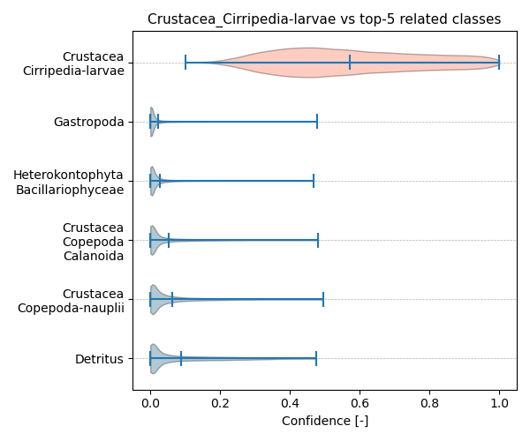

Figure showcasing the confidence distribution of the top-5 most related classes, which are determined by computing the mean confidence value of all non-target classes and selecting the five with the highest means, compared to Crustacea_Cirripedia-larvae.

## Temporal density

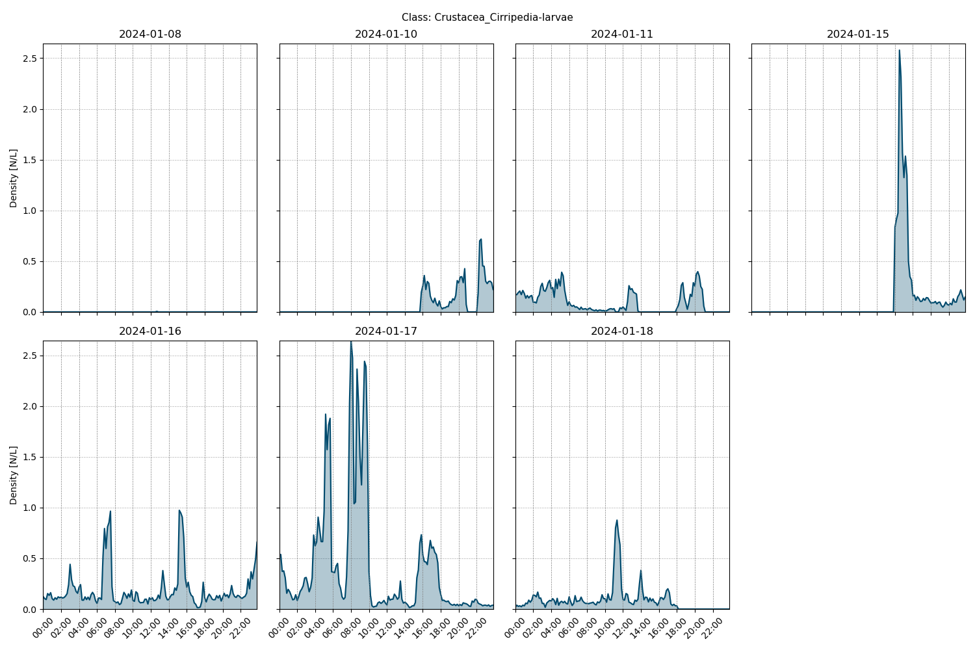

Figure showcasing the daily density estimates for Crustacea_Cirripedia-larvae per 10 minutes.

## Spatio-temporal density

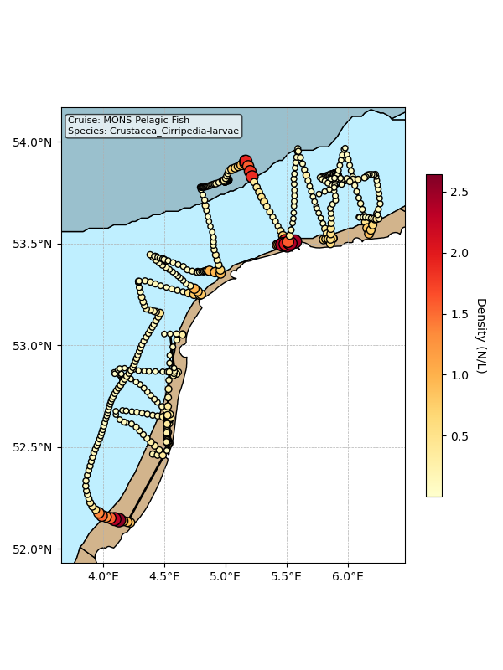

Map showing mean density estimates for Crustacea_Cirripedia-larvae along the cruise transect. OSPAR eutrophication areas are plotted in the background with different colours.

## Classification examples

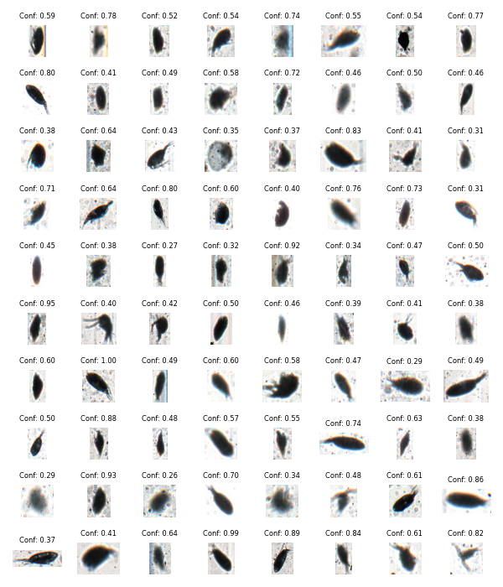

Figure showing several images classified as Crustacea_Cirripedia-larvae with model confidence.

# Class: Crustacea_Cladocera

## Statistics

|  |  |
| --- | --- |
| Metric | Value |
| Class ID | 14 |
| Class | Crustacea Cladocera |
| Number of predictions | 28,906 |
| Percentage of total images | 0.17 % |
| Min confidence | 0.12 % |
| Max confidence | 1.00 % |
| Average confidence | 0.59 % |
| Min density | 0.00 n/L |
| Max density | 0.60 n/L |
| Average density | 0.14 n/L |

## Model confidence

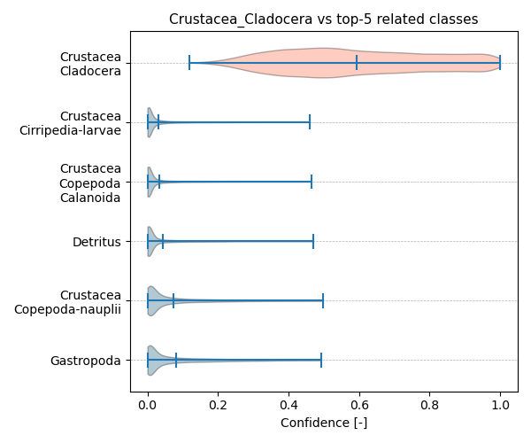

Figure showcasing the confidence distribution of the top-5 most related classes, which are determined by computing the mean confidence value of all non-target classes and selecting the five with the highest means, compared to Crustacea_Cladocera.

## Temporal density

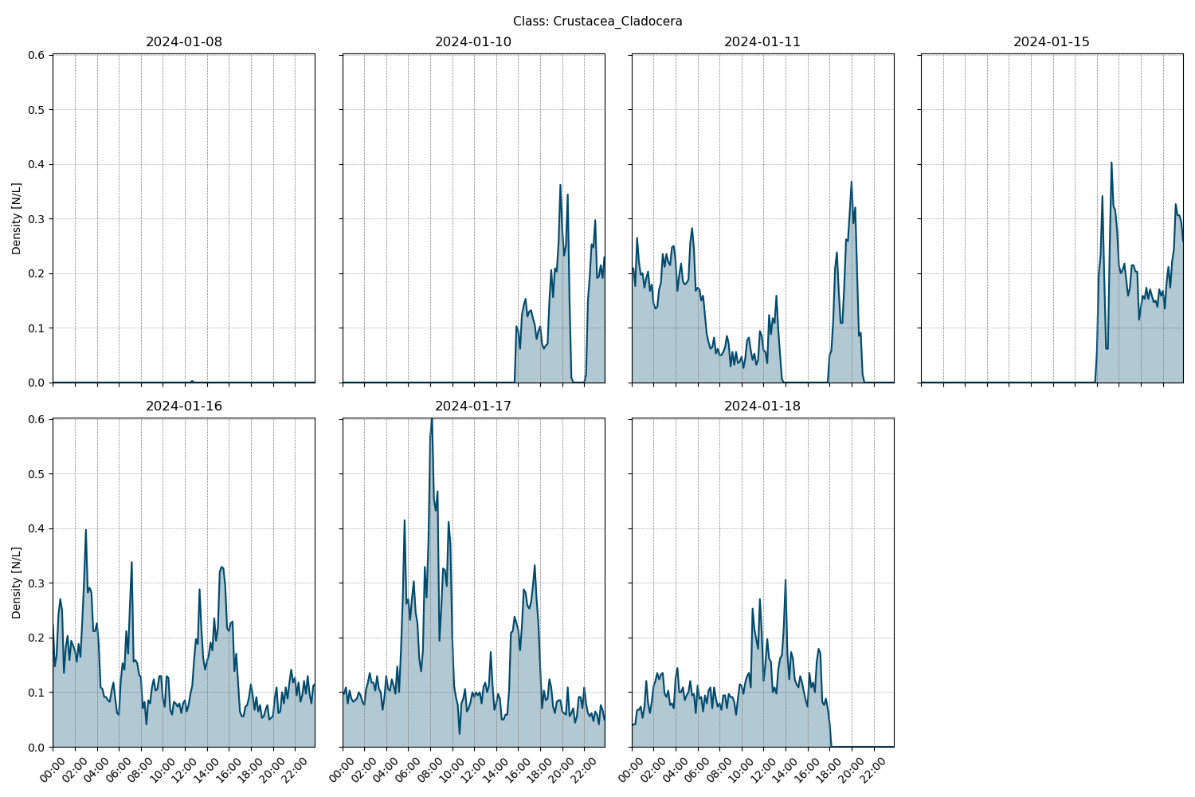

Figure showcasing the daily density estimates for Crustacea_Cladocera per 10 minutes.

## Spatio-temporal density

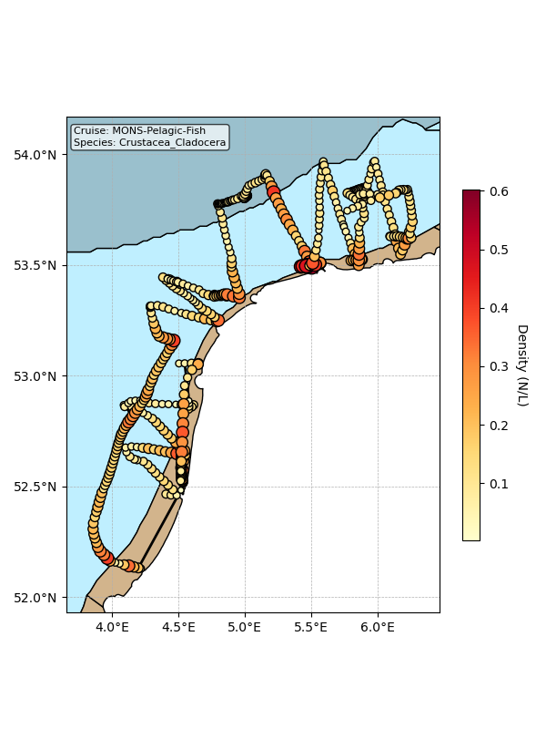

Map showing mean density estimates for Crustacea_Cladocera along the cruise transect. OSPAR eutrophication areas are plotted in the background with different colours.

## Classification examples

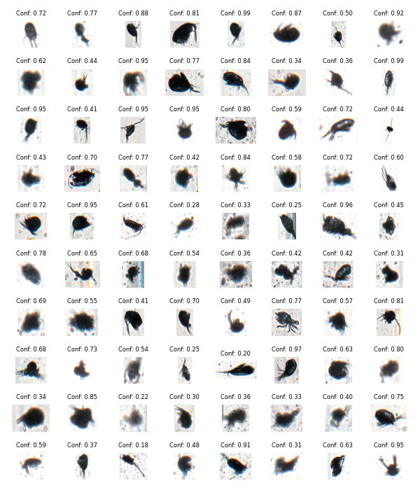

Figure showing several images classified as Crustacea_Cladocera with model confidence.

# Class: Haptophyta_Phaeocystales

## Statistics

|  |  |
| --- | --- |
| Metric | Value |
| Class ID | 33 |
| Class | Haptophyta Phaeocystales |
| Number of predictions | 26,281 |
| Percentage of total images | 0.15 % |
| Min confidence | 0.14 % |
| Max confidence | 1.00 % |
| Average confidence | 0.69 % |
| Min density | 0.00 n/L |
| Max density | 31.06 n/L |
| Average density | 0.14 n/L |

## Model confidence

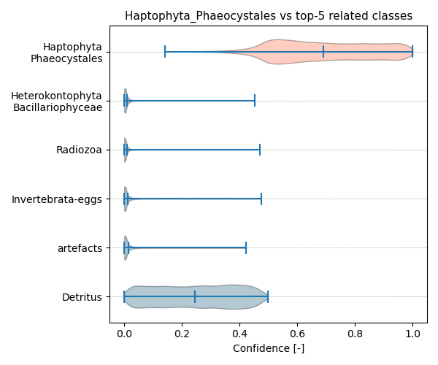

Figure showcasing the confidence distribution of the top-5 most related classes, which are determined by computing the mean confidence value of all non-target classes and selecting the five with the highest means, compared to Haptophyta_Phaeocystales.

## Temporal density

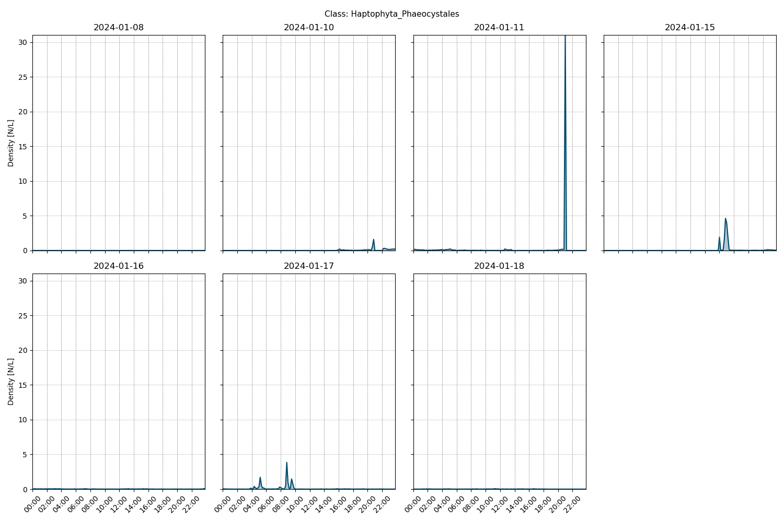

Figure showcasing the daily density estimates for Haptophyta_Phaeocystales per 10 minutes.

## Spatio-temporal density

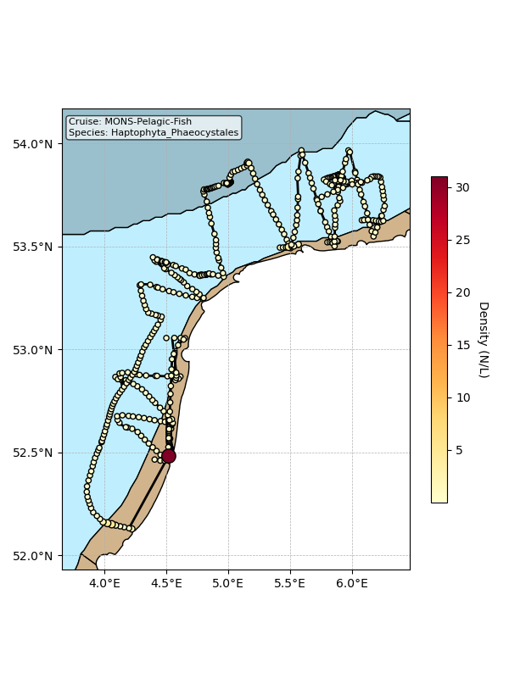

Map showing mean density estimates for Haptophyta_Phaeocystales along the cruise transect. OSPAR eutrophication areas are plotted in the background with different colours.

## Classification examples

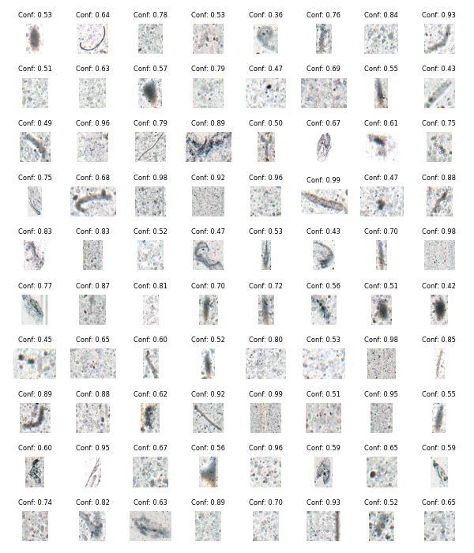

Figure showing several images classified as Haptophyta_Phaeocystales with model confidence.

# Class: Bryozoa-larvae

## Statistics

|  |  |
| --- | --- |
| Metric | Value |
| Class ID | 4 |
| Class | Bryozoa larvae |
| Number of predictions | 19,249 |
| Percentage of total images | 0.11 % |
| Min confidence | 0.12 % |
| Max confidence | 1.00 % |
| Average confidence | 0.61 % |
| Min density | 0.00 n/L |
| Max density | 2.29 n/L |
| Average density | 0.10 n/L |

## Model confidence

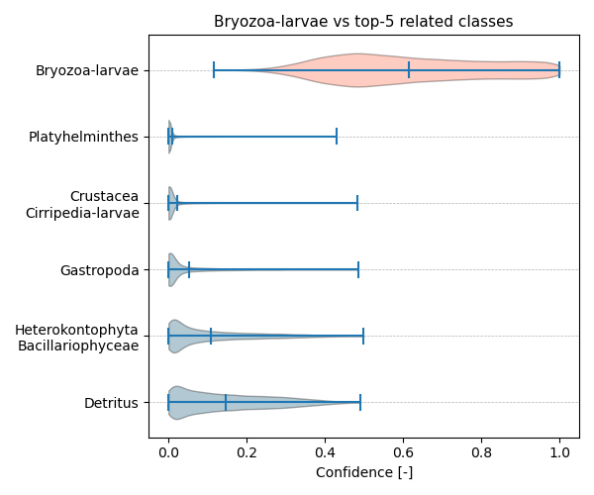

Figure showcasing the confidence distribution of the top-5 most related classes, which are determined by computing the mean confidence value of all non-target classes and selecting the five with the highest means, compared to Bryozoa-larvae.

## Temporal density

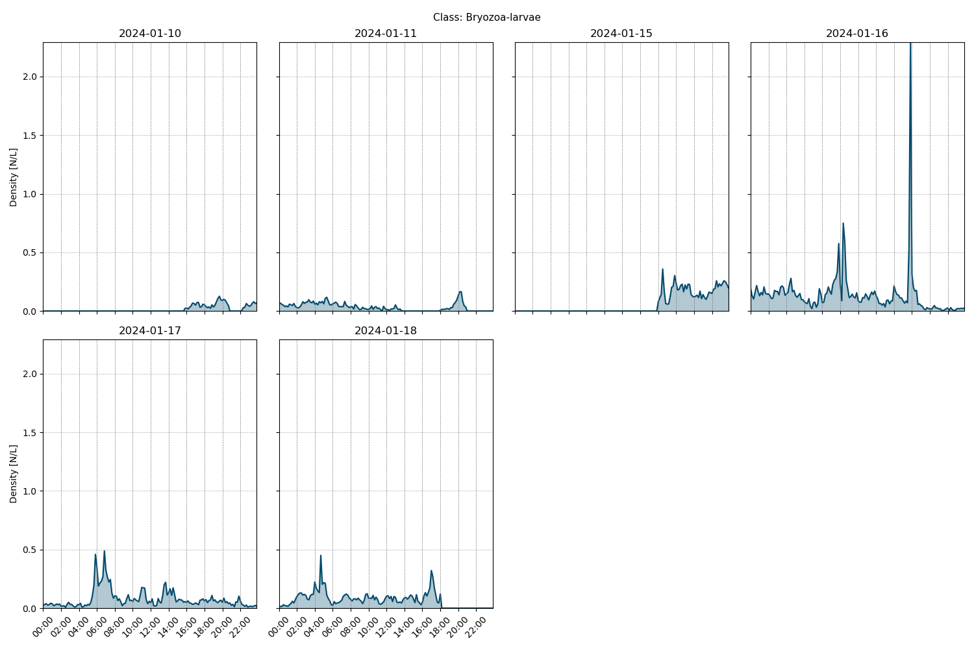

Figure showcasing the daily density estimates for Bryozoa-larvae per 10 minutes.

## Spatio-temporal density

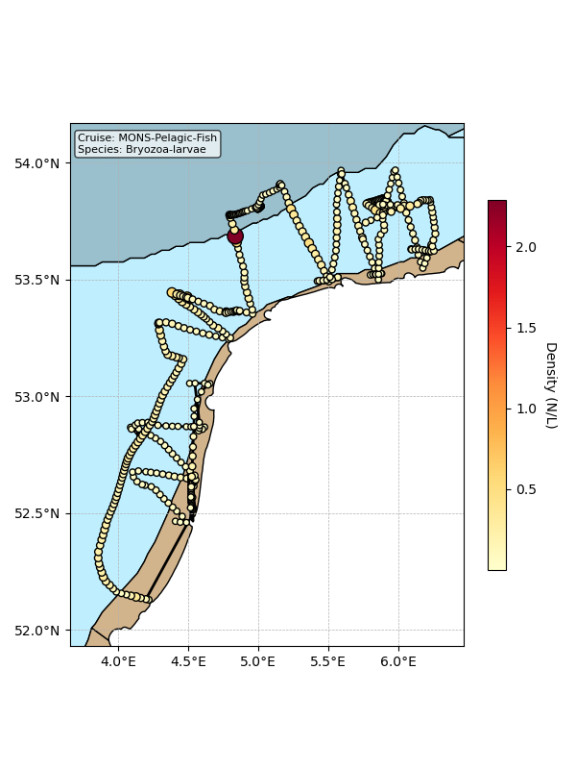

Map showing mean density estimates for Bryozoa-larvae along the cruise transect. OSPAR eutrophication areas are plotted in the background with different colours.

## Classification examples

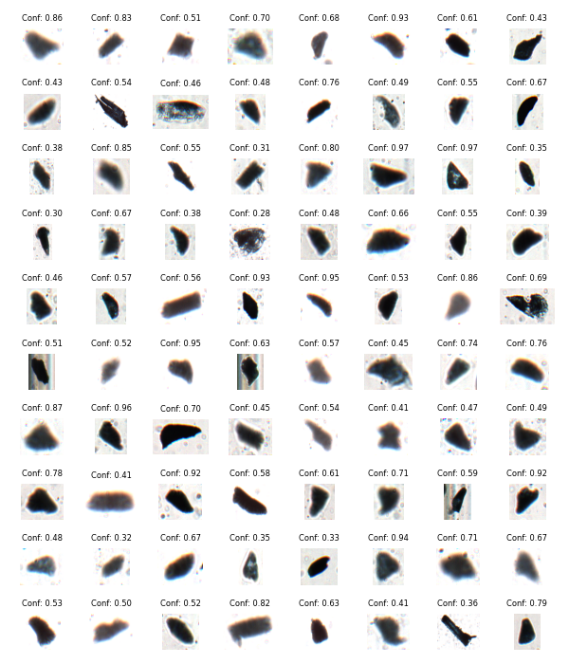

Figure showing several images classified as Bryozoa-larvae with model confidence.

# Class: Annelida_Polychaeta-larvae

## Statistics

|  |  |
| --- | --- |
| Metric | Value |
| Class ID | 0 |
| Class | Annelida Polychaeta larvae |
| Number of predictions | 17,662 |
| Percentage of total images | 0.10 % |
| Min confidence | 0.12 % |
| Max confidence | 1.00 % |
| Average confidence | 0.53 % |
| Min density | 0.00 n/L |
| Max density | 1.20 n/L |
| Average density | 0.09 n/L |

## Model confidence

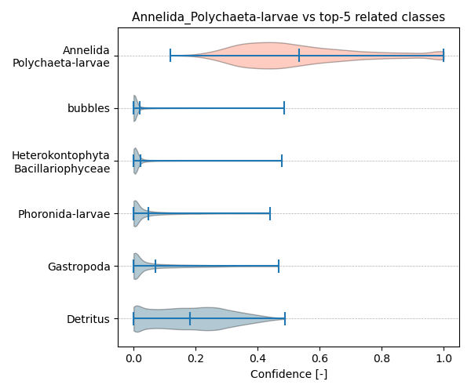

Figure showcasing the confidence distribution of the top-5 most related classes, which are determined by computing the mean confidence value of all non-target classes and selecting the five with the highest means, compared to Annelida_Polychaeta-larvae.

## Temporal density

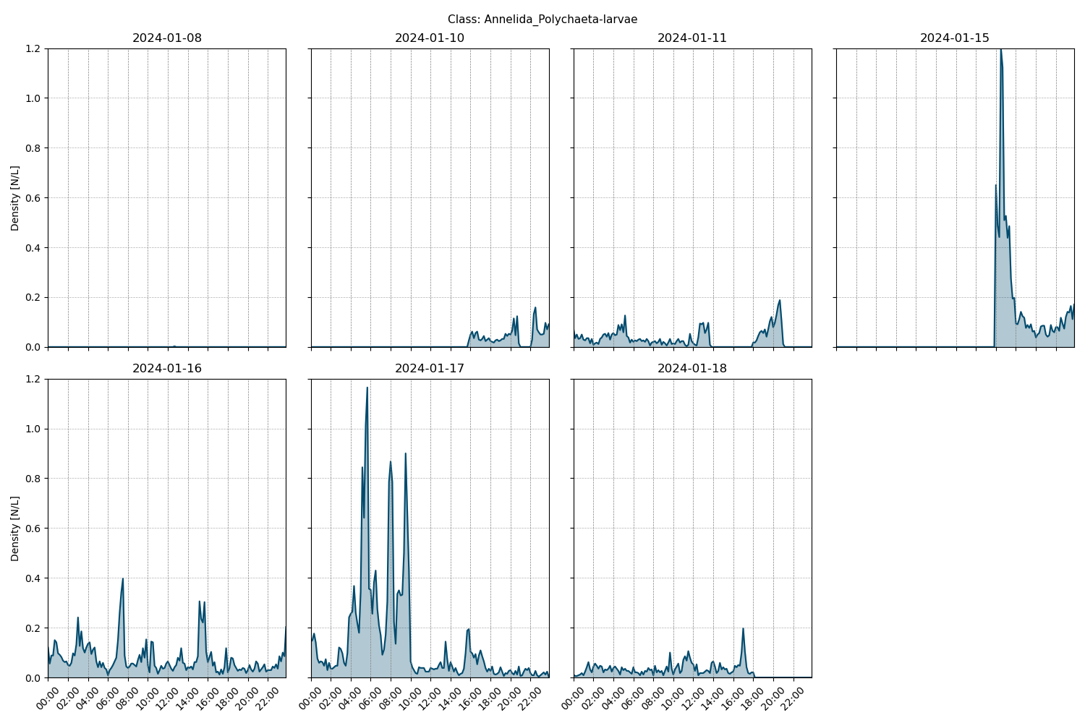

Figure showcasing the daily density estimates for Annelida_Polychaeta-larvae per 10 minutes.

## Spatio-temporal density

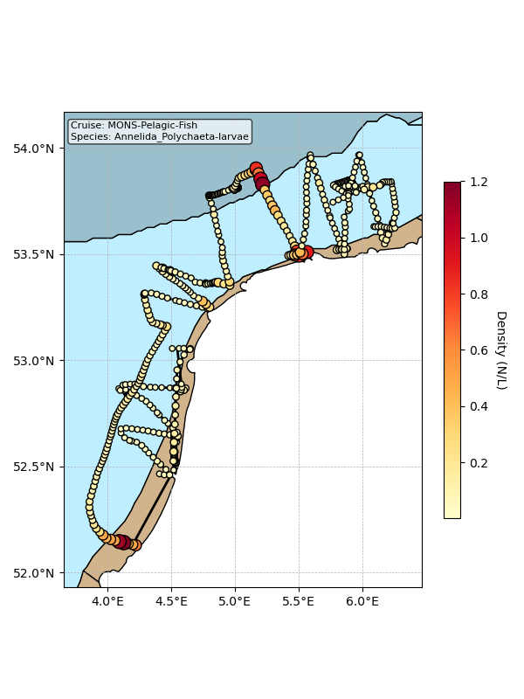

Map showing mean density estimates for Annelida_Polychaeta-larvae along the cruise transect. OSPAR eutrophication areas are plotted in the background with different colours.

## Classification examples

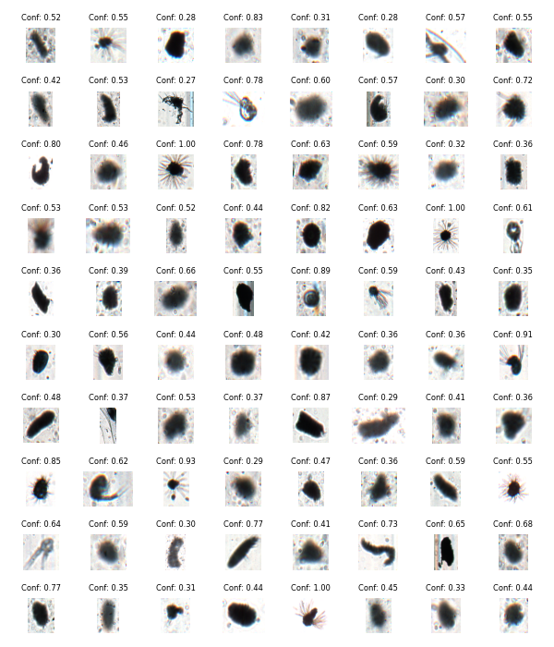

Figure showing several images classified as Annelida_Polychaeta-larvae with model confidence.

# Class: Crustacea_Copepoda_Cyclopoida

## Statistics

|  |  |
| --- | --- |
| Metric | Value |
| Class ID | 17 |
| Class | Crustacea Copepoda Cyclopoida |
| Number of predictions | 17,220 |
| Percentage of total images | 0.10 % |
| Min confidence | 0.12 % |
| Max confidence | 1.00 % |
| Average confidence | 0.63 % |
| Min density | 0.00 n/L |
| Max density | 0.29 n/L |
| Average density | 0.09 n/L |

## Model confidence

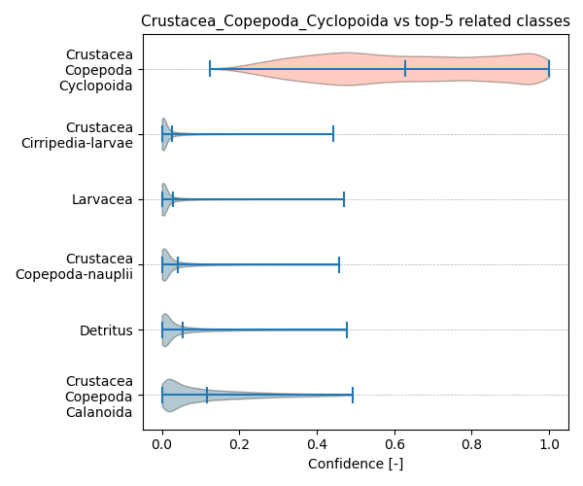

Figure showcasing the confidence distribution of the top-5 most related classes, which are determined by computing the mean confidence value of all non-target classes and selecting the five with the highest means, compared to Crustacea_Copepoda_Cyclopoida.

## Temporal density

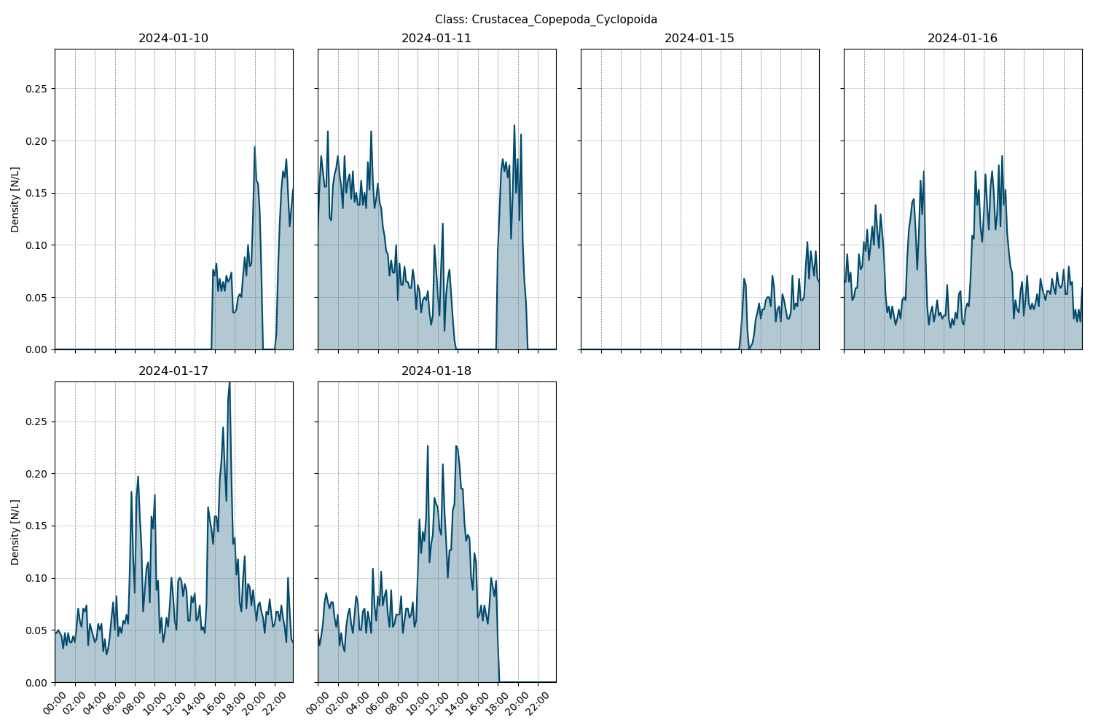

Figure showcasing the daily density estimates for Crustacea_Copepoda_Cyclopoida per 10 minutes.

## Spatio-temporal density

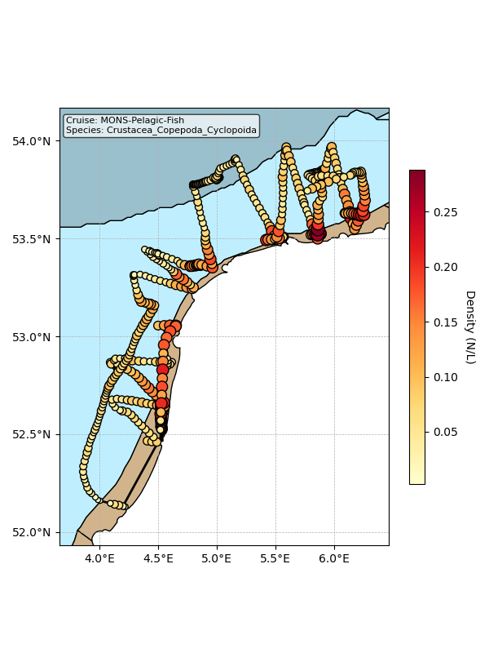

Map showing mean density estimates for Crustacea_Copepoda_Cyclopoida along the cruise transect. OSPAR eutrophication areas are plotted in the background with different colours.

## Classification examples

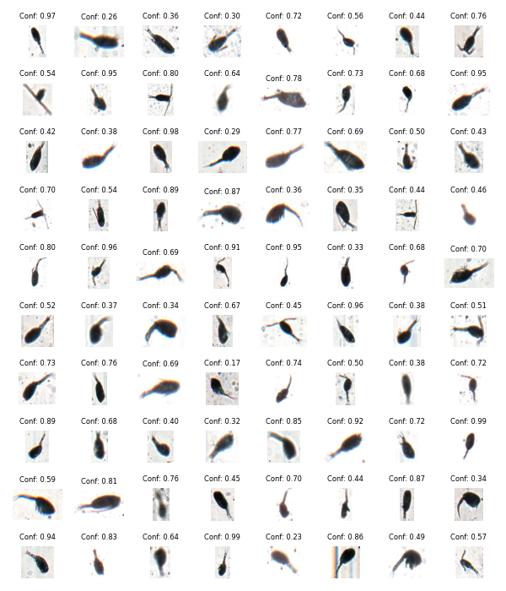

Figure showing several images classified as Crustacea_Copepoda_Cyclopoida with model confidence.

# Class: Platyhelminthes

## Statistics

|  |  |
| --- | --- |
| Metric | Value |
| Class ID | 44 |
| Class | Platyhelminthes |
| Number of predictions | 9,004 |
| Percentage of total images | 0.05 % |
| Min confidence | 0.14 % |
| Max confidence | 1.00 % |
| Average confidence | 0.68 % |
| Min density | 0.00 n/L |
| Max density | 1.08 n/L |
| Average density | 0.05 n/L |

## Model confidence

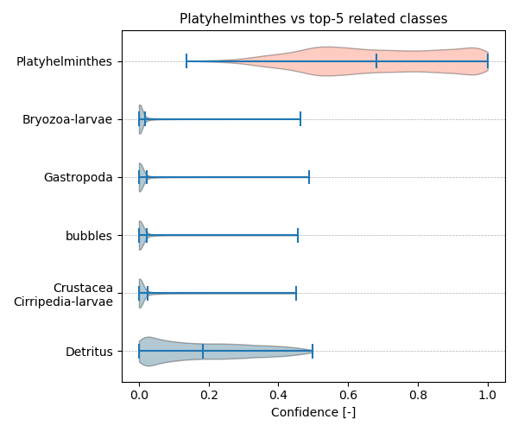

Figure showcasing the confidence distribution of the top-5 most related classes, which are determined by computing the mean confidence value of all non-target classes and selecting the five with the highest means, compared to Platyhelminthes.

## Temporal density

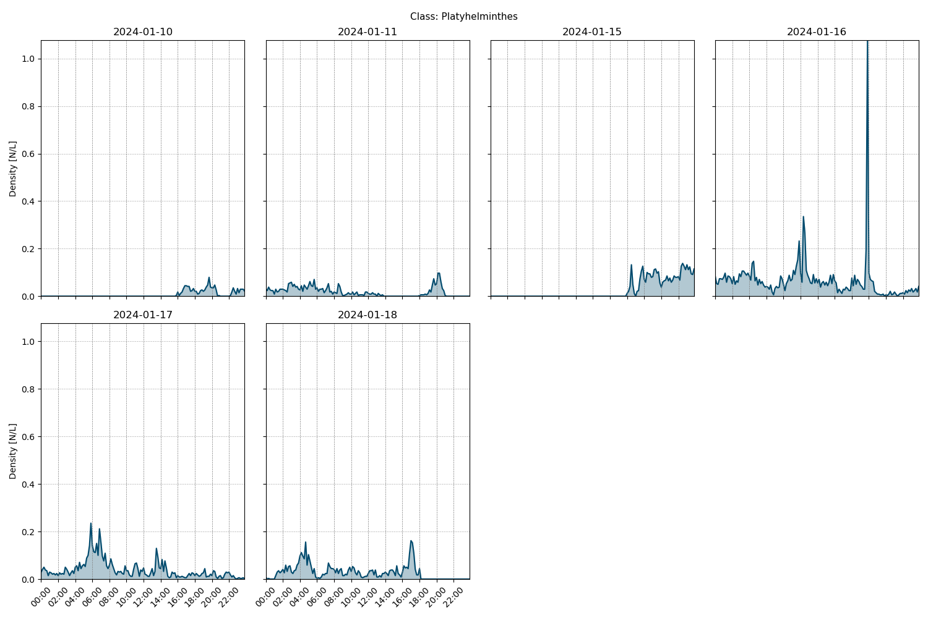

Figure showcasing the daily density estimates for Platyhelminthes per 10 minutes.

## Spatio-temporal density

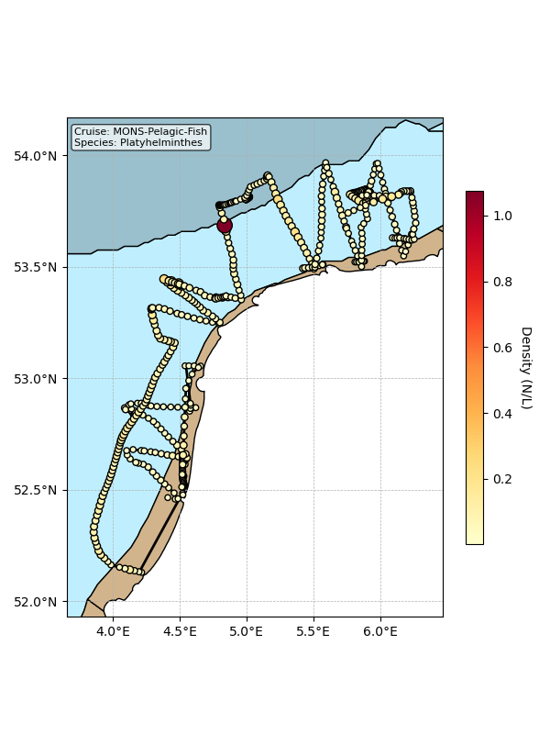

Map showing mean density estimates for Platyhelminthes along the cruise transect. OSPAR eutrophication areas are plotted in the background with different colours.

## Classification examples

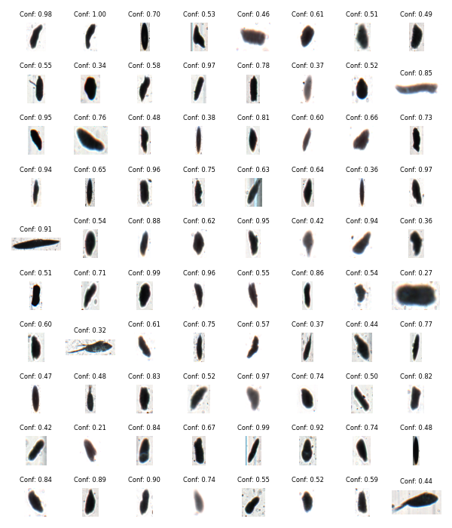

Figure showing several images classified as Platyhelminthes with model confidence.

# Class: Radiozoa

## Statistics

|  |  |
| --- | --- |
| Metric | Value |
| Class ID | 45 |
| Class | Radiozoa |
| Number of predictions | 8,399 |
| Percentage of total images | 0.05 % |
| Min confidence | 0.13 % |
| Max confidence | 1.00 % |
| Average confidence | 0.61 % |
| Min density | 0.00 n/L |
| Max density | 2.36 n/L |
| Average density | 0.05 n/L |

## Model confidence

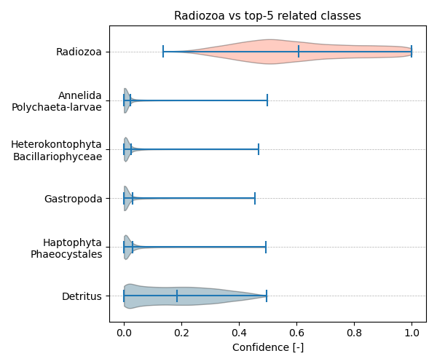

Figure showcasing the confidence distribution of the top-5 most related classes, which are determined by computing the mean confidence value of all non-target classes and selecting the five with the highest means, compared to Radiozoa.

## Temporal density

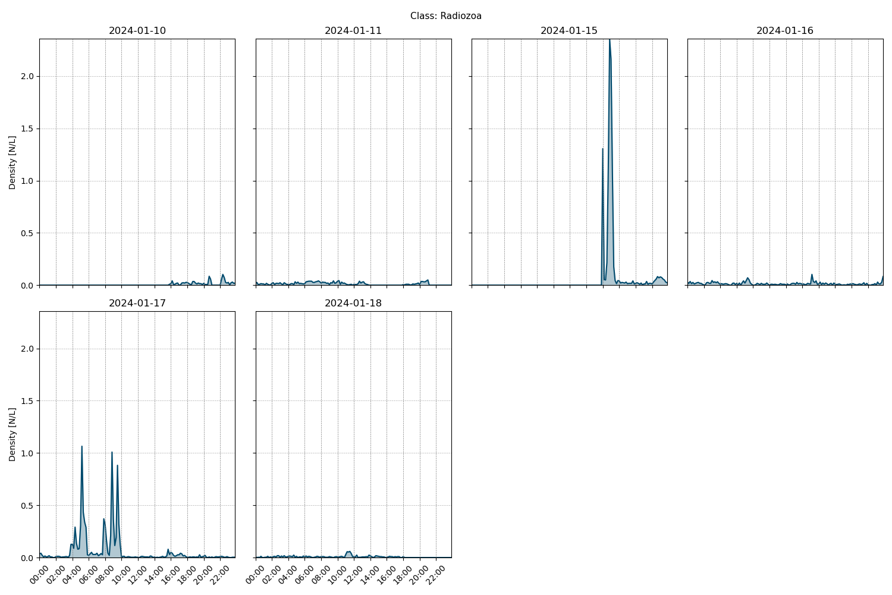

Figure showcasing the daily density estimates for Radiozoa per 10 minutes.

## Spatio-temporal density

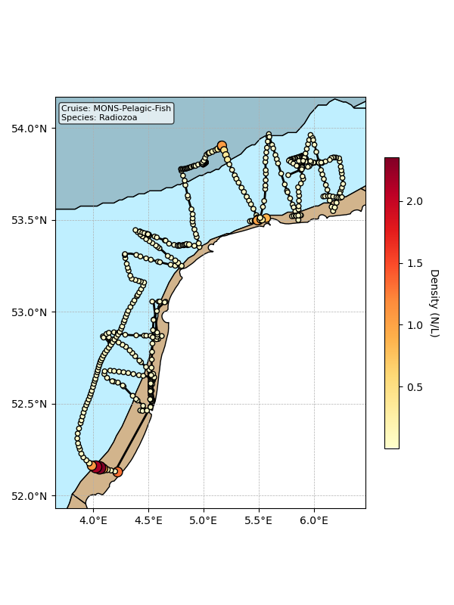

Map showing mean density estimates for Radiozoa along the cruise transect. OSPAR eutrophication areas are plotted in the background with different colours.

## Classification examples

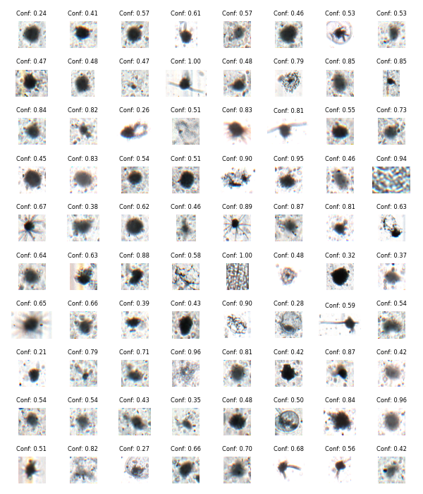

Figure showing several images classified as Radiozoa with model confidence.

# Class: artefacts

## Statistics

|  |  |
| --- | --- |
| Metric | Value |
| Class ID | 47 |
| Class | artefacts |
| Number of predictions | 7,497 |
| Percentage of total images | 0.04 % |
| Min confidence | 0.20 % |
| Max confidence | 1.00 % |
| Average confidence | 0.71 % |
| Min density | 0.00 n/L |
| Max density | 1.81 n/L |
| Average density | 0.04 n/L |

## Model confidence

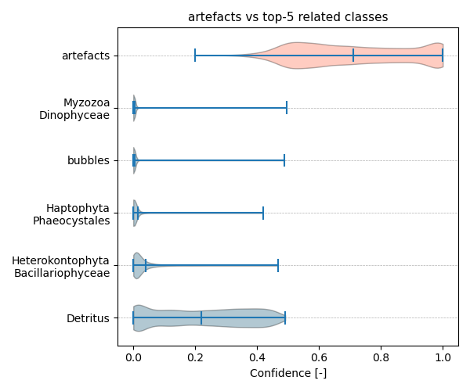

Figure showcasing the confidence distribution of the top-5 most related classes, which are determined by computing the mean confidence value of all non-target classes and selecting the five with the highest means, compared to artefacts.

## Temporal density

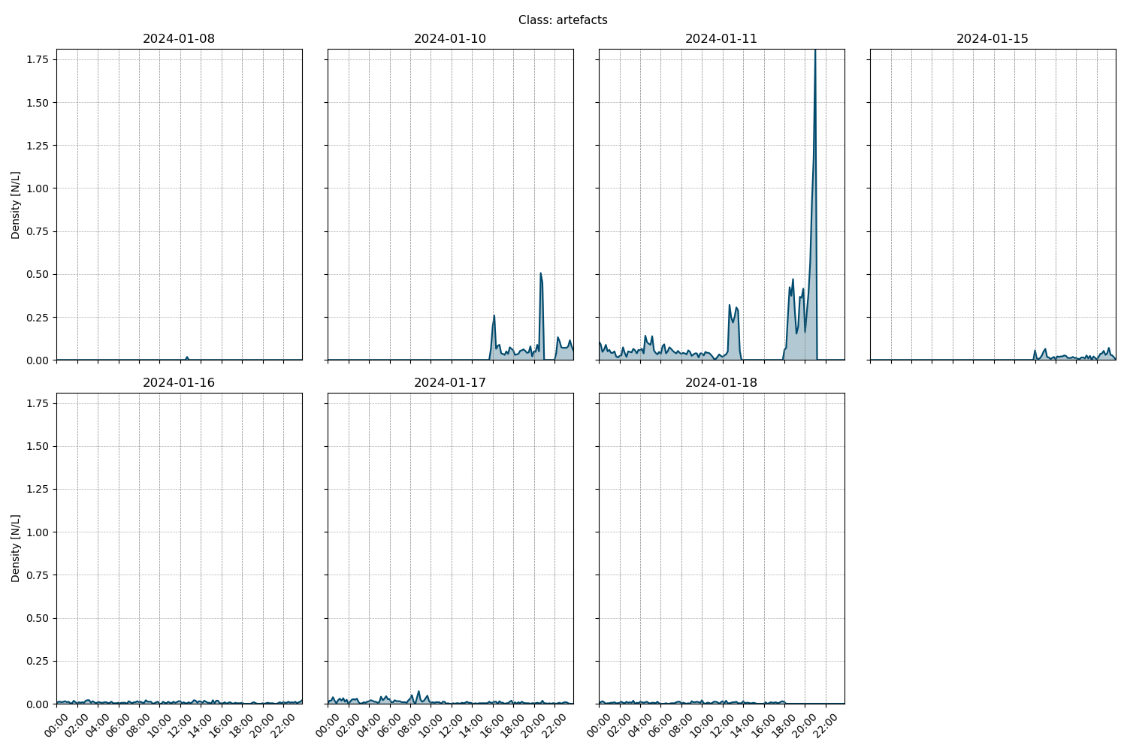

Figure showcasing the daily density estimates for artefacts per 10 minutes.

## Spatio-temporal density

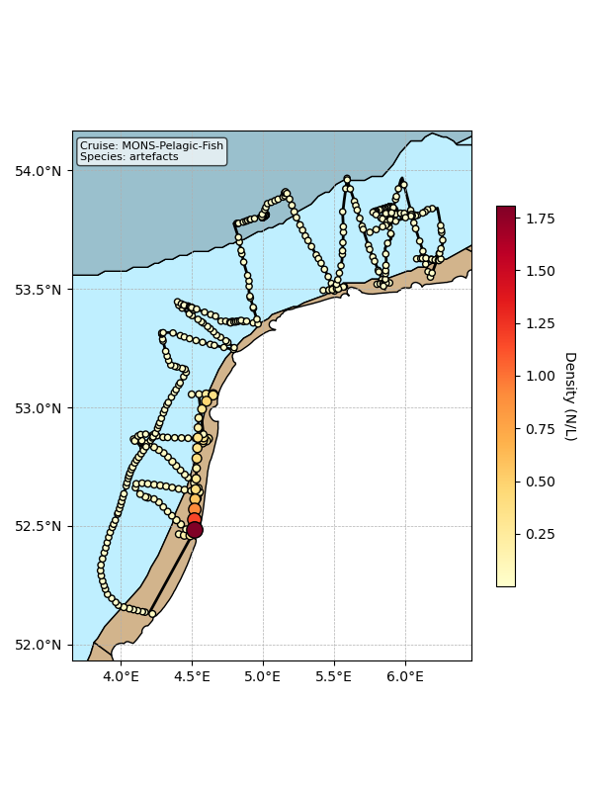

Map showing mean density estimates for artefacts along the cruise transect. OSPAR eutrophication areas are plotted in the background with different colours.

## Classification examples

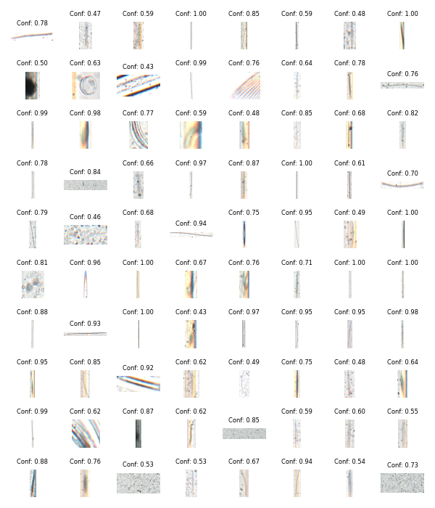

Figure showing several images classified as artefacts with model confidence.

# Class: Crustacea_Euphausidae

## Statistics

|  |  |
| --- | --- |
| Metric | Value |
| Class ID | 22 |
| Class | Crustacea Euphausidae |
| Number of predictions | 6,342 |
| Percentage of total images | 0.04 % |
| Min confidence | 0.12 % |
| Max confidence | 1.00 % |
| Average confidence | 0.53 % |
| Min density | 0.00 n/L |
| Max density | 0.23 n/L |
| Average density | 0.03 n/L |

## Model confidence

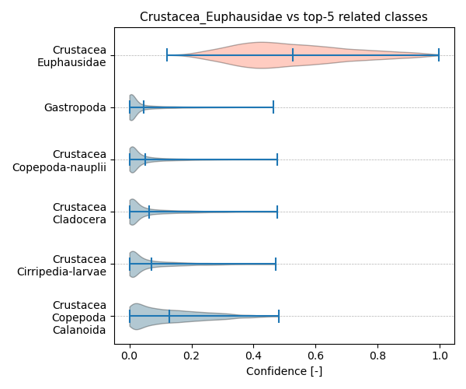

Figure showcasing the confidence distribution of the top-5 most related classes, which are determined by computing the mean confidence value of all non-target classes and selecting the five with the highest means, compared to Crustacea_Euphausidae.

## Temporal density

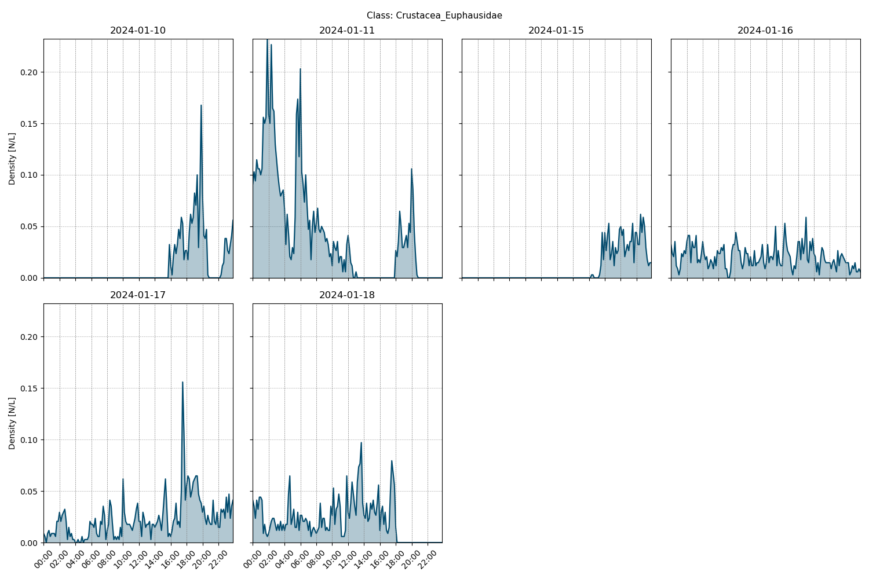

Figure showcasing the daily density estimates for Crustacea_Euphausidae per 10 minutes.

## Spatio-temporal density

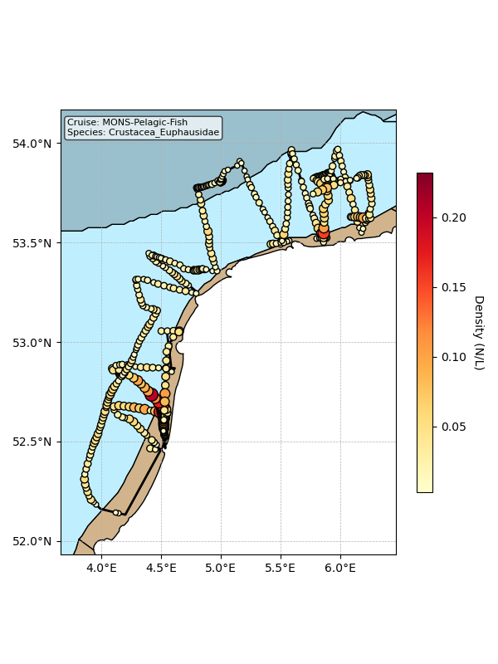

Map showing mean density estimates for Crustacea_Euphausidae along the cruise transect. OSPAR eutrophication areas are plotted in the background with different colours.

## Classification examples

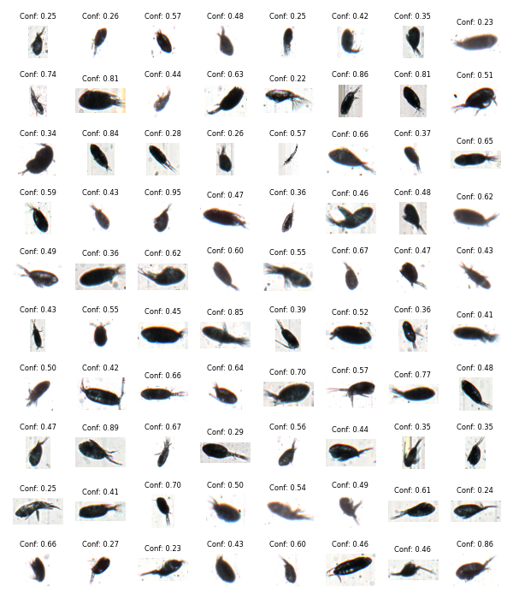

Figure showing several images classified as Crustacea_Euphausidae with model confidence.

# Class: Ciliophora

## Statistics

|  |  |
| --- | --- |
| Metric | Value |
| Class ID | 6 |
| Class | Ciliophora |
| Number of predictions | 4,276 |
| Percentage of total images | 0.03 % |
| Min confidence | 0.12 % |
| Max confidence | 1.00 % |
| Average confidence | 0.61 % |
| Min density | 0.00 n/L |
| Max density | 0.09 n/L |
| Average density | 0.02 n/L |

## Model confidence

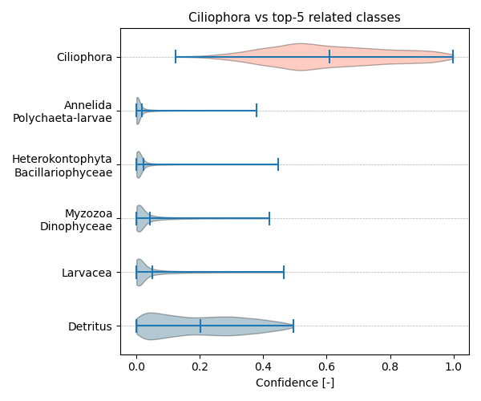

Figure showcasing the confidence distribution of the top-5 most related classes, which are determined by computing the mean confidence value of all non-target classes and selecting the five with the highest means, compared to Ciliophora.

## Temporal density

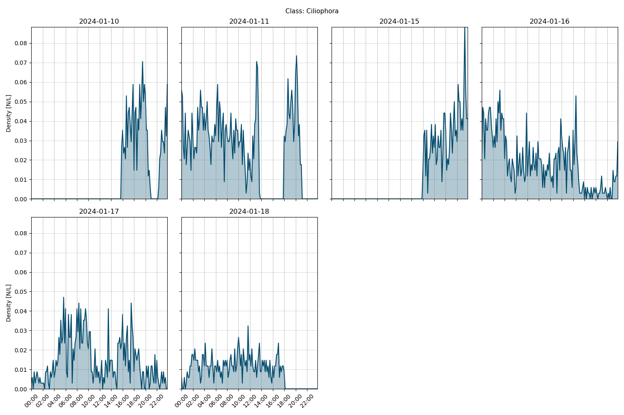

Figure showcasing the daily density estimates for Ciliophora per 10 minutes.

## Spatio-temporal density

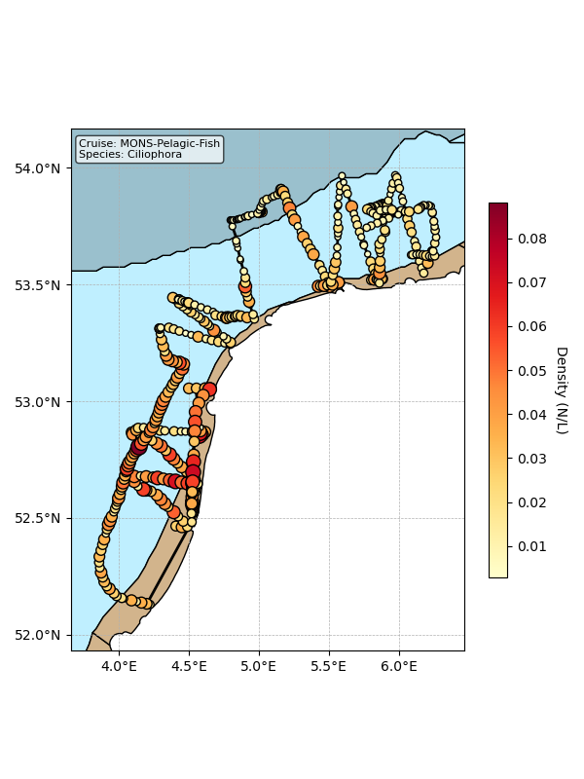

Map showing mean density estimates for Ciliophora along the cruise transect. OSPAR eutrophication areas are plotted in the background with different colours.

## Classification examples

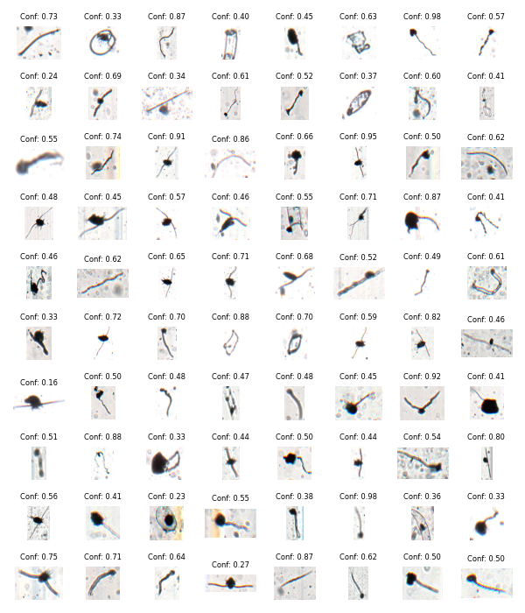

Figure showing several images classified as Ciliophora with model confidence.

# Class: Chaetognatha

## Statistics

|  |  |
| --- | --- |
| Metric | Value |
| Class ID | 5 |
| Class | Chaetognatha |
| Number of predictions | 3,269 |
| Percentage of total images | 0.02 % |
| Min confidence | 0.15 % |
| Max confidence | 1.00 % |
| Average confidence | 0.88 % |
| Min density | 0.00 n/L |
| Max density | 0.14 n/L |
| Average density | 0.02 n/L |

## Model confidence

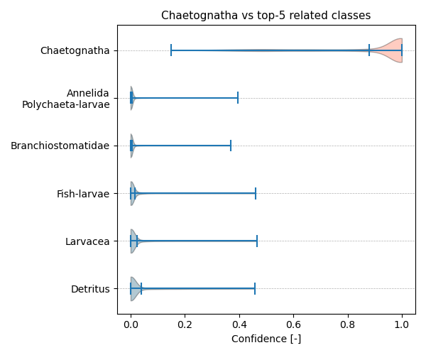

Figure showcasing the confidence distribution of the top-5 most related classes, which are determined by computing the mean confidence value of all non-target classes and selecting the five with the highest means, compared to Chaetognatha.

## Temporal density

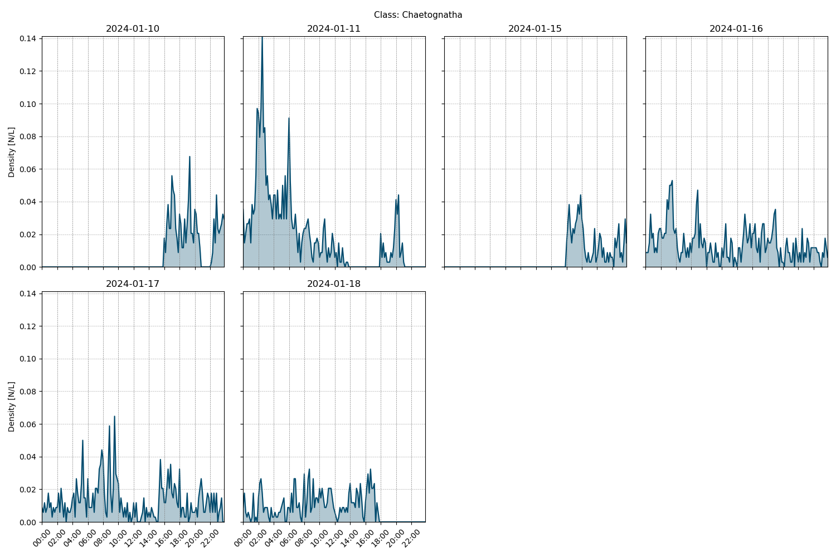

Figure showcasing the daily density estimates for Chaetognatha per 10 minutes.

## Spatio-temporal density

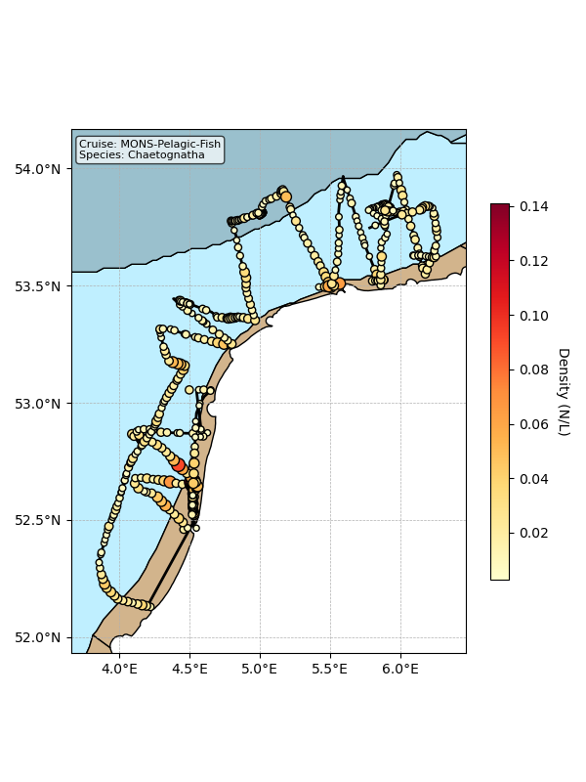

Map showing mean density estimates for Chaetognatha along the cruise transect. OSPAR eutrophication areas are plotted in the background with different colours.

## Classification examples

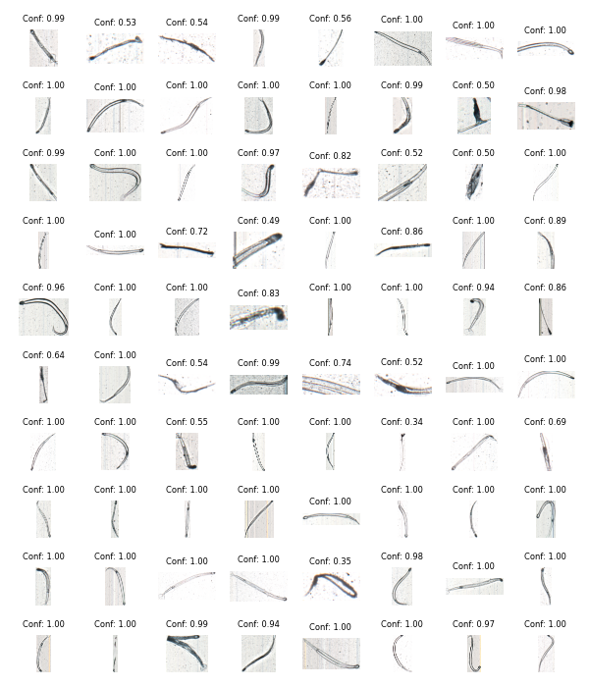

Figure showing several images classified as Chaetognatha with model confidence.

# Class: Fish-eggs

## Statistics

|  |  |
| --- | --- |
| Metric | Value |
| Class ID | 30 |
| Class | Fish eggs |
| Number of predictions | 3,114 |
| Percentage of total images | 0.02 % |
| Min confidence | 0.10 % |
| Max confidence | 1.00 % |
| Average confidence | 0.68 % |
| Min density | 0.00 n/L |
| Max density | 0.28 n/L |
| Average density | 0.02 n/L |

## Model confidence

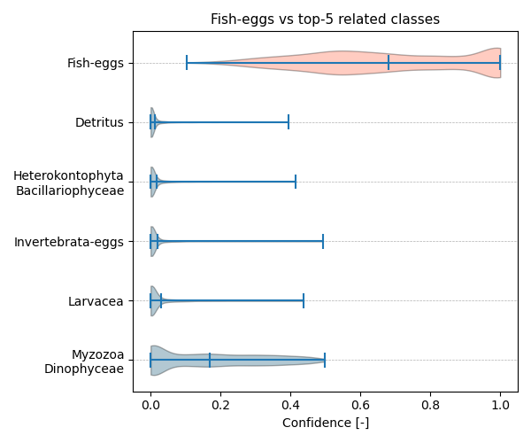

Figure showcasing the confidence distribution of the top-5 most related classes, which are determined by computing the mean confidence value of all non-target classes and selecting the five with the highest means, compared to Fish-eggs.

## Temporal density

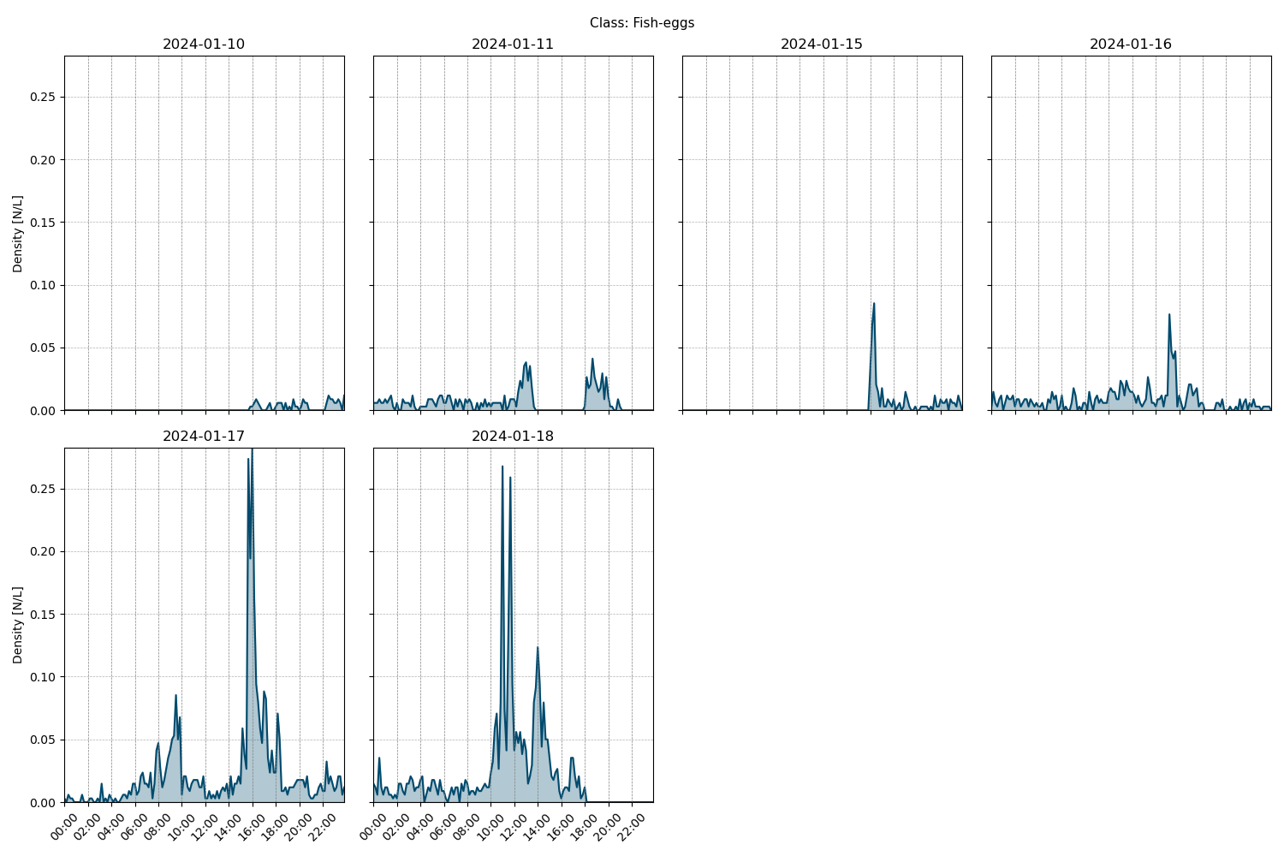

Figure showcasing the daily density estimates for Fish-eggs per 10 minutes.

## Spatio-temporal density

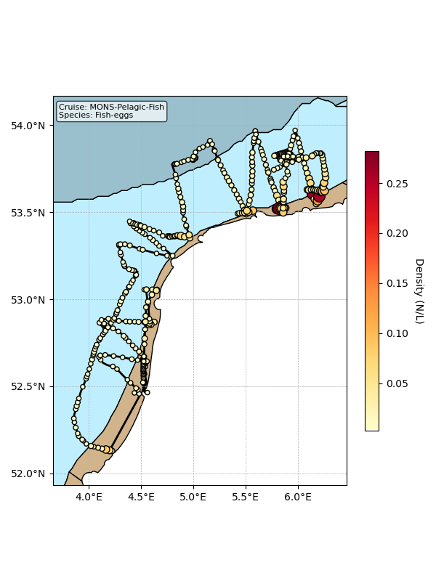

Map showing mean density estimates for Fish-eggs along the cruise transect. OSPAR eutrophication areas are plotted in the background with different colours.

## Classification examples

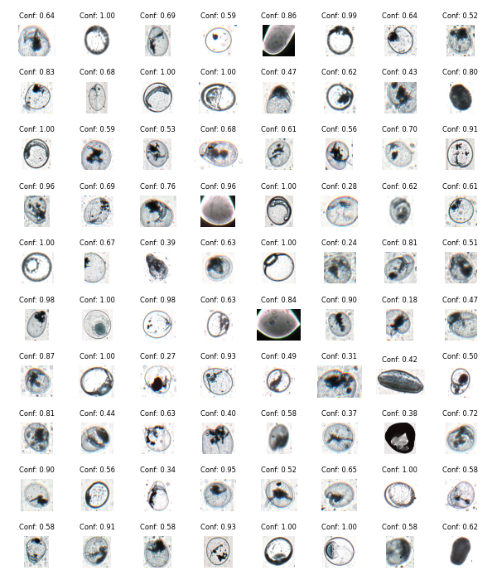

Figure showing several images classified as Fish-eggs with model confidence.

# Class: Crustacea-exuvia

## Statistics

|  |  |
| --- | --- |
| Metric | Value |
| Class ID | 11 |
| Class | Crustacea exuvia |
| Number of predictions | 3,095 |
| Percentage of total images | 0.02 % |
| Min confidence | 0.15 % |
| Max confidence | 1.00 % |
| Average confidence | 0.73 % |
| Min density | 0.00 n/L |
| Max density | 0.12 n/L |
| Average density | 0.02 n/L |

## Model confidence

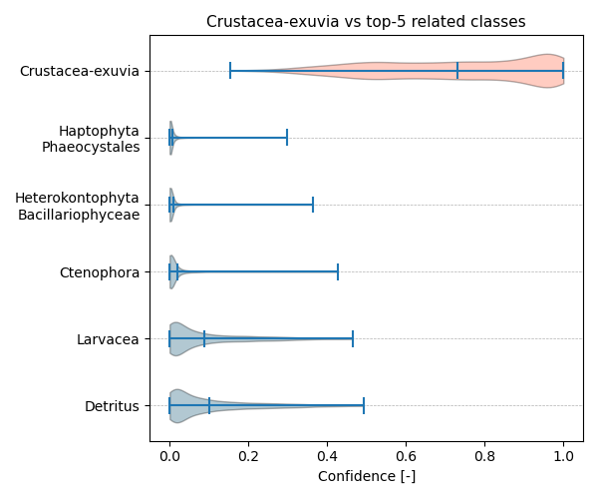

Figure showcasing the confidence distribution of the top-5 most related classes, which are determined by computing the mean confidence value of all non-target classes and selecting the five with the highest means, compared to Crustacea-exuvia.

## Temporal density

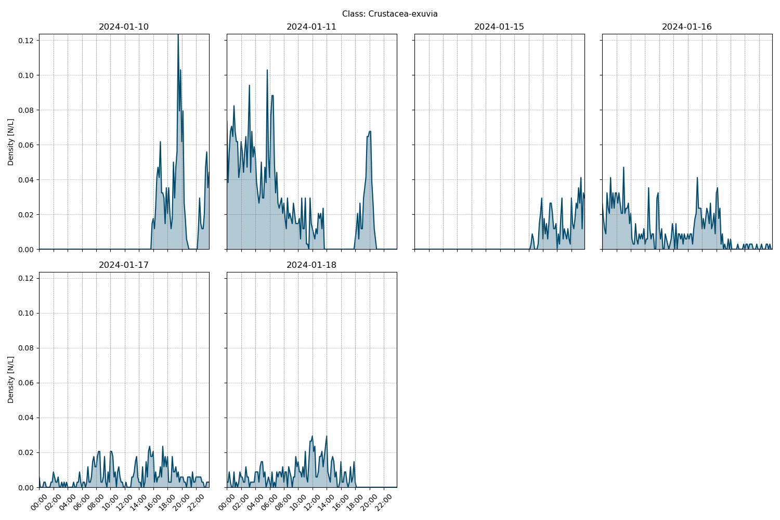

Figure showcasing the daily density estimates for Crustacea-exuvia per 10 minutes.

## Spatio-temporal density

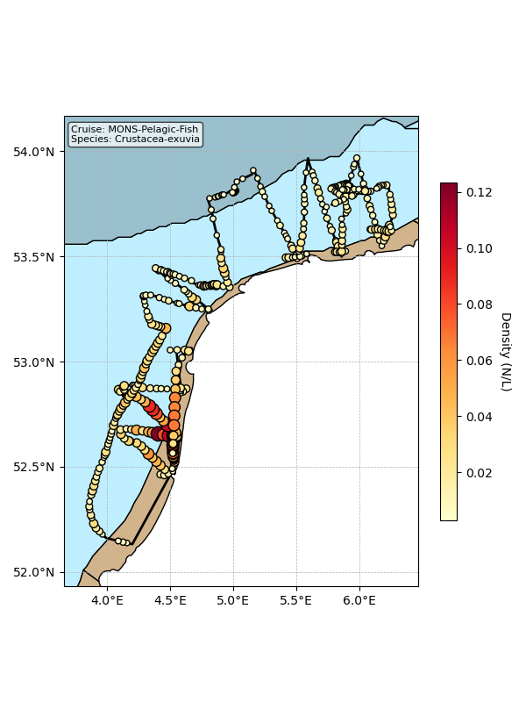

Map showing mean density estimates for Crustacea-exuvia along the cruise transect. OSPAR eutrophication areas are plotted in the background with different colours.

## Classification examples

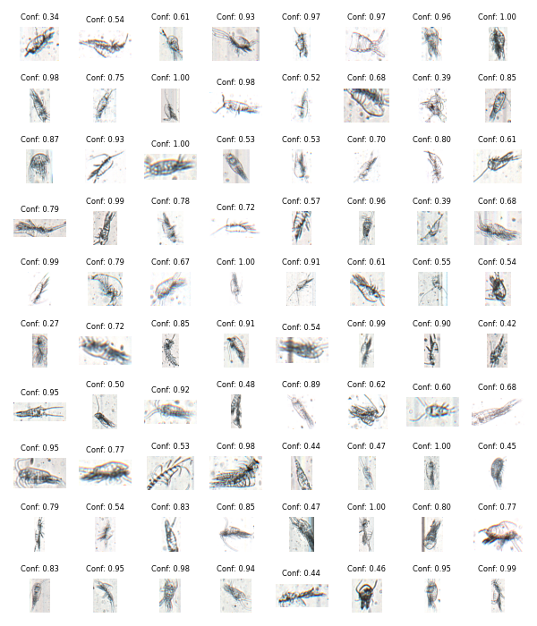

Figure showing several images classified as Crustacea-exuvia with model confidence.

# Class: Hemichordata_Enteropneusta-larvae

## Statistics

|  |  |
| --- | --- |
| Metric | Value |
| Class ID | 34 |
| Class | Hemichordata Enteropneusta larvae |
| Number of predictions | 3,085 |
| Percentage of total images | 0.02 % |
| Min confidence | 0.11 % |
| Max confidence | 1.00 % |
| Average confidence | 0.59 % |
| Min density | 0.00 n/L |
| Max density | 0.15 n/L |
| Average density | 0.02 n/L |

## Model confidence

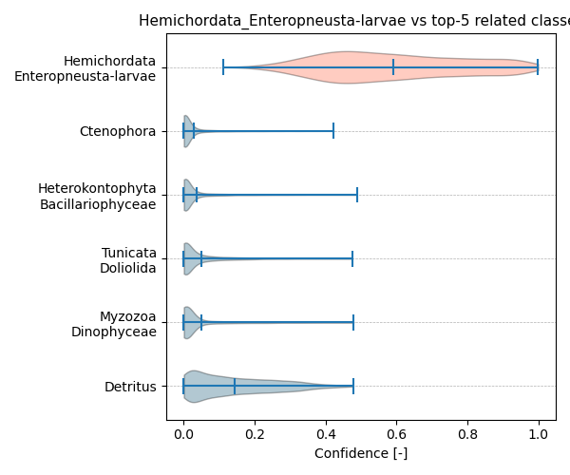

Figure showcasing the confidence distribution of the top-5 most related classes, which are determined by computing the mean confidence value of all non-target classes and selecting the five with the highest means, compared to Hemichordata_Enteropneusta-larvae.

## Temporal density

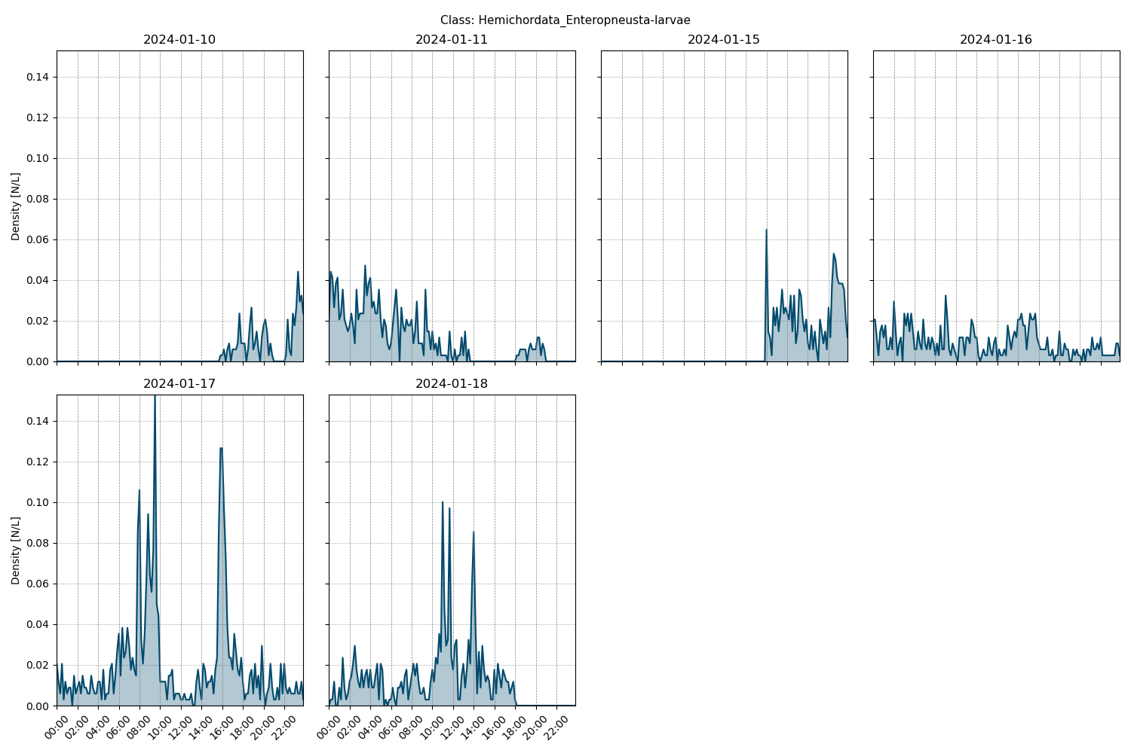

Figure showcasing the daily density estimates for Hemichordata_Enteropneusta-larvae per 10 minutes.

## Spatio-temporal density

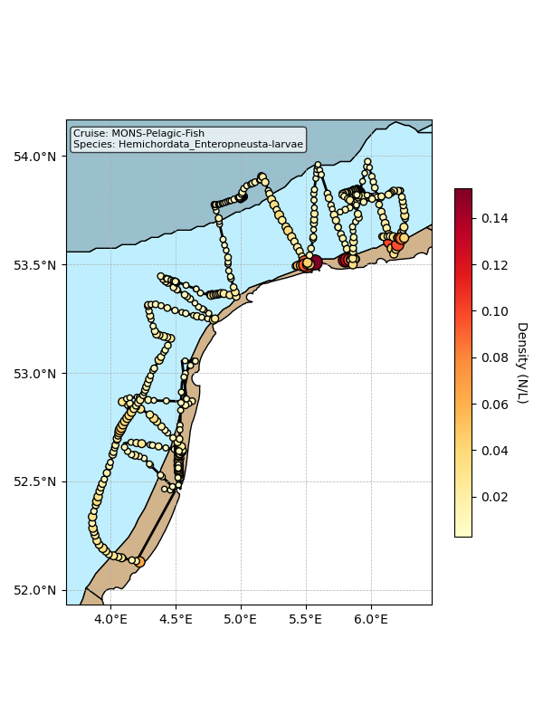

Map showing mean density estimates for Hemichordata_Enteropneusta-larvae along the cruise transect. OSPAR eutrophication areas are plotted in the background with different colours.

## Classification examples

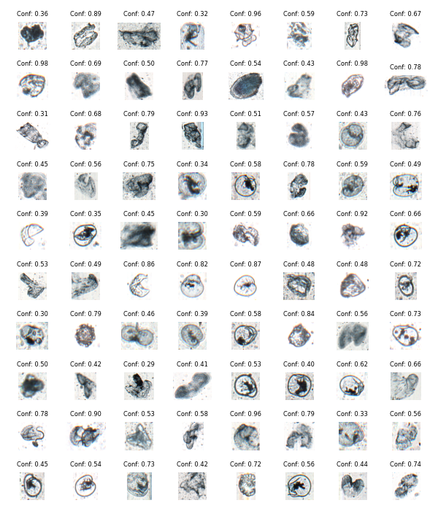

Figure showing several images classified as Hemichordata_Enteropneusta-larvae with model confidence.

# Class: Invertebrata-eggs

## Statistics

|  |  |
| --- | --- |
| Metric | Value |
| Class ID | 36 |
| Class | Invertebrata eggs |
| Number of predictions | 2,803 |
| Percentage of total images | 0.02 % |
| Min confidence | 0.18 % |
| Max confidence | 1.00 % |
| Average confidence | 0.54 % |
| Min density | 0.00 n/L |
| Max density | 0.48 n/L |
| Average density | 0.02 n/L |

## Model confidence

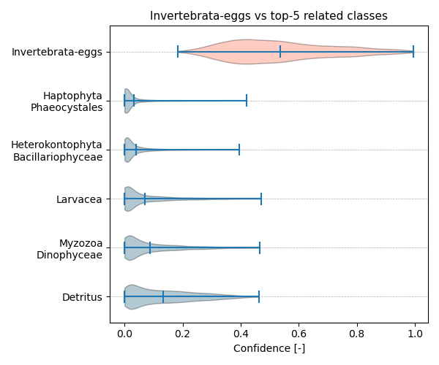

Figure showcasing the confidence distribution of the top-5 most related classes, which are determined by computing the mean confidence value of all non-target classes and selecting the five with the highest means, compared to Invertebrata-eggs.

## Temporal density

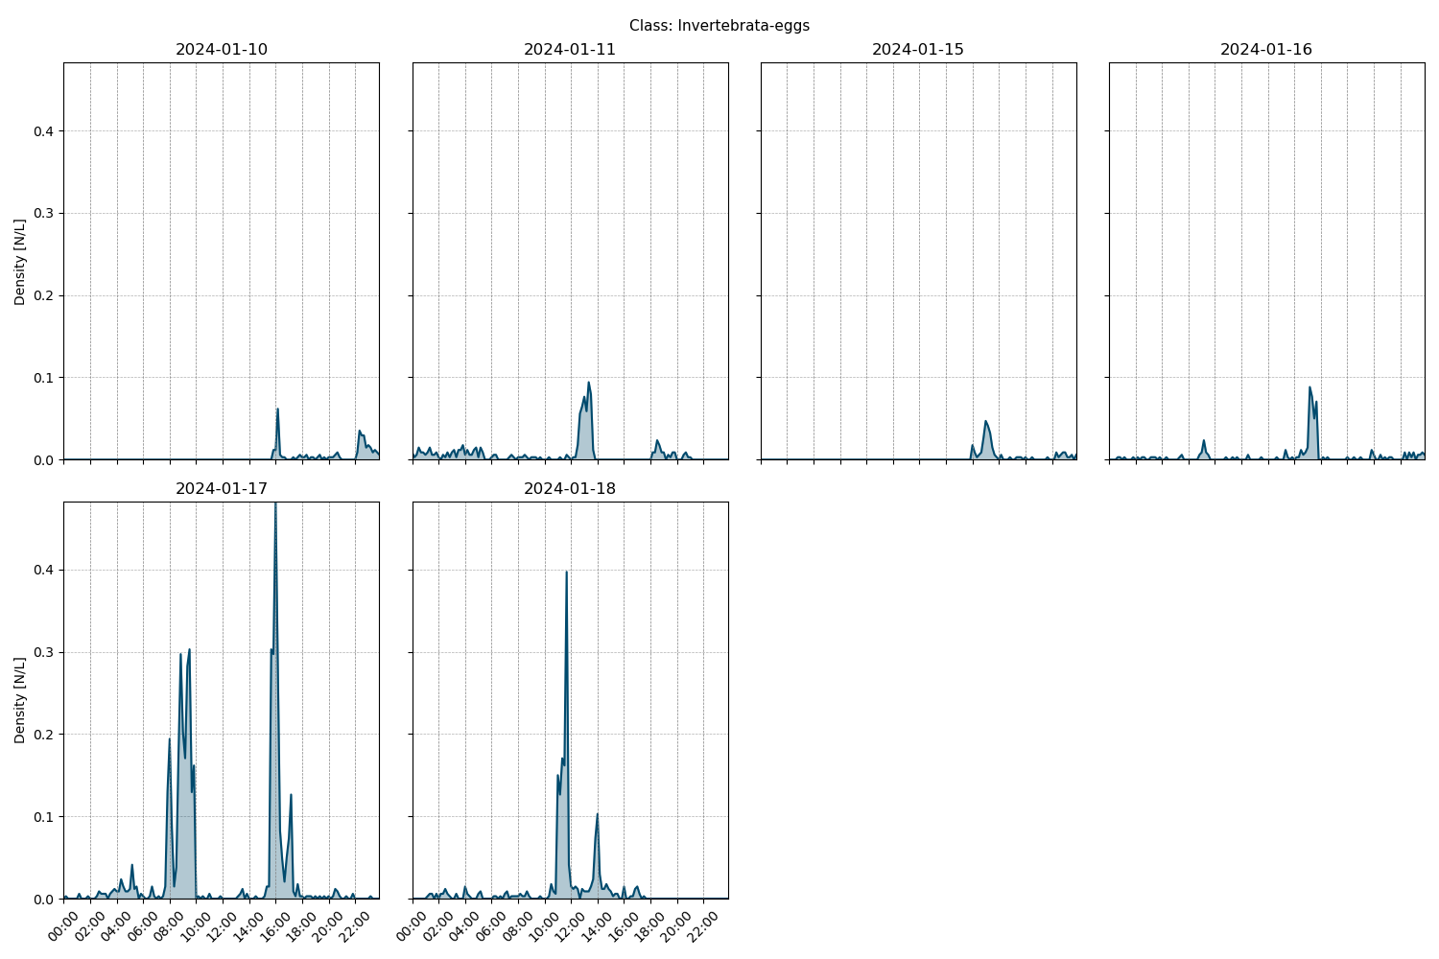

Figure showcasing the daily density estimates for Invertebrata-eggs per 10 minutes.

## Spatio-temporal density

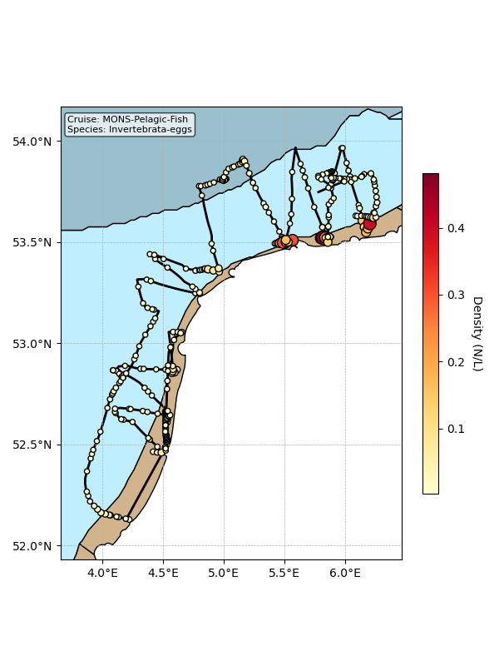

Map showing mean density estimates for Invertebrata-eggs along the cruise transect. OSPAR eutrophication areas are plotted in the background with different colours.

## Classification examples

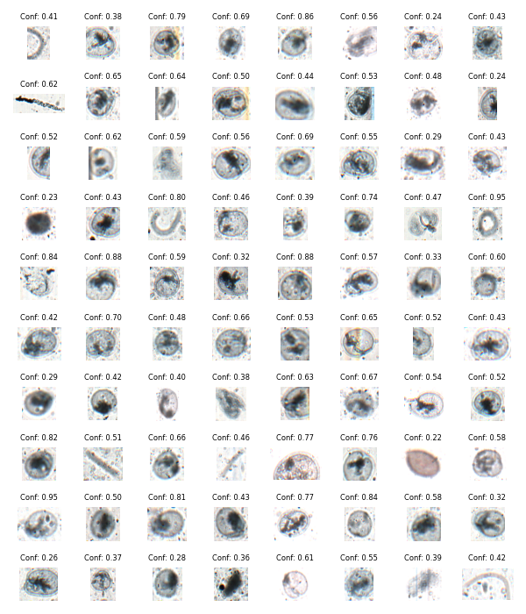

Figure showing several images classified as Invertebrata-eggs with model confidence.

# Class: Ctenophora

## Statistics

|  |  |
| --- | --- |
| Metric | Value |
| Class ID | 24 |
| Class | Ctenophora |
| Number of predictions | 2,681 |
| Percentage of total images | 0.02 % |
| Min confidence | 0.10 % |
| Max confidence | 1.00 % |
| Average confidence | 0.55 % |
| Min density | 0.00 n/L |
| Max density | 0.09 n/L |
| Average density | 0.01 n/L |

## Model confidence

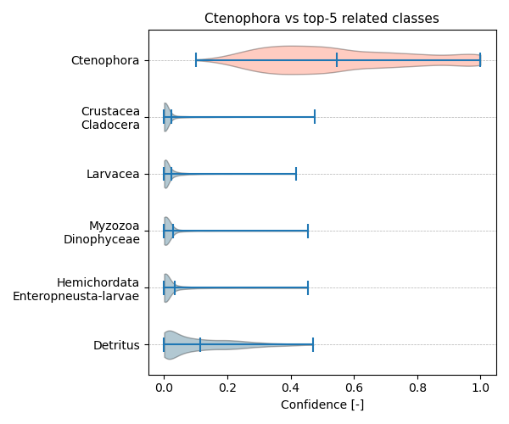

Figure showcasing the confidence distribution of the top-5 most related classes, which are determined by computing the mean confidence value of all non-target classes and selecting the five with the highest means, compared to Ctenophora.

## Temporal density

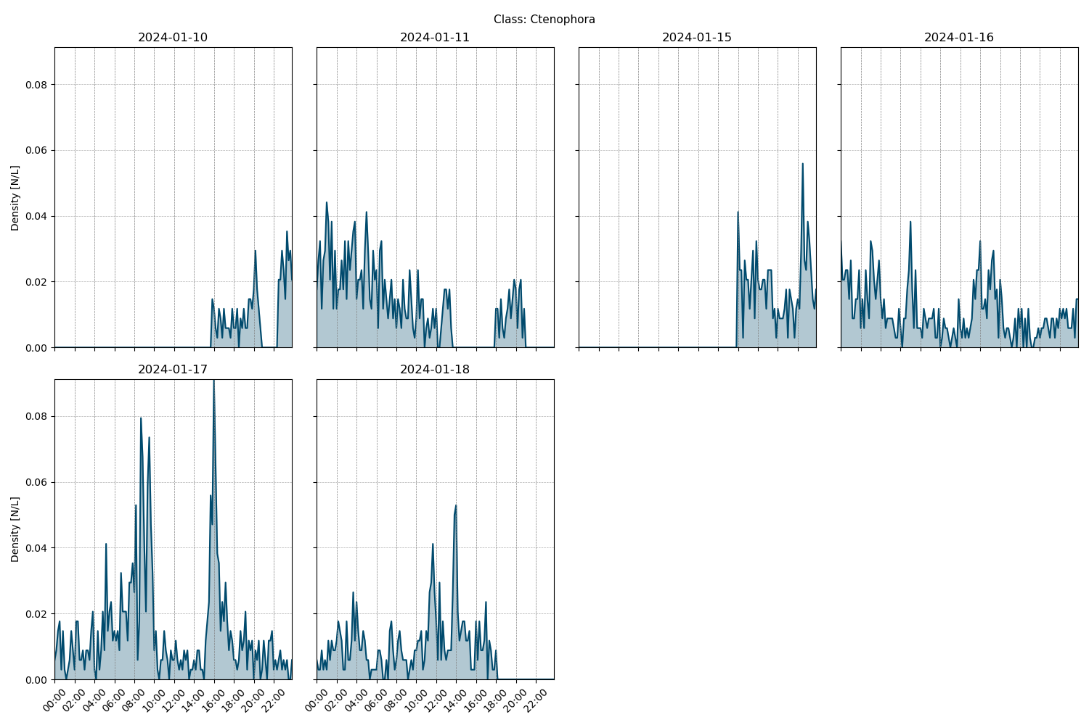

Figure showcasing the daily density estimates for Ctenophora per 10 minutes.

## Spatio-temporal density

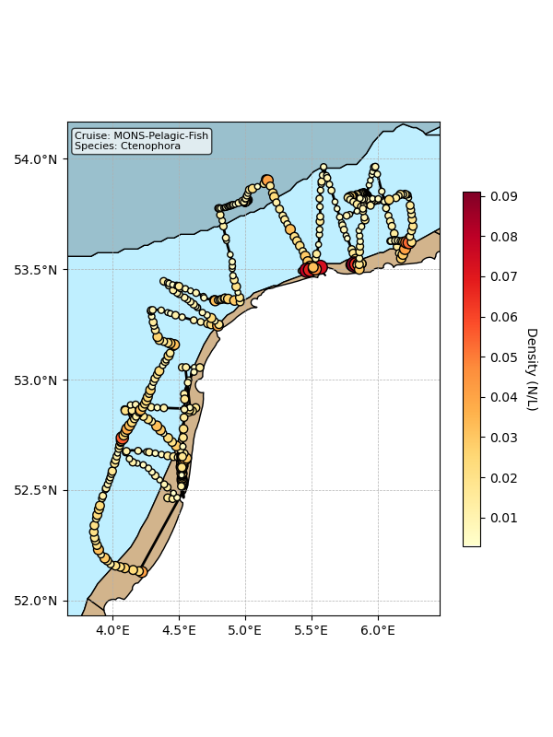

Map showing mean density estimates for Ctenophora along the cruise transect. OSPAR eutrophication areas are plotted in the background with different colours.

## Classification examples

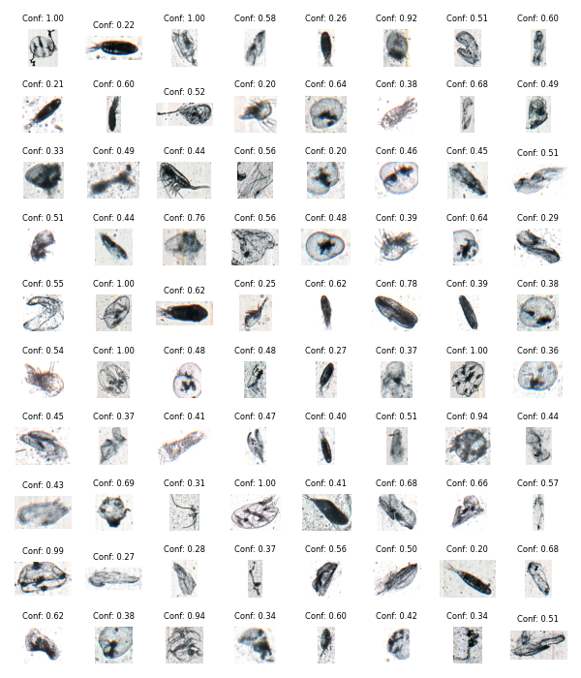

Figure showing several images classified as Ctenophora with model confidence.

# Class: Crustacea_Decapoda-larvae

## Statistics

|  |  |
| --- | --- |
| Metric | Value |
| Class ID | 21 |
| Class | Crustacea Decapoda larvae |
| Number of predictions | 2,250 |
| Percentage of total images | 0.01 % |
| Min confidence | 0.13 % |
| Max confidence | 1.00 % |
| Average confidence | 0.59 % |
| Min density | 0.00 n/L |
| Max density | 0.06 n/L |
| Average density | 0.01 n/L |

## Model confidence

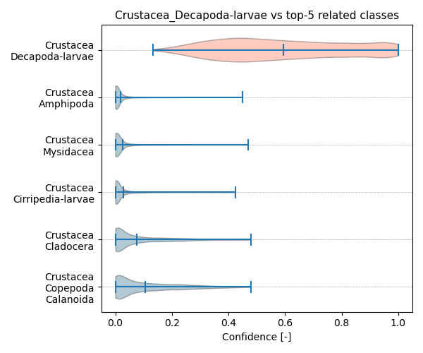

Figure showcasing the confidence distribution of the top-5 most related classes, which are determined by computing the mean confidence value of all non-target classes and selecting the five with the highest means, compared to Crustacea_Decapoda-larvae.

## Temporal density

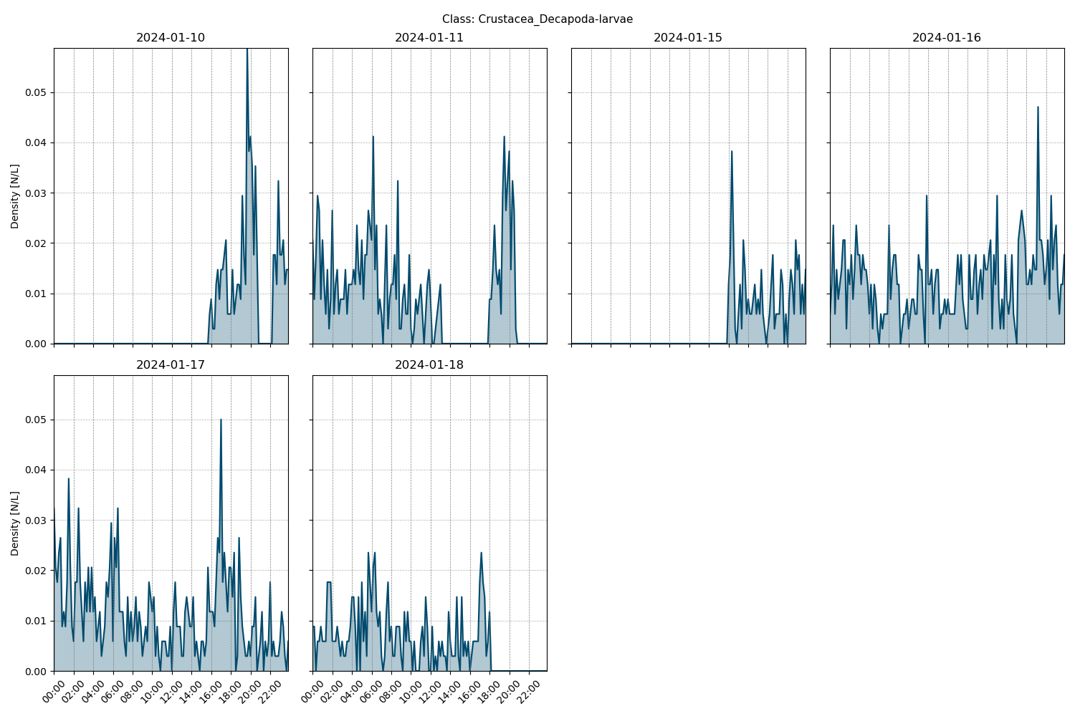

Figure showcasing the daily density estimates for Crustacea_Decapoda-larvae per 10 minutes.

## Spatio-temporal density

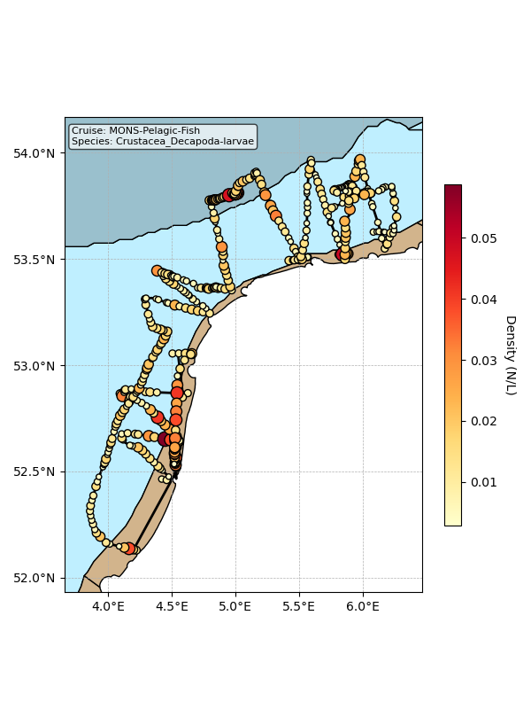

Map showing mean density estimates for Crustacea_Decapoda-larvae along the cruise transect. OSPAR eutrophication areas are plotted in the background with different colours.

## Classification examples

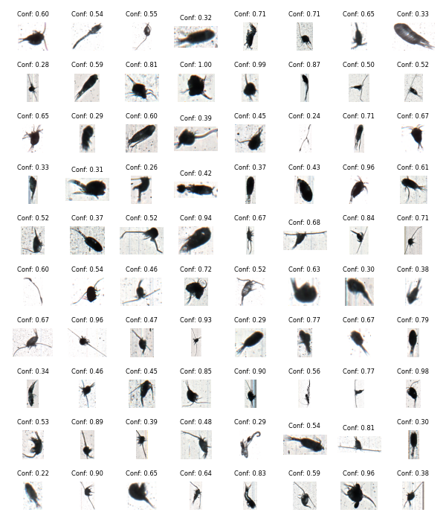

Figure showing several images classified as Crustacea_Decapoda-larvae with model confidence.

# Class: Echinodermata_Ophiuroidea-larvae

## Statistics

|  |  |
| --- | --- |
| Metric | Value |
| Class ID | 29 |
| Class | Echinodermata Ophiuroidea larvae |
| Number of predictions | 2,048 |
| Percentage of total images | 0.01 % |
| Min confidence | 0.11 % |
| Max confidence | 1.00 % |
| Average confidence | 0.57 % |
| Min density | 0.00 n/L |
| Max density | 0.06 n/L |
| Average density | 0.01 n/L |

## Model confidence

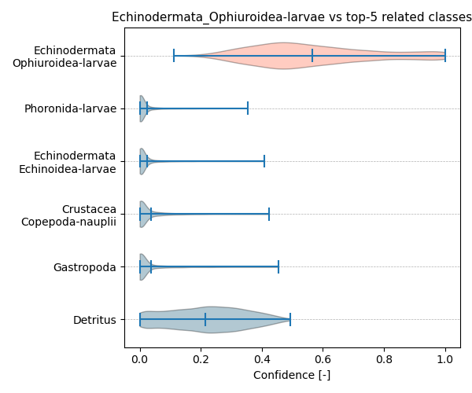

Figure showcasing the confidence distribution of the top-5 most related classes, which are determined by computing the mean confidence value of all non-target classes and selecting the five with the highest means, compared to Echinodermata_Ophiuroidea-larvae.

## Temporal density

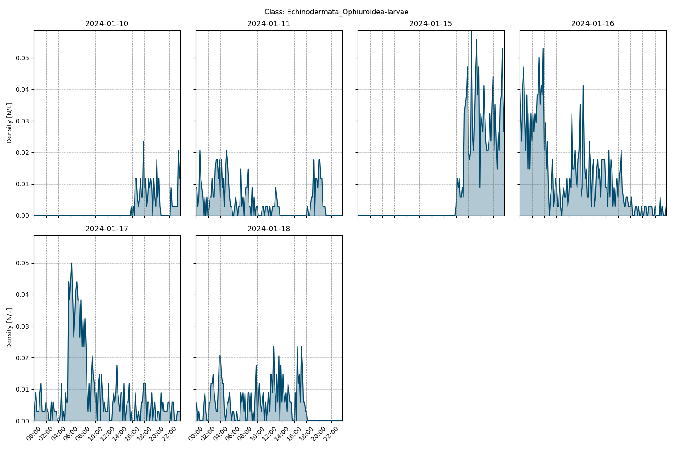

Figure showcasing the daily density estimates for Echinodermata_Ophiuroidea-larvae per 10 minutes.

## Spatio-temporal density

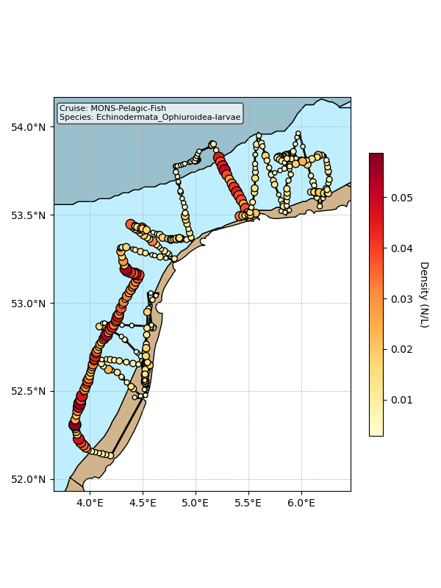

Map showing mean density estimates for Echinodermata_Ophiuroidea-larvae along the cruise transect. OSPAR eutrophication areas are plotted in the background with different colours.

## Classification examples

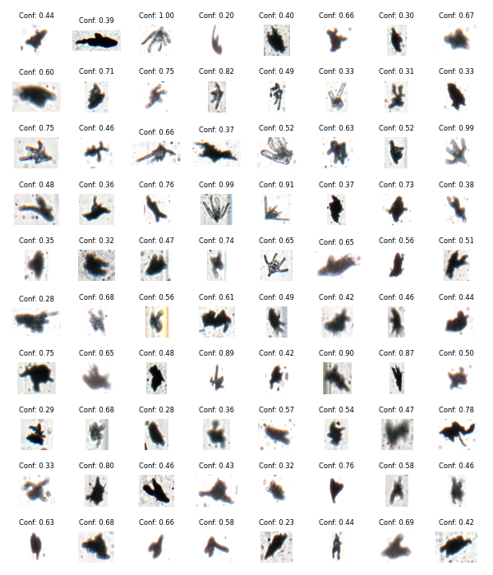

Figure showing several images classified as Echinodermata_Ophiuroidea-larvae with model confidence.

# Class: Echinodermata_Asteroida-larvae

## Statistics

|  |  |
| --- | --- |
| Metric | Value |
| Class ID | 27 |
| Class | Echinodermata Asteroida larvae |
| Number of predictions | 1,636 |
| Percentage of total images | 0.01 % |
| Min confidence | 0.12 % |
| Max confidence | 1.00 % |
| Average confidence | 0.61 % |
| Min density | 0.00 n/L |
| Max density | 0.06 n/L |
| Average density | 0.01 n/L |

## Model confidence

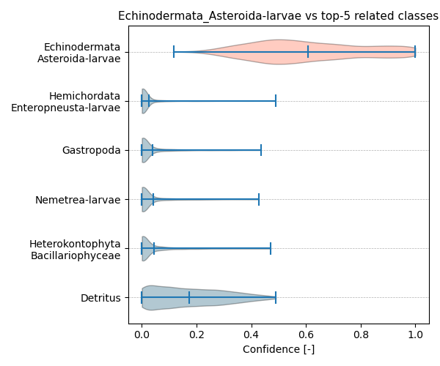

Figure showcasing the confidence distribution of the top-5 most related classes, which are determined by computing the mean confidence value of all non-target classes and selecting the five with the highest means, compared to Echinodermata_Asteroida-larvae.

## Temporal density

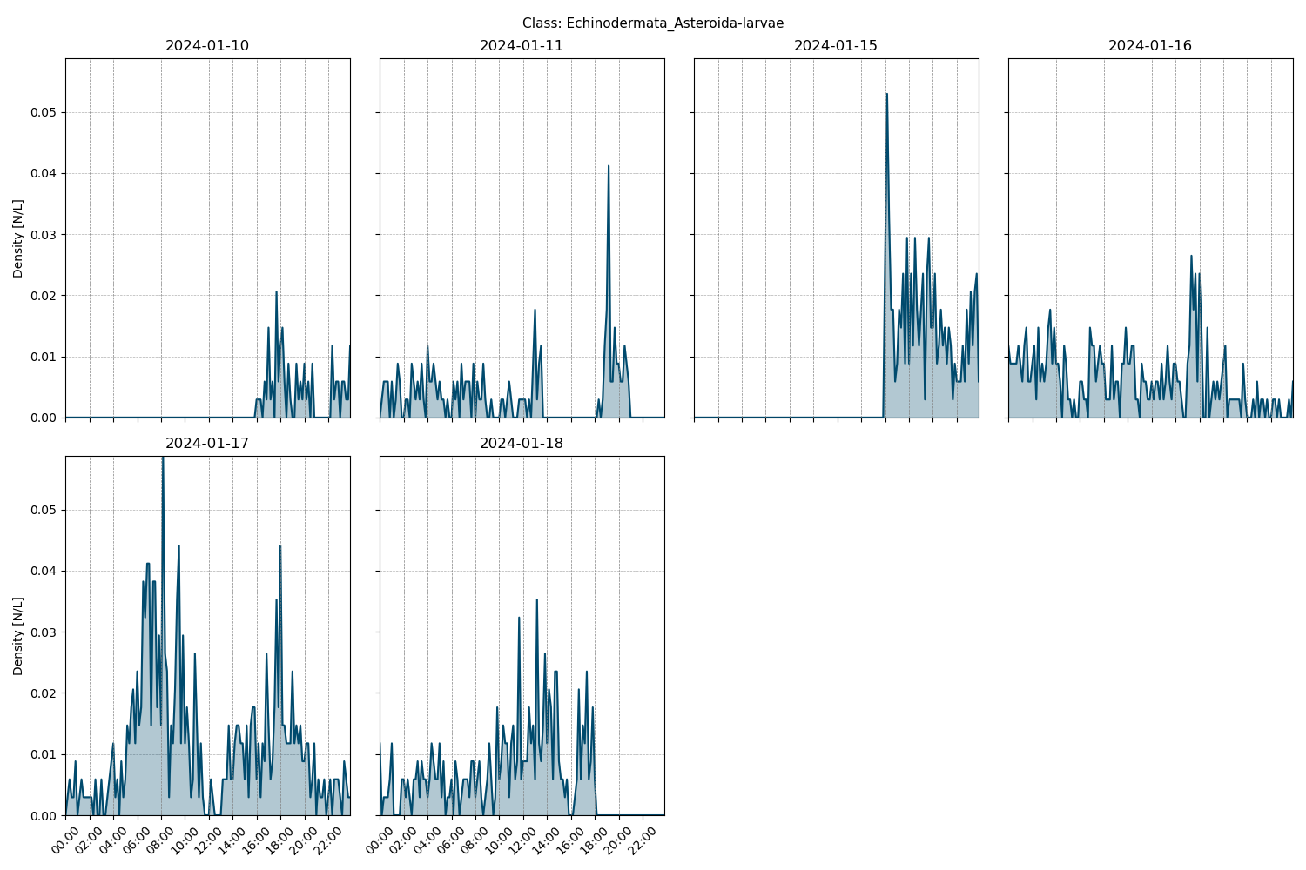

Figure showcasing the daily density estimates for Echinodermata_Asteroida-larvae per 10 minutes.

## Spatio-temporal density

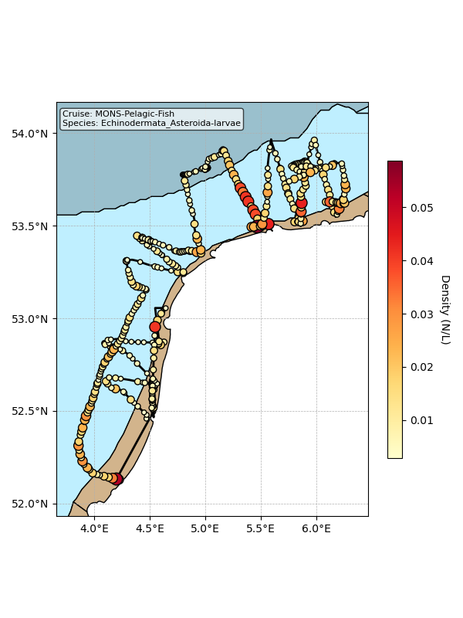

Map showing mean density estimates for Echinodermata_Asteroida-larvae along the cruise transect. OSPAR eutrophication areas are plotted in the background with different colours.

## Classification examples

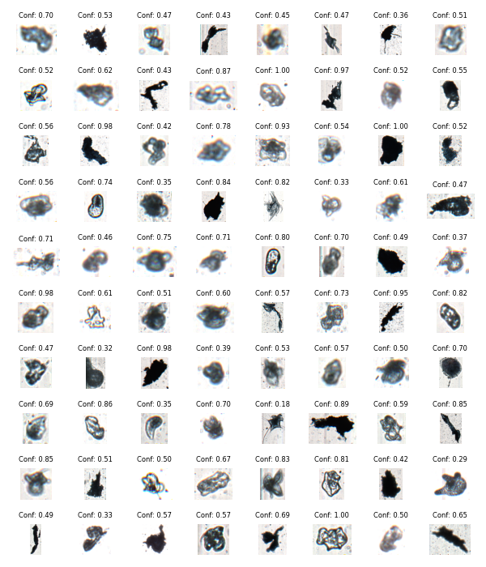

Figure showing several images classified as Echinodermata_Asteroida-larvae with model confidence.

# Class: Tunicata_Doliolida

## Statistics

|  |  |
| --- | --- |
| Metric | Value |
| Class ID | 46 |
| Class | Tunicata Doliolida |
| Number of predictions | 1,500 |
| Percentage of total images | 0.01 % |
| Min confidence | 0.15 % |
| Max confidence | 0.99 % |
| Average confidence | 0.50 % |
| Min density | 0.00 n/L |
| Max density | 0.10 n/L |
| Average density | 0.01 n/L |

## Model confidence

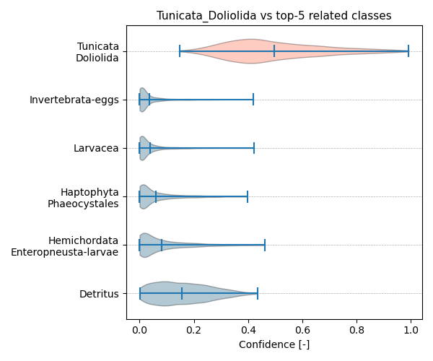

Figure showcasing the confidence distribution of the top-5 most related classes, which are determined by computing the mean confidence value of all non-target classes and selecting the five with the highest means, compared to Tunicata_Doliolida.

## Temporal density

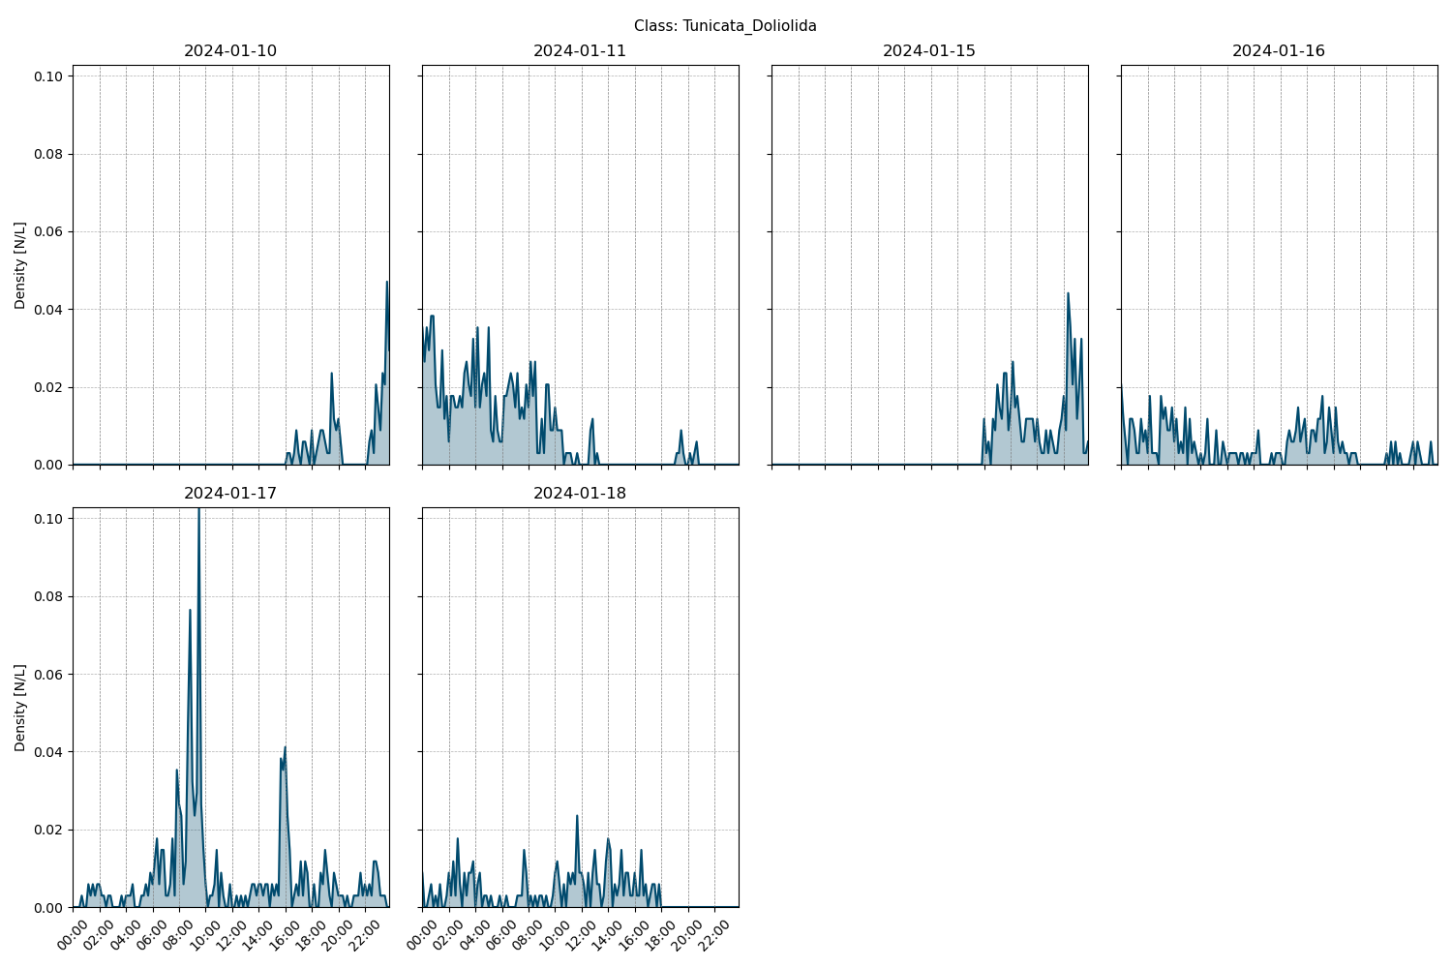

Figure showcasing the daily density estimates for Tunicata_Doliolida per 10 minutes.

## Spatio-temporal density

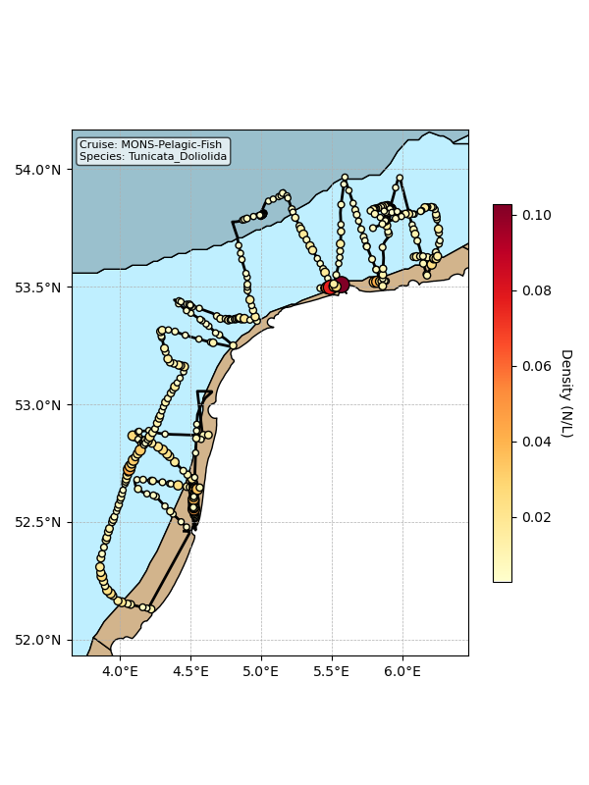

Map showing mean density estimates for Tunicata_Doliolida along the cruise transect. OSPAR eutrophication areas are plotted in the background with different colours.

## Classification examples

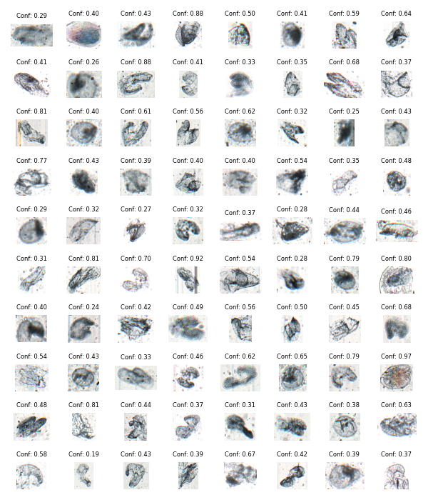

Figure showing several images classified as Tunicata_Doliolida with model confidence.

# Class: Nemetrea-larvae

## Statistics

|  |  |
| --- | --- |
| Metric | Value |
| Class ID | 42 |
| Class | Nemetrea larvae |
| Number of predictions | 1,401 |
| Percentage of total images | 0.01 % |
| Min confidence | 0.12 % |
| Max confidence | 1.00 % |
| Average confidence | 0.67 % |
| Min density | 0.00 n/L |
| Max density | 0.04 n/L |
| Average density | 0.01 n/L |

## Model confidence

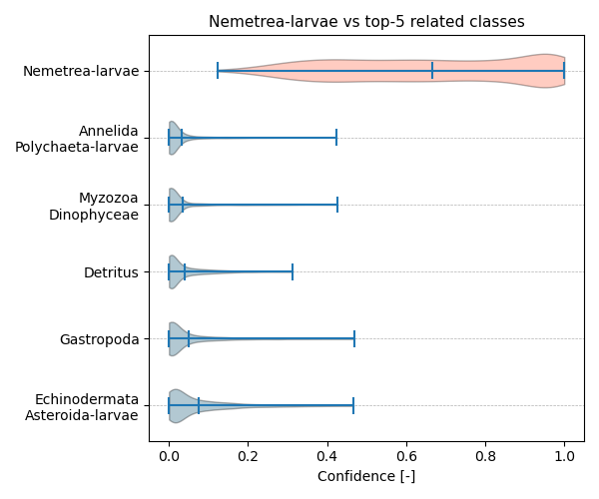

Figure showcasing the confidence distribution of the top-5 most related classes, which are determined by computing the mean confidence value of all non-target classes and selecting the five with the highest means, compared to Nemetrea-larvae.

## Temporal density

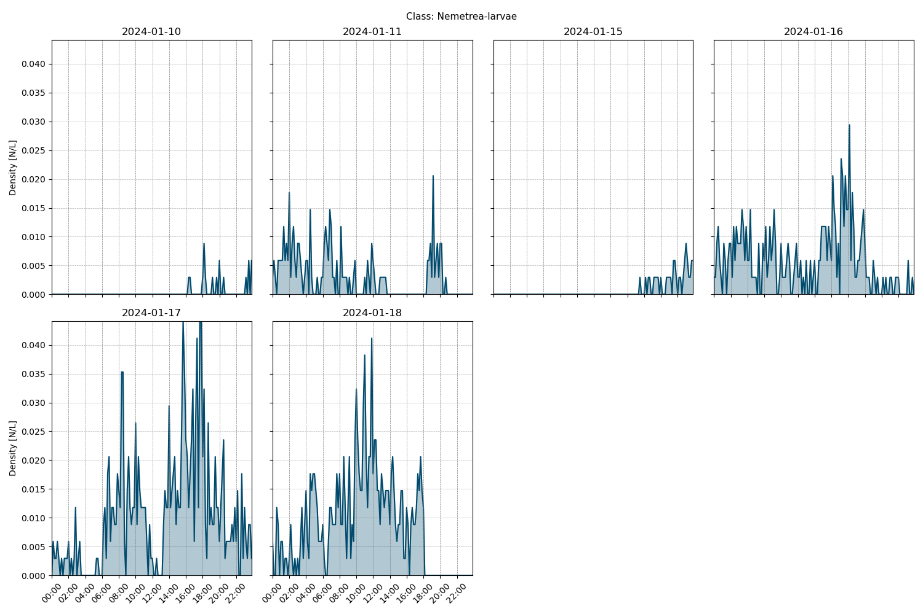

Figure showcasing the daily density estimates for Nemetrea-larvae per 10 minutes.

## Spatio-temporal density

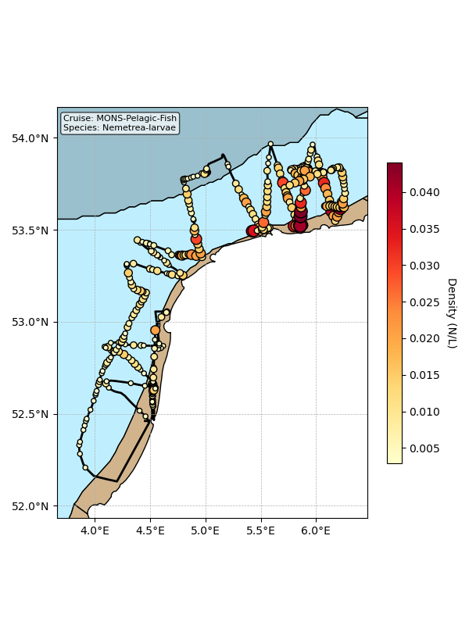

Map showing mean density estimates for Nemetrea-larvae along the cruise transect. OSPAR eutrophication areas are plotted in the background with different colours.

## Classification examples

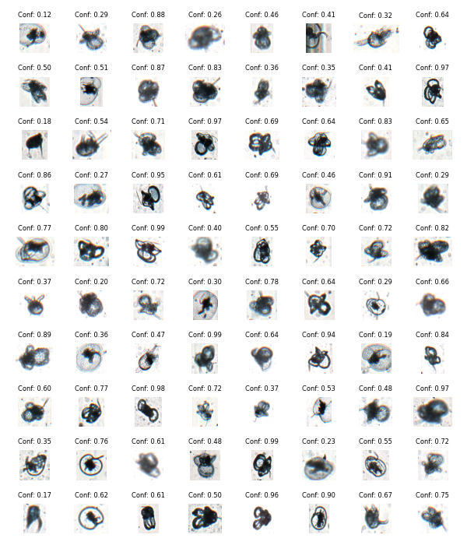

Figure showing several images classified as Nemetrea-larvae with model confidence.

# Class: Crustacea_Mysidacea

## Statistics

|  |  |
| --- | --- |
| Metric | Value |
| Class ID | 23 |
| Class | Crustacea Mysidacea |
| Number of predictions | 1,212 |
| Percentage of total images | 0.01 % |
| Min confidence | 0.13 % |
| Max confidence | 1.00 % |
| Average confidence | 0.76 % |
| Min density | 0.00 n/L |
| Max density | 0.20 n/L |
| Average density | 0.01 n/L |

## Model confidence

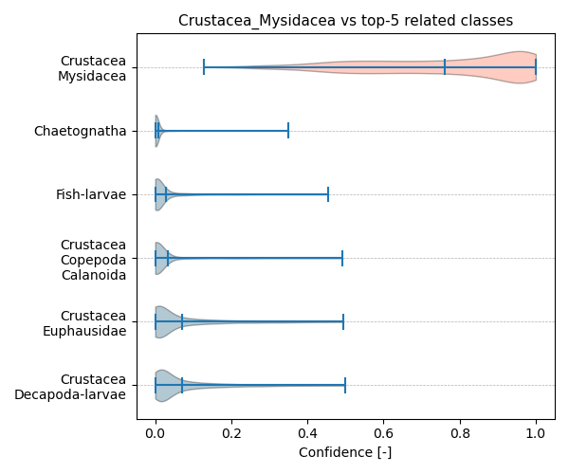

Figure showcasing the confidence distribution of the top-5 most related classes, which are determined by computing the mean confidence value of all non-target classes and selecting the five with the highest means, compared to Crustacea_Mysidacea.

## Temporal density

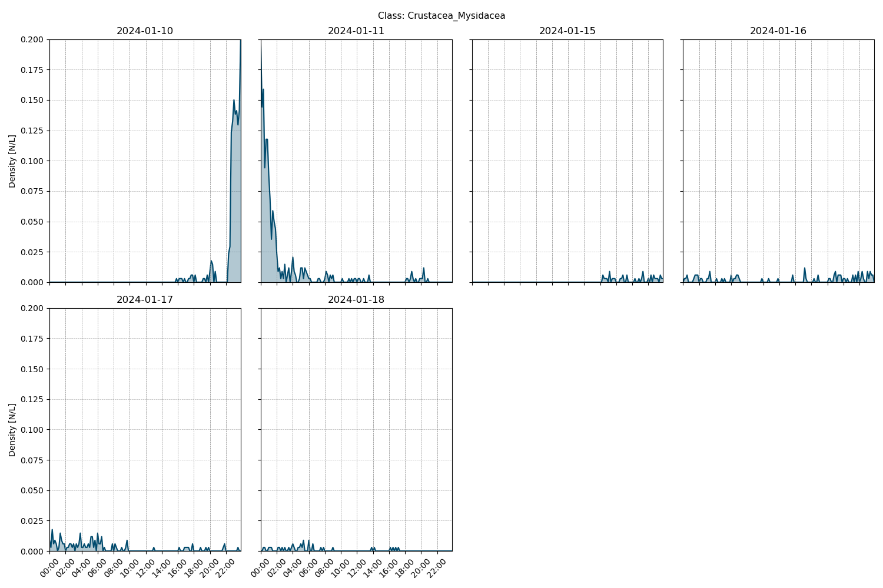

Figure showcasing the daily density estimates for Crustacea_Mysidacea per 10 minutes.

## Spatio-temporal density

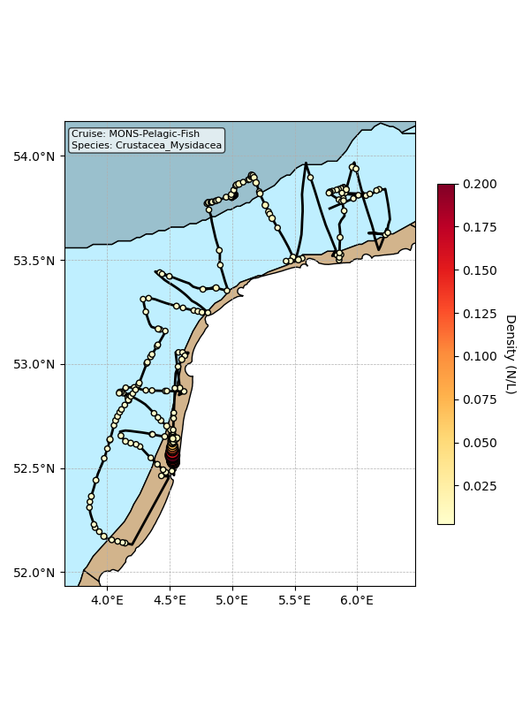

Map showing mean density estimates for Crustacea_Mysidacea along the cruise transect. OSPAR eutrophication areas are plotted in the background with different colours.

## Classification examples

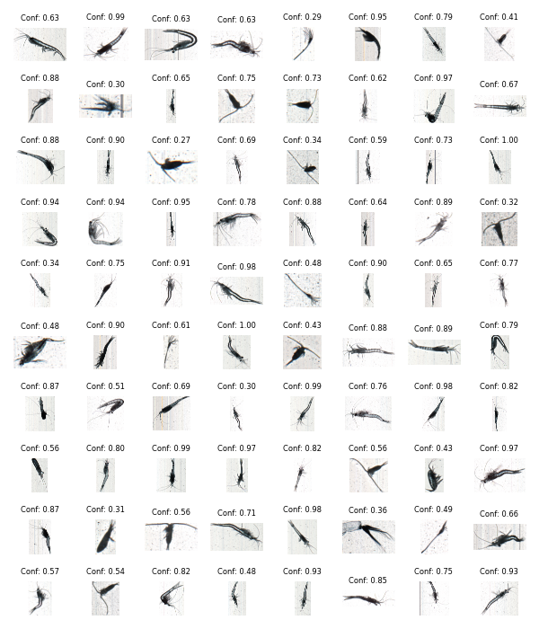

Figure showing several images classified as Crustacea_Mysidacea with model confidence.

# Class: Crustacea_Copepoda_Harpacticoida

## Statistics

|  |  |
| --- | --- |
| Metric | Value |
| Class ID | 18 |
| Class | Crustacea Copepoda Harpacticoida |
| Number of predictions | 1,095 |
| Percentage of total images | 0.01 % |
| Min confidence | 0.13 % |
| Max confidence | 0.85 % |
| Average confidence | 0.36 % |
| Min density | 0.00 n/L |
| Max density | 0.03 n/L |
| Average density | 0.01 n/L |

## Model confidence

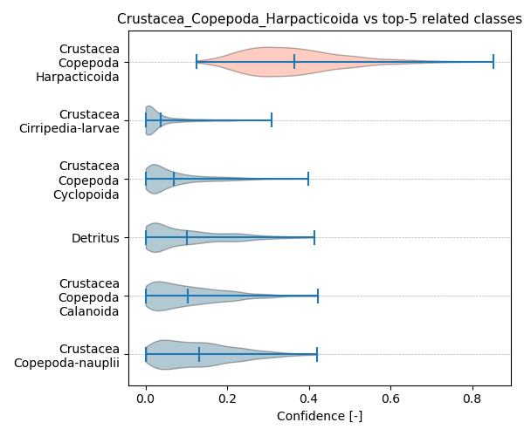

Figure showcasing the confidence distribution of the top-5 most related classes, which are determined by computing the mean confidence value of all non-target classes and selecting the five with the highest means, compared to Crustacea_Copepoda_Harpacticoida.

## Temporal density

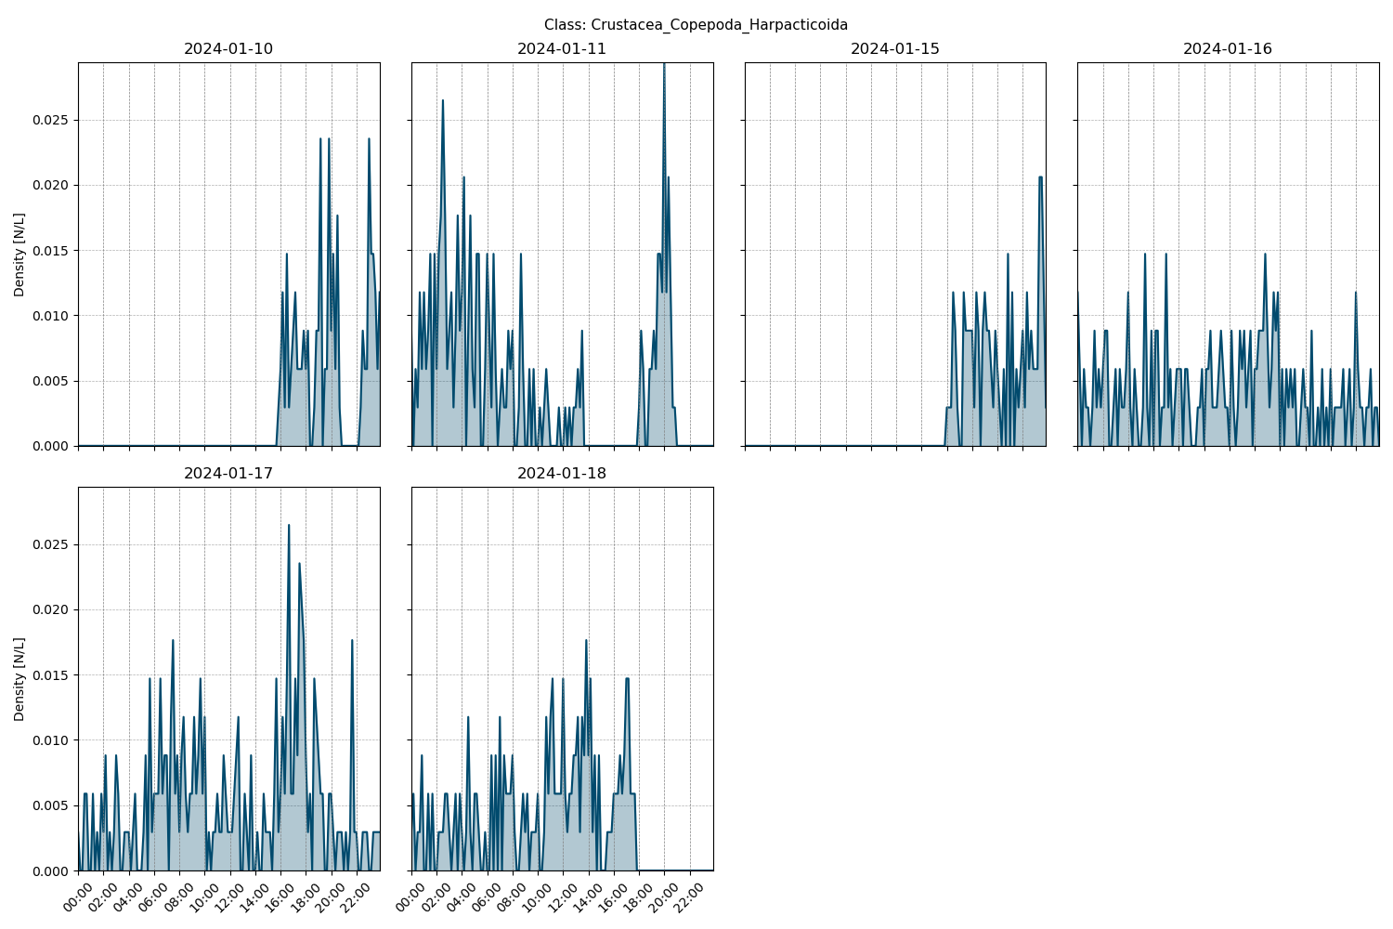

Figure showcasing the daily density estimates for Crustacea_Copepoda_Harpacticoida per 10 minutes.

## Spatio-temporal density

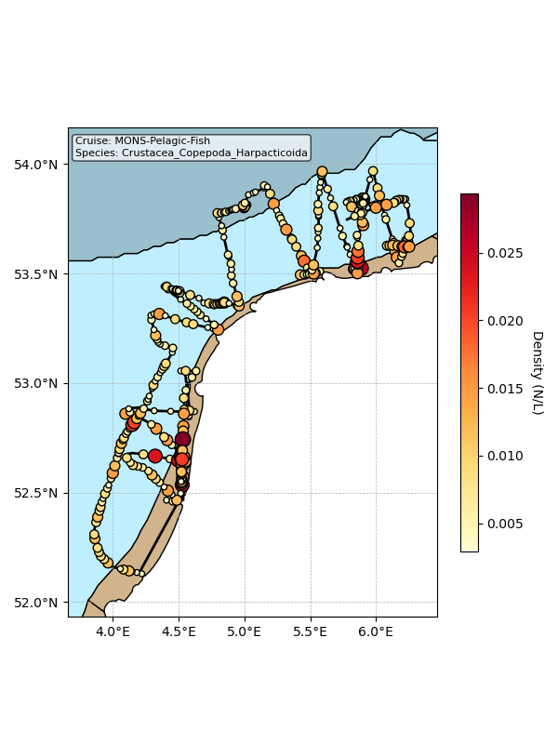

Map showing mean density estimates for Crustacea_Copepoda_Harpacticoida along the cruise transect. OSPAR eutrophication areas are plotted in the background with different colours.

## Classification examples

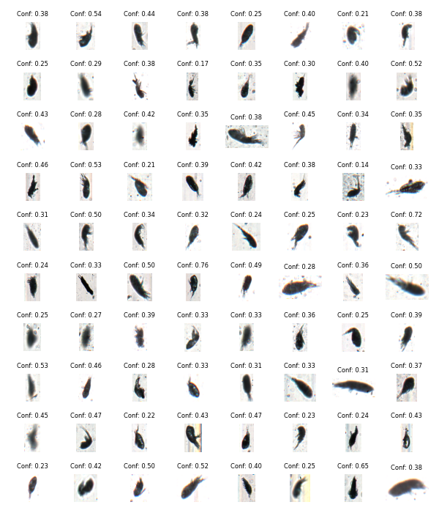

Figure showing several images classified as Crustacea_Copepoda_Harpacticoida with model confidence.

# Class: Cnidaria_Hydrozoa_Siphonophora

## Statistics

|  |  |
| --- | --- |
| Metric | Value |
| Class ID | 9 |
| Class | Cnidaria Hydrozoa Siphonophora |
| Number of predictions | 1,042 |
| Percentage of total images | 0.01 % |
| Min confidence | 0.11 % |
| Max confidence | 1.00 % |
| Average confidence | 0.59 % |
| Min density | 0.00 n/L |
| Max density | 0.04 n/L |
| Average density | 0.01 n/L |

## Model confidence

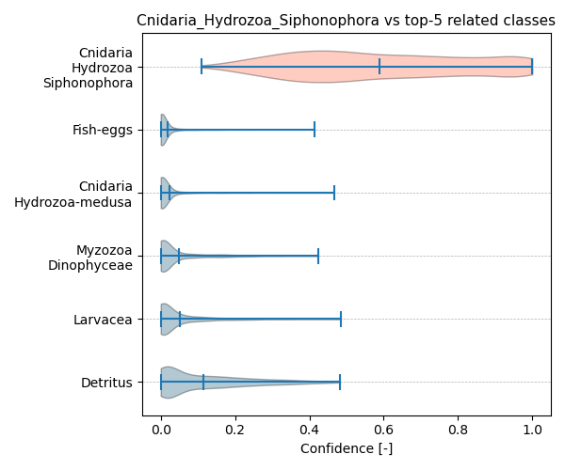

Figure showcasing the confidence distribution of the top-5 most related classes, which are determined by computing the mean confidence value of all non-target classes and selecting the five with the highest means, compared to Cnidaria_Hydrozoa_Siphonophora.

## Temporal density

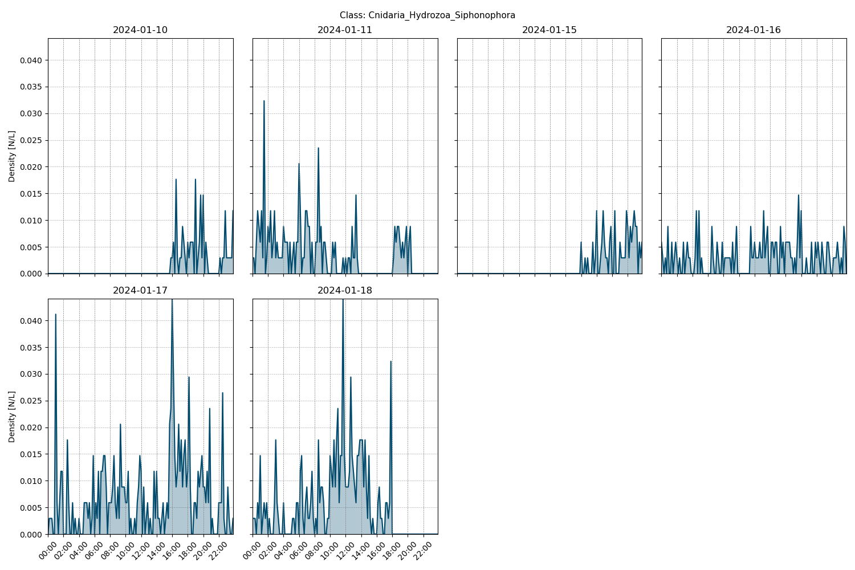

Figure showcasing the daily density estimates for Cnidaria_Hydrozoa_Siphonophora per 10 minutes.

## Spatio-temporal density

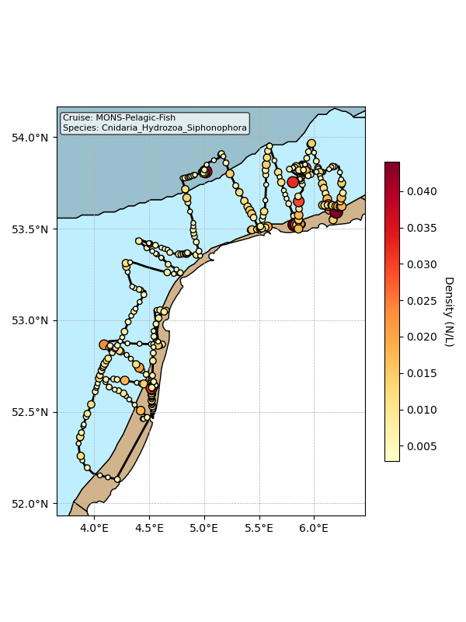

Map showing mean density estimates for Cnidaria_Hydrozoa_Siphonophora along the cruise transect. OSPAR eutrophication areas are plotted in the background with different colours.

## Classification examples

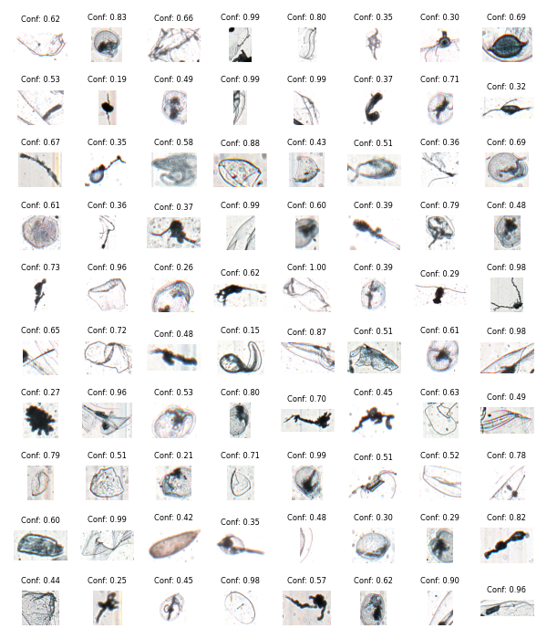

Figure showing several images classified as Cnidaria_Hydrozoa_Siphonophora with model confidence.

# Class: Cnidaria_Hydrozoa-medusa

## Statistics

|  |  |
| --- | --- |
| Metric | Value |
| Class ID | 7 |
| Class | Cnidaria Hydrozoa medusa |
| Number of predictions | 979 |
| Percentage of total images | 0.01 % |
| Min confidence | 0.17 % |
| Max confidence | 1.00 % |
| Average confidence | 0.83 % |
| Min density | 0.00 n/L |
| Max density | 0.04 n/L |
| Average density | 0.01 n/L |

## Model confidence

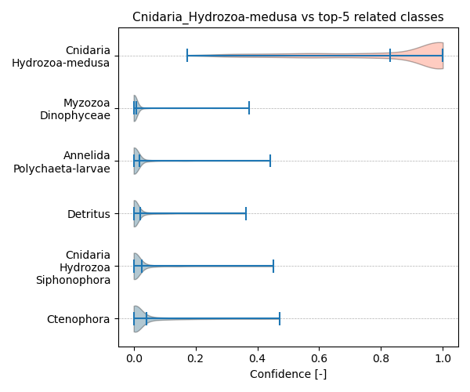

Figure showcasing the confidence distribution of the top-5 most related classes, which are determined by computing the mean confidence value of all non-target classes and selecting the five with the highest means, compared to Cnidaria_Hydrozoa-medusa.

## Temporal density

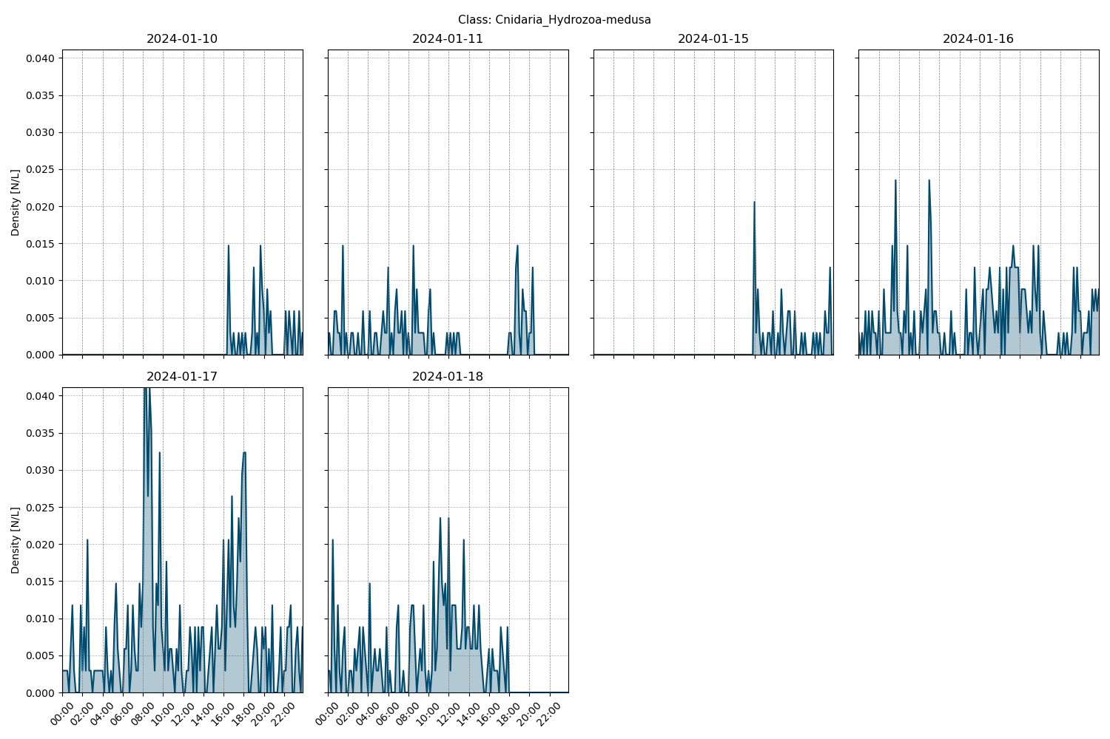

Figure showcasing the daily density estimates for Cnidaria_Hydrozoa-medusa per 10 minutes.

## Spatio-temporal density

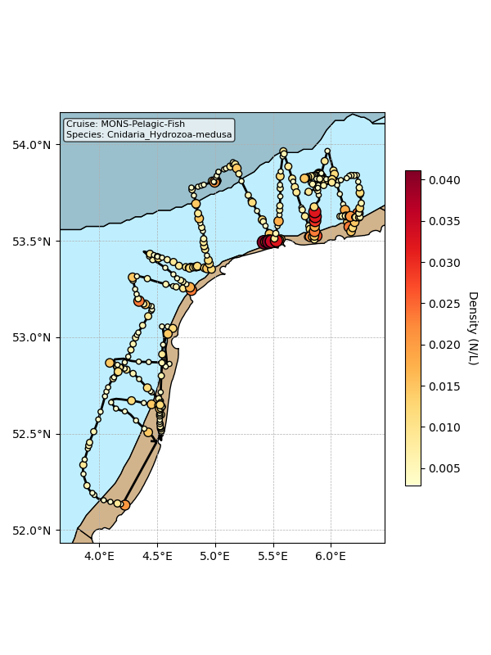

Map showing mean density estimates for Cnidaria_Hydrozoa-medusa along the cruise transect. OSPAR eutrophication areas are plotted in the background with different colours.

## Classification examples

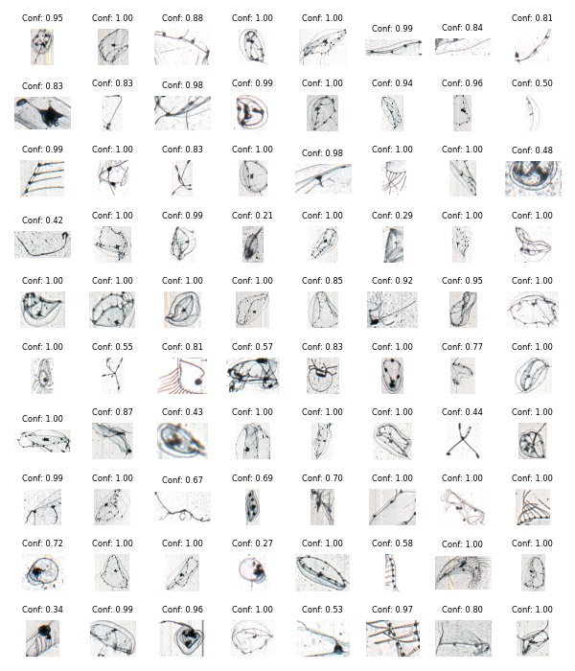

Figure showing several images classified as Cnidaria_Hydrozoa-medusa with model confidence.

# Class: Branchiostomatidae

## Statistics

|  |  |
| --- | --- |
| Metric | Value |
| Class ID | 3 |
| Class | Branchiostomatidae |
| Number of predictions | 904 |
| Percentage of total images | 0.01 % |
| Min confidence | 0.12 % |
| Max confidence | 1.00 % |
| Average confidence | 0.55 % |
| Min density | 0.00 n/L |
| Max density | 0.03 n/L |
| Average density | 0.01 n/L |

## Model confidence

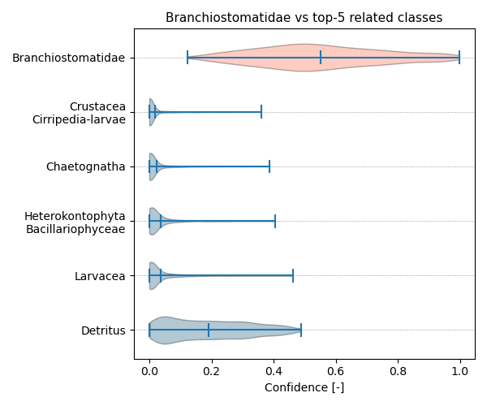

Figure showcasing the confidence distribution of the top-5 most related classes, which are determined by computing the mean confidence value of all non-target classes and selecting the five with the highest means, compared to Branchiostomatidae.

## Temporal density

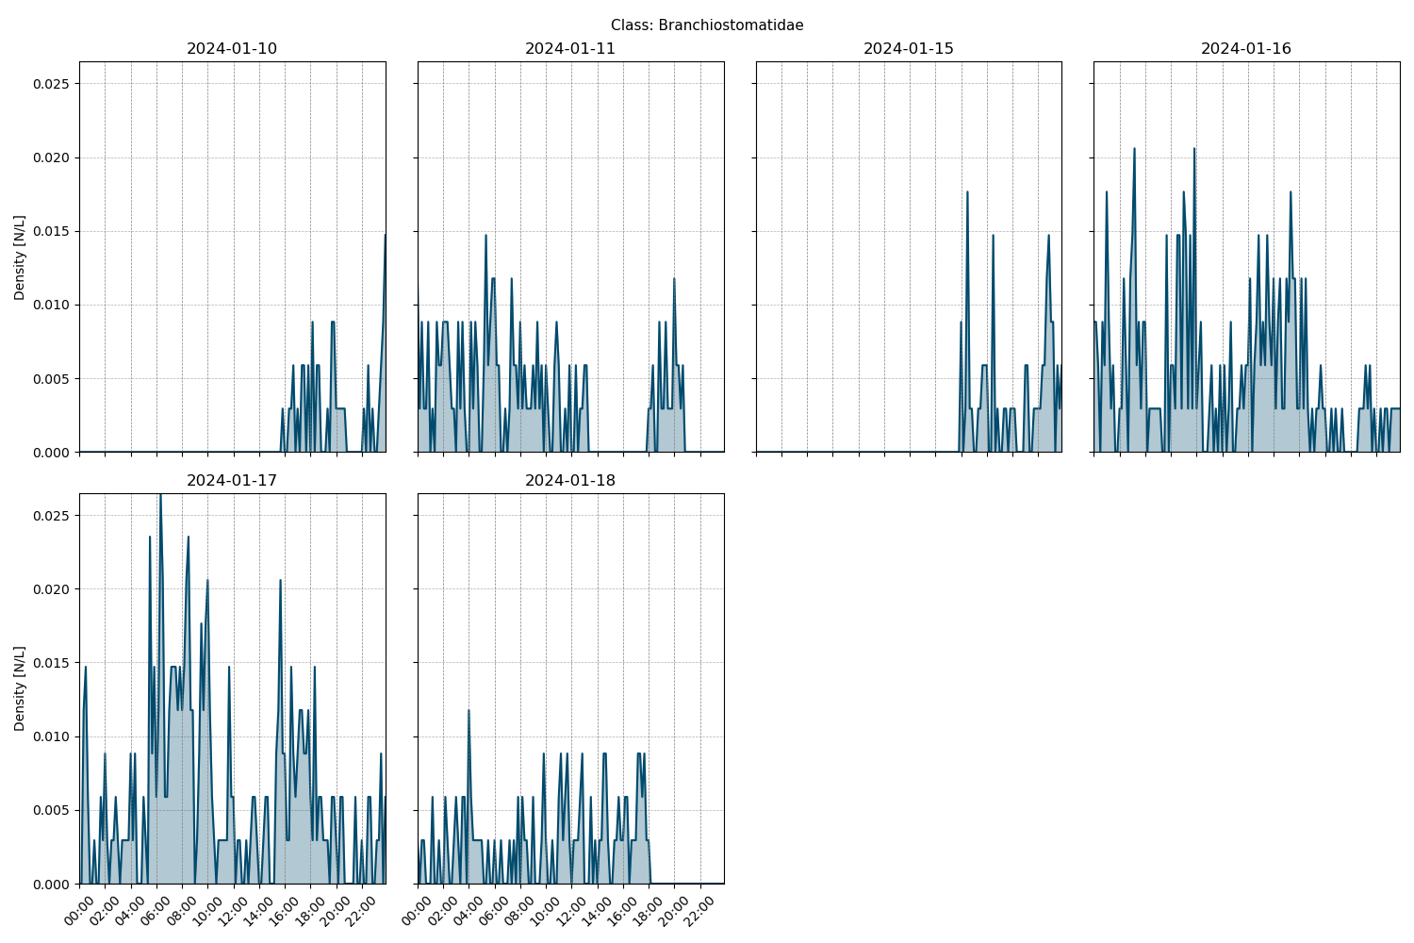

Figure showcasing the daily density estimates for Branchiostomatidae per 10 minutes.

## Spatio-temporal density

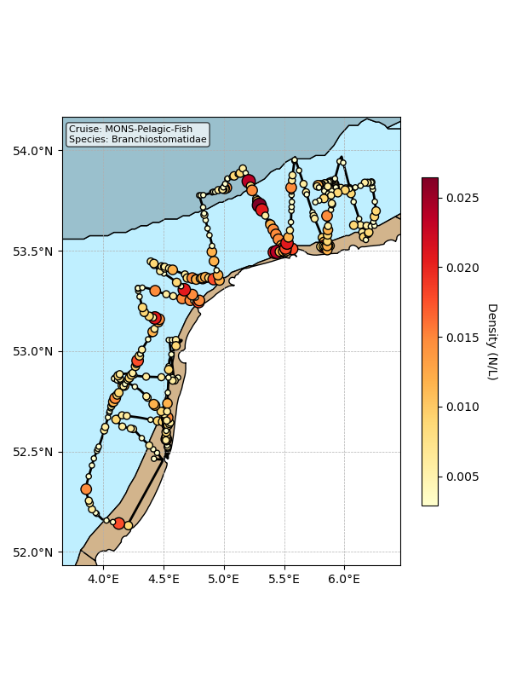

Map showing mean density estimates for Branchiostomatidae along the cruise transect. OSPAR eutrophication areas are plotted in the background with different colours.

## Classification examples

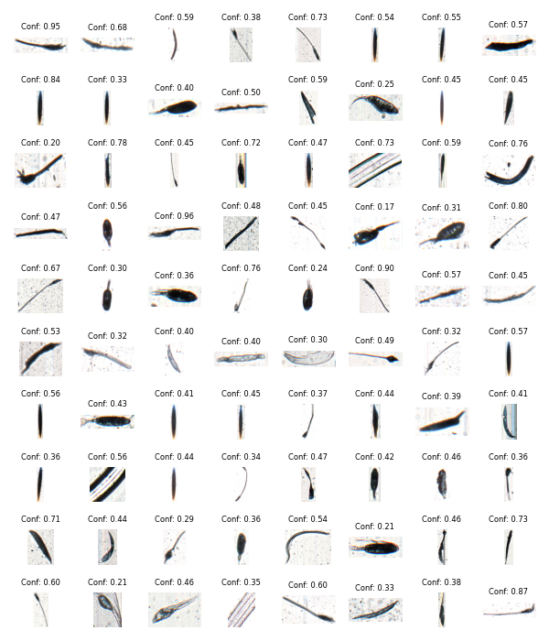

Figure showing several images classified as Branchiostomatidae with model confidence.

# Class: Echinodermata_Echinoidea-larvae

## Statistics

|  |  |
| --- | --- |
| Metric | Value |
| Class ID | 28 |
| Class | Echinodermata Echinoidea larvae |
| Number of predictions | 802 |
| Percentage of total images | 0.00 % |
| Min confidence | 0.16 % |
| Max confidence | 0.99 % |
| Average confidence | 0.53 % |
| Min density | 0.00 n/L |
| Max density | 0.02 n/L |
| Average density | 0.01 n/L |

## Model confidence

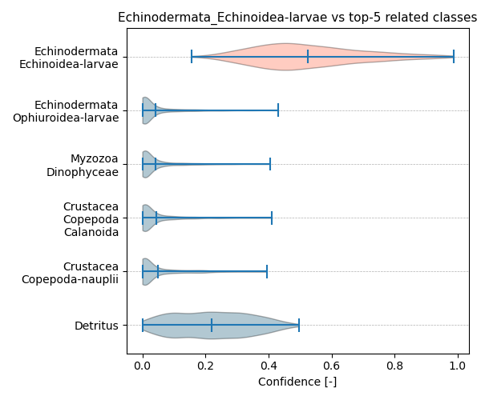

Figure showcasing the confidence distribution of the top-5 most related classes, which are determined by computing the mean confidence value of all non-target classes and selecting the five with the highest means, compared to Echinodermata_Echinoidea-larvae.

## Temporal density

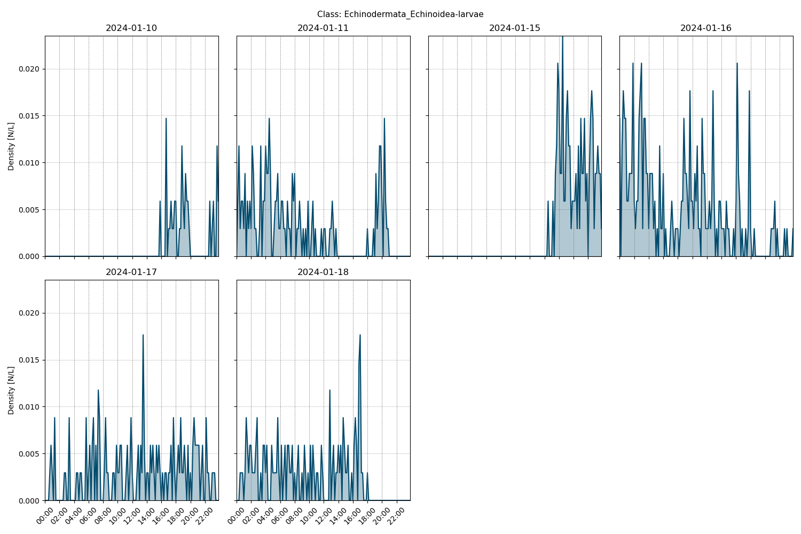

Figure showcasing the daily density estimates for Echinodermata_Echinoidea-larvae per 10 minutes.

## Spatio-temporal density

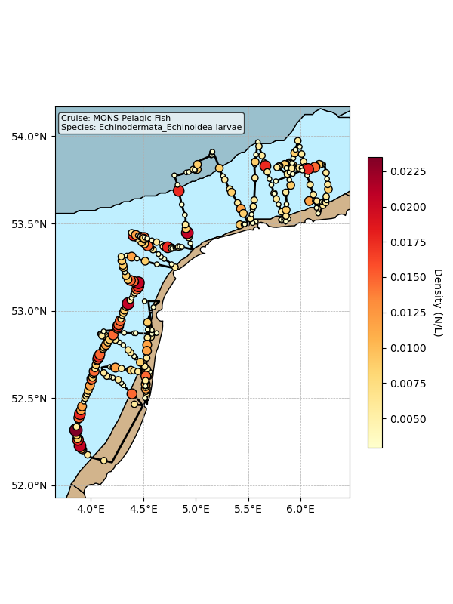

Map showing mean density estimates for Echinodermata_Echinoidea-larvae along the cruise transect. OSPAR eutrophication areas are plotted in the background with different colours.

## Classification examples

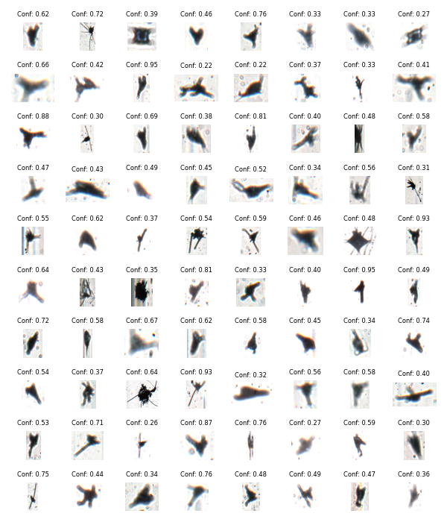

Figure showing several images classified as Echinodermata_Echinoidea-larvae with model confidence.

# Class: Fish-larvae

## Statistics

|  |  |
| --- | --- |
| Metric | Value |
| Class ID | 31 |
| Class | Fish larvae |
| Number of predictions | 672 |
| Percentage of total images | 0.00 % |
| Min confidence | 0.08 % |
| Max confidence | 1.00 % |
| Average confidence | 0.56 % |
| Min density | 0.00 n/L |
| Max density | 0.03 n/L |
| Average density | 0.01 n/L |

## Model confidence

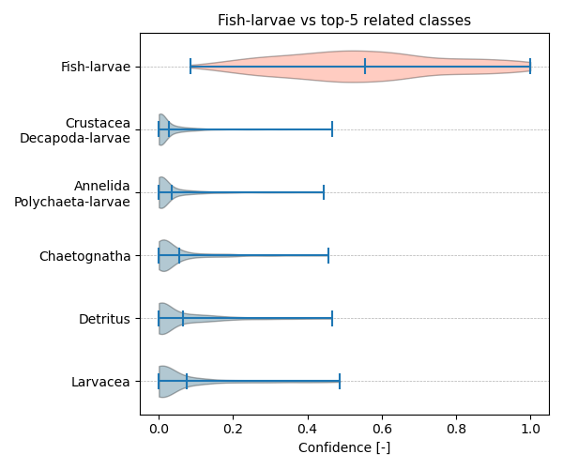

Figure showcasing the confidence distribution of the top-5 most related classes, which are determined by computing the mean confidence value of all non-target classes and selecting the five with the highest means, compared to Fish-larvae.

## Temporal density

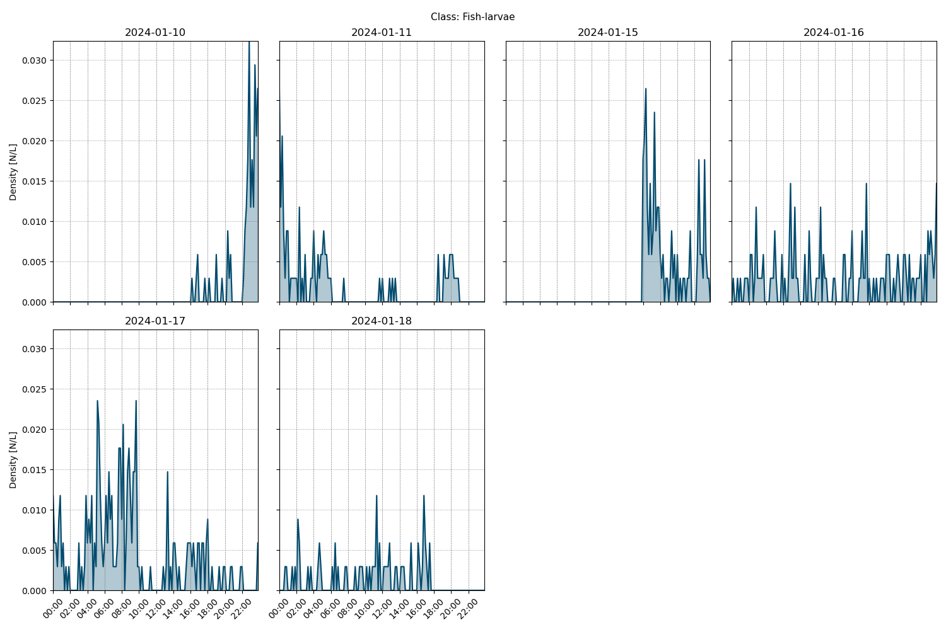

Figure showcasing the daily density estimates for Fish-larvae per 10 minutes.

## Spatio-temporal density

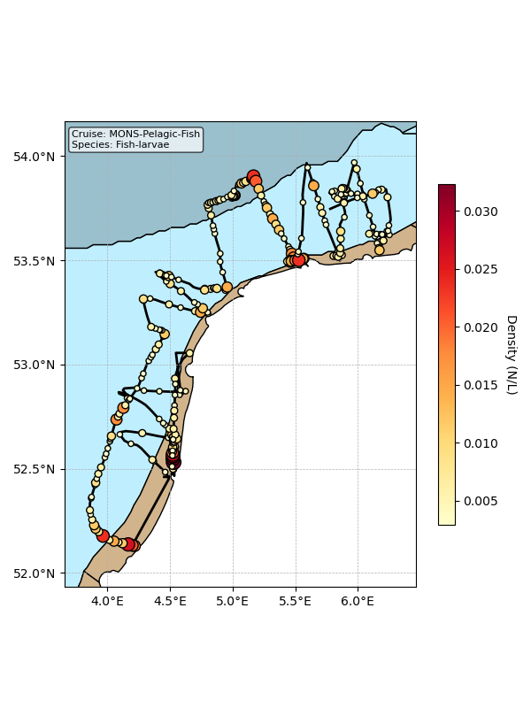

Map showing mean density estimates for Fish-larvae along the cruise transect. OSPAR eutrophication areas are plotted in the background with different colours.

## Classification examples

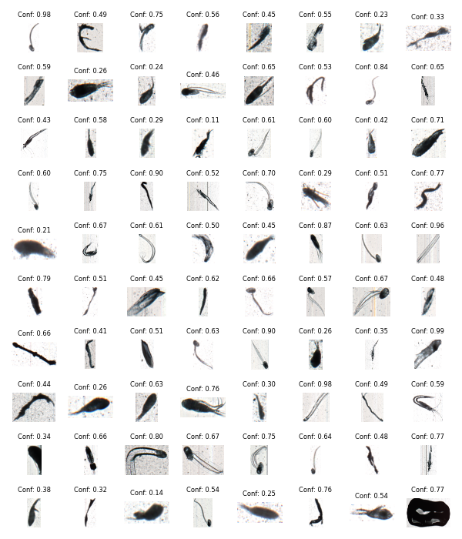

Figure showing several images classified as Fish-larvae with model confidence.

# Class: Annelida_Polychaeta_Tomopteris

## Statistics

|  |  |
| --- | --- |
| Metric | Value |
| Class ID | 1 |
| Class | Annelida Polychaeta Tomopteris |
| Number of predictions | 601 |
| Percentage of total images | 0.00 % |
| Min confidence | 0.17 % |
| Max confidence | 1.00 % |
| Average confidence | 0.56 % |
| Min density | 0.00 n/L |
| Max density | 0.04 n/L |
| Average density | 0.01 n/L |

## Model confidence

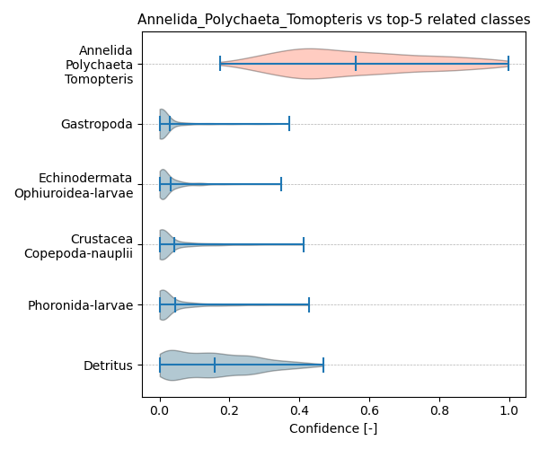

Figure showcasing the confidence distribution of the top-5 most related classes, which are determined by computing the mean confidence value of all non-target classes and selecting the five with the highest means, compared to Annelida_Polychaeta_Tomopteris.

## Temporal density

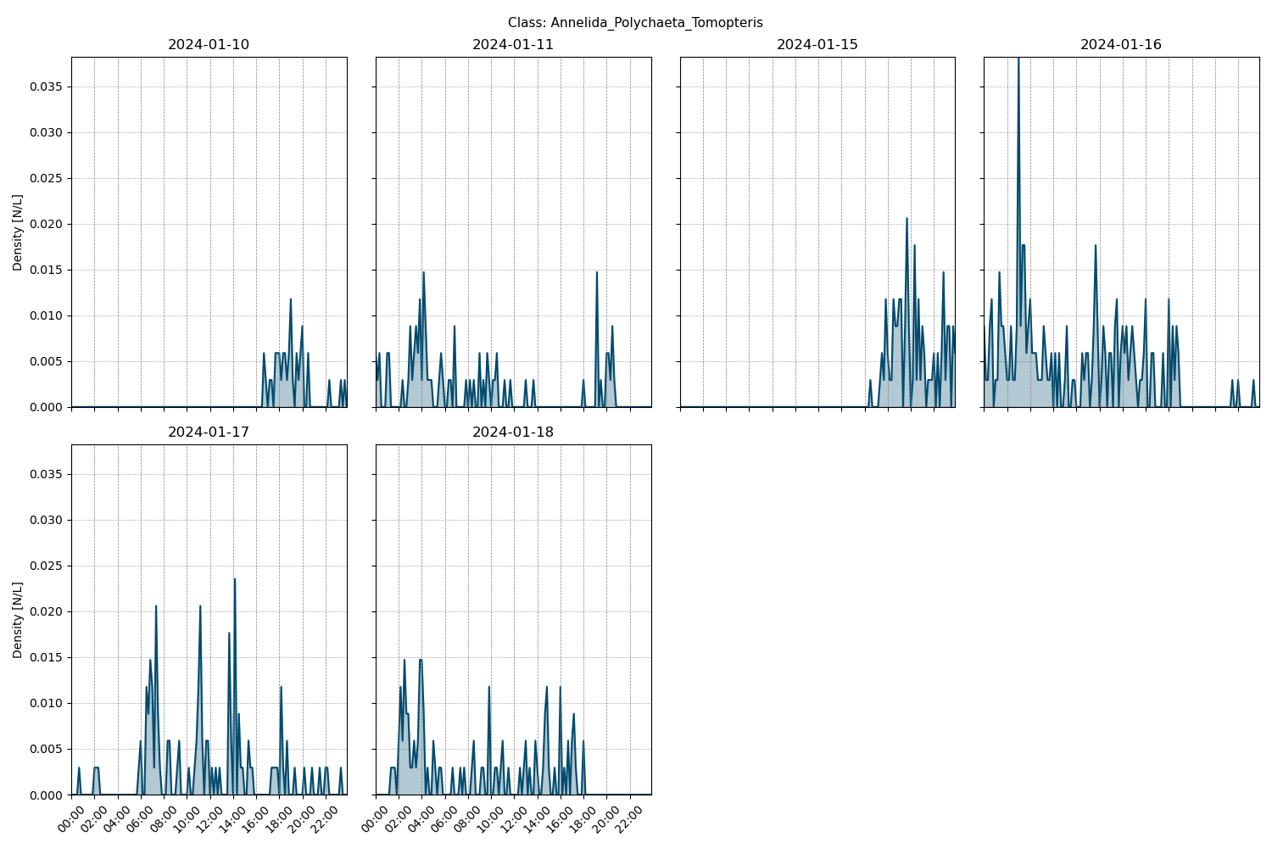

Figure showcasing the daily density estimates for Annelida_Polychaeta_Tomopteris per 10 minutes.

## Spatio-temporal density

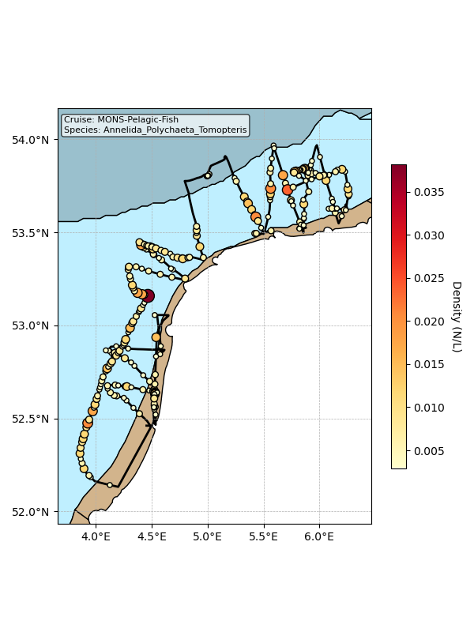

Map showing mean density estimates for Annelida_Polychaeta_Tomopteris along the cruise transect. OSPAR eutrophication areas are plotted in the background with different colours.

## Classification examples

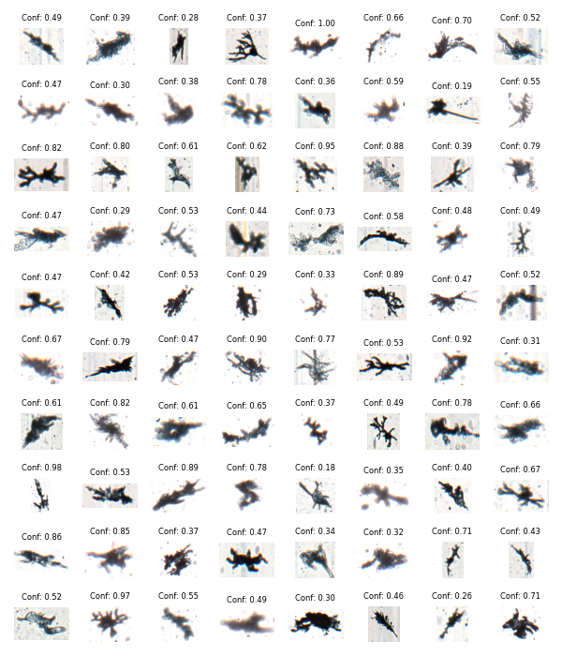

Figure showing several images classified as Annelida_Polychaeta_Tomopteris with model confidence.

# Class: Crustacea_Amphipoda

## Statistics

|  |  |
| --- | --- |
| Metric | Value |
| Class ID | 12 |
| Class | Crustacea Amphipoda |
| Number of predictions | 521 |
| Percentage of total images | 0.00 % |
| Min confidence | 0.15 % |
| Max confidence | 1.00 % |
| Average confidence | 0.59 % |
| Min density | 0.00 n/L |
| Max density | 0.02 n/L |
| Average density | 0.01 n/L |

## Model confidence

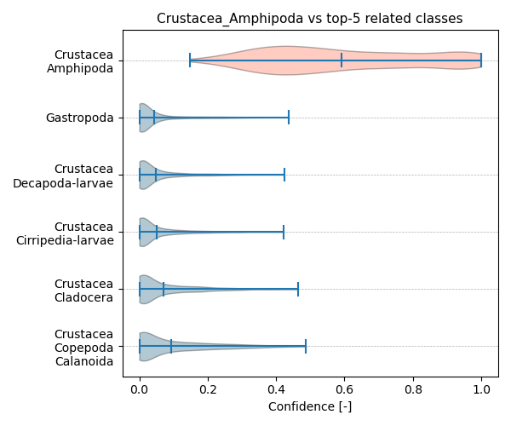

Figure showcasing the confidence distribution of the top-5 most related classes, which are determined by computing the mean confidence value of all non-target classes and selecting the five with the highest means, compared to Crustacea_Amphipoda.

## Temporal density

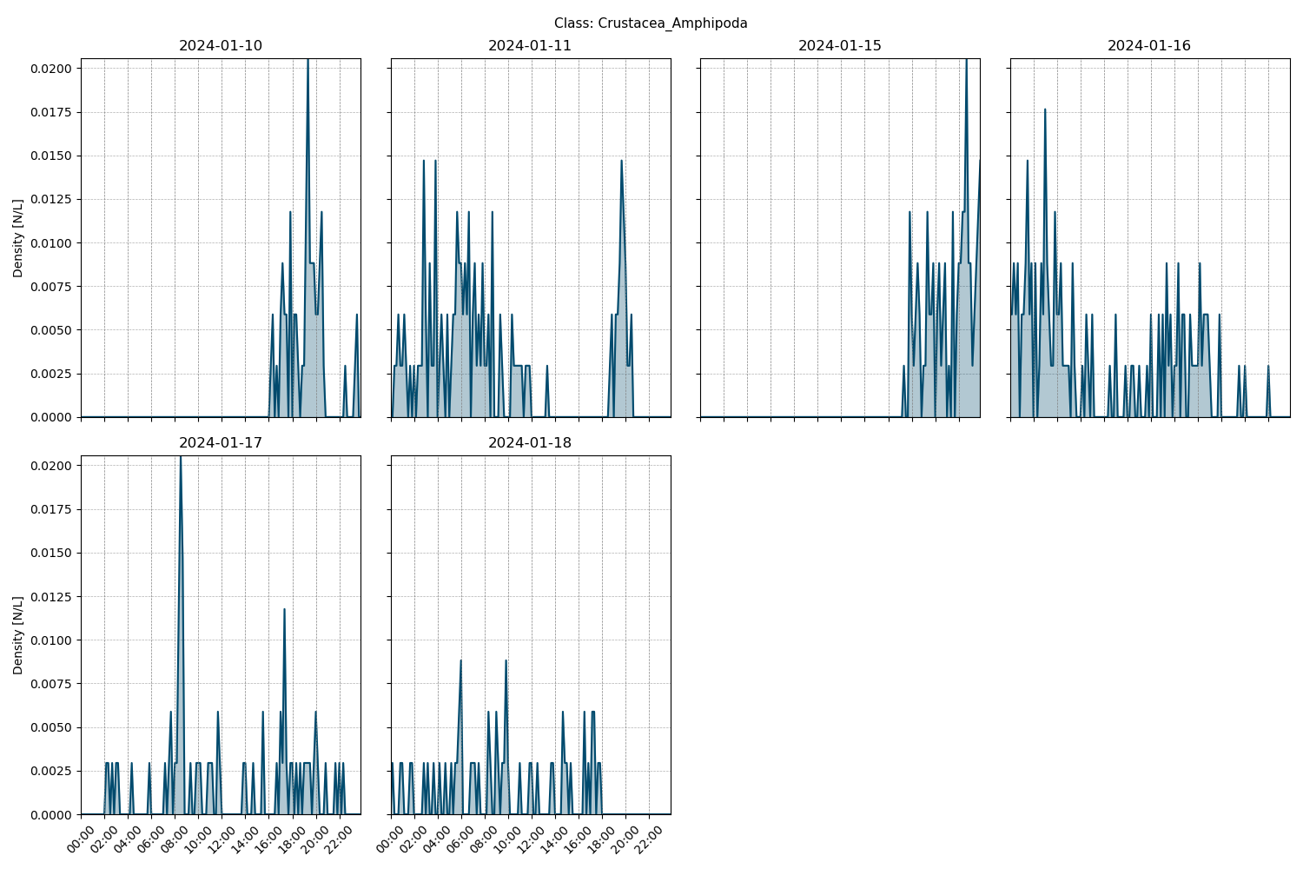

Figure showcasing the daily density estimates for Crustacea_Amphipoda per 10 minutes.

## Spatio-temporal density

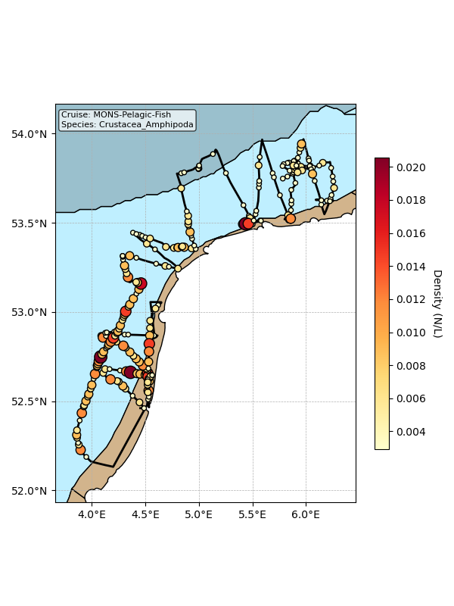

Map showing mean density estimates for Crustacea_Amphipoda along the cruise transect. OSPAR eutrophication areas are plotted in the background with different colours.

## Classification examples

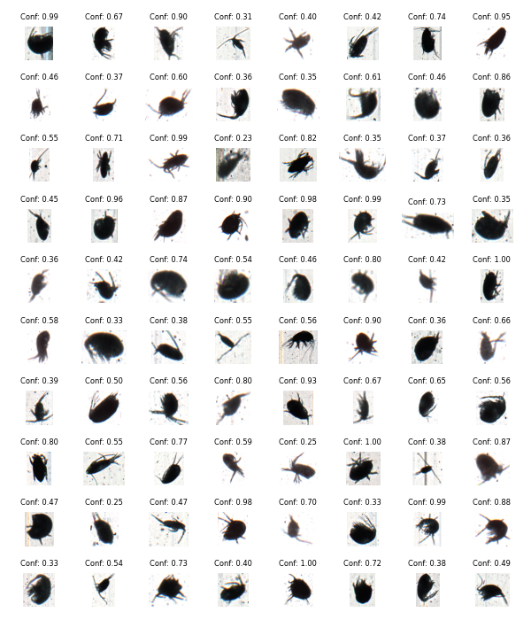

Figure showing several images classified as Crustacea_Amphipoda with model confidence.

# Class: Cnidaria_Hydrozoa-polyp

## Statistics

|  |  |
| --- | --- |
| Metric | Value |
| Class ID | 8 |
| Class | Cnidaria Hydrozoa polyp |
| Number of predictions | 281 |
| Percentage of total images | 0.00 % |
| Min confidence | 0.17 % |
| Max confidence | 1.00 % |
| Average confidence | 0.67 % |
| Min density | 0.00 n/L |
| Max density | 0.01 n/L |
| Average density | 0.00 n/L |

## Model confidence

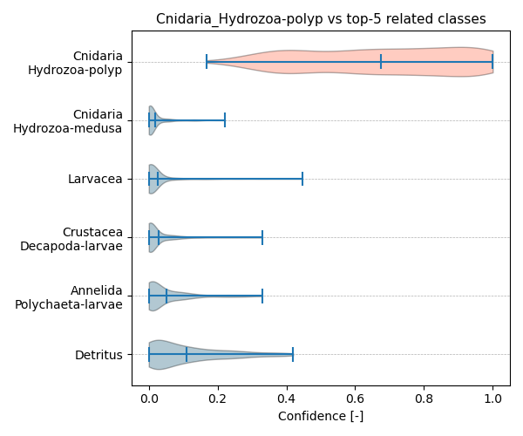

Figure showcasing the confidence distribution of the top-5 most related classes, which are determined by computing the mean confidence value of all non-target classes and selecting the five with the highest means, compared to Cnidaria_Hydrozoa-polyp.

## Temporal density

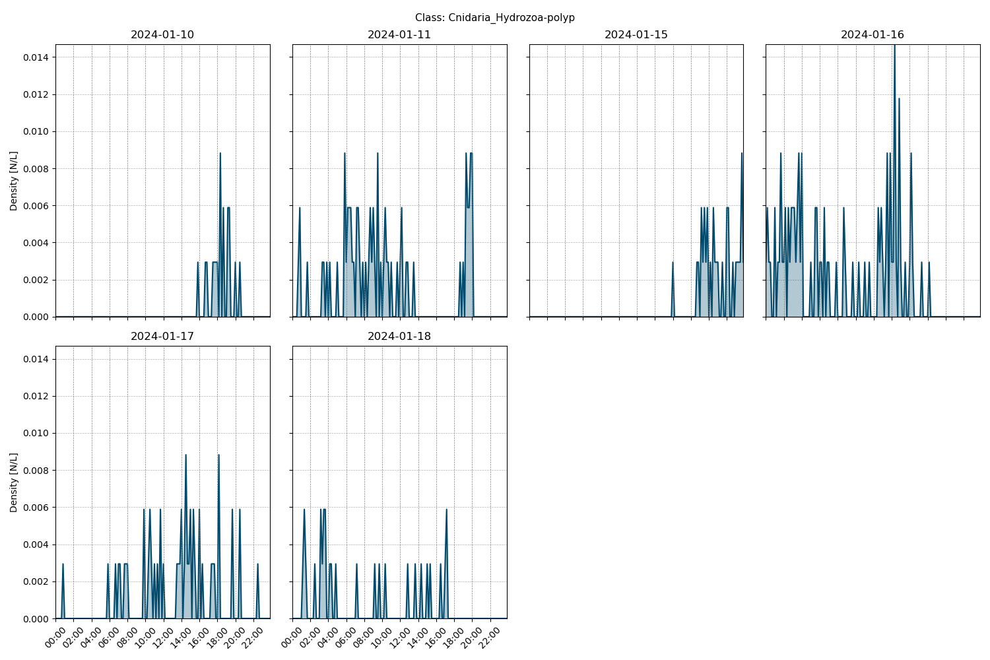

Figure showcasing the daily density estimates for Cnidaria_Hydrozoa-polyp per 10 minutes.

## Spatio-temporal density

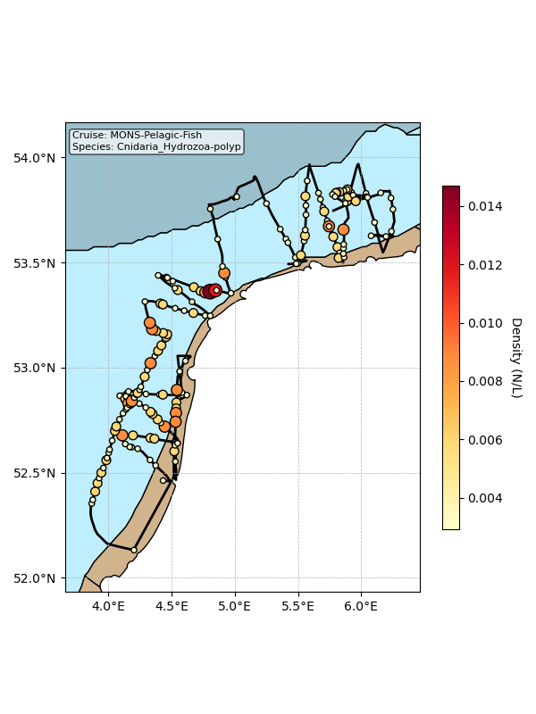

Map showing mean density estimates for Cnidaria_Hydrozoa-polyp along the cruise transect. OSPAR eutrophication areas are plotted in the background with different colours.

## Classification examples

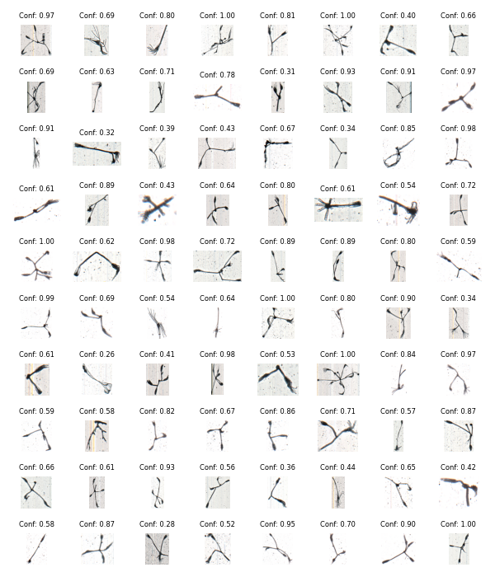

Figure showing several images classified as Cnidaria_Hydrozoa-polyp with model confidence.

# Class: Mollusca_Gastropoda

## Statistics

|  |  |
| --- | --- |
| Metric | Value |
| Class ID | 39 |
| Class | Mollusca Gastropoda |
| Number of predictions | 217 |
| Percentage of total images | 0.00 % |
| Min confidence | 0.14 % |
| Max confidence | 0.91 % |
| Average confidence | 0.34 % |
| Min density | 0.00 n/L |
| Max density | 0.01 n/L |
| Average density | 0.00 n/L |

## Model confidence

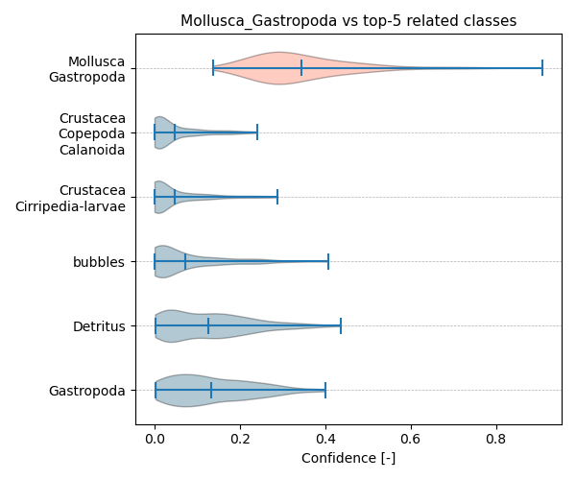

Figure showcasing the confidence distribution of the top-5 most related classes, which are determined by computing the mean confidence value of all non-target classes and selecting the five with the highest means, compared to Mollusca_Gastropoda.

## Temporal density

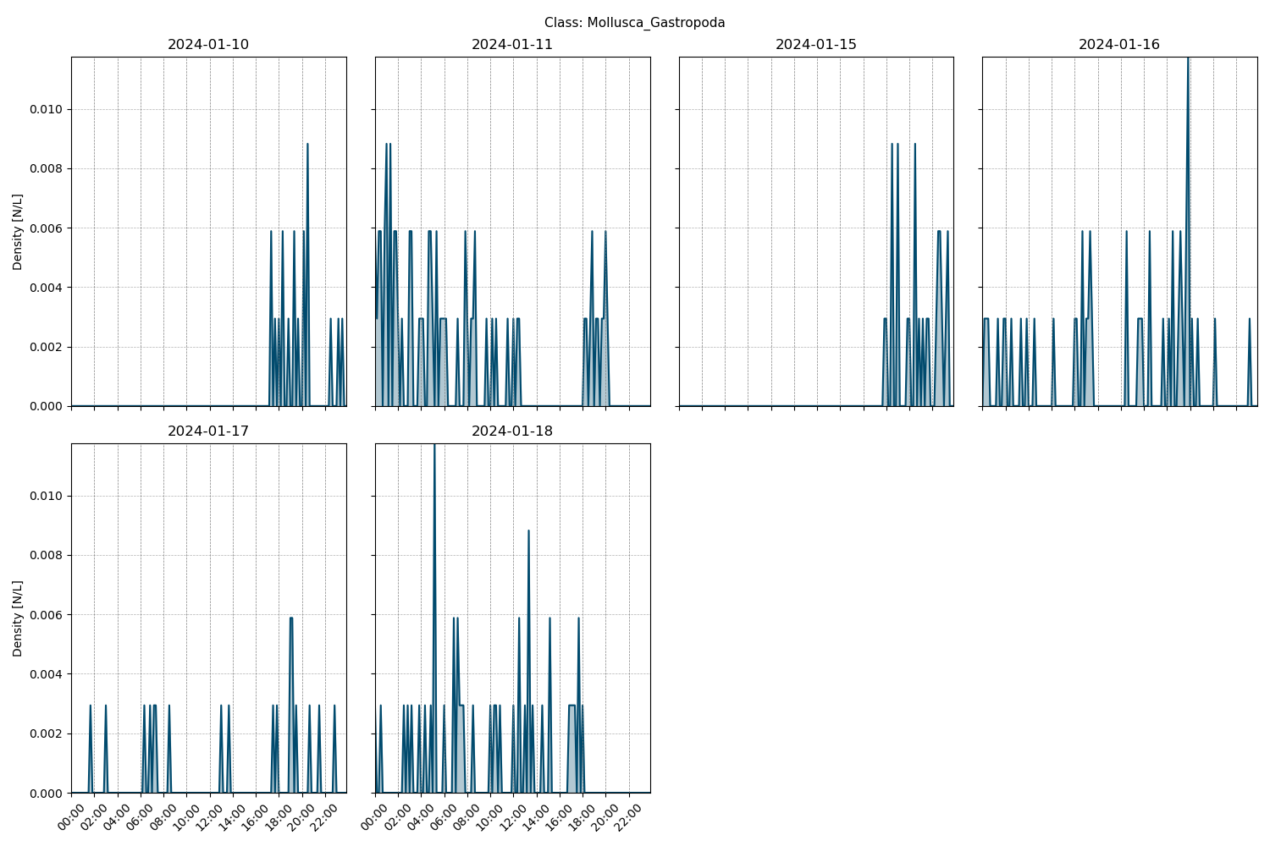

Figure showcasing the daily density estimates for Mollusca_Gastropoda per 10 minutes.

## Spatio-temporal density

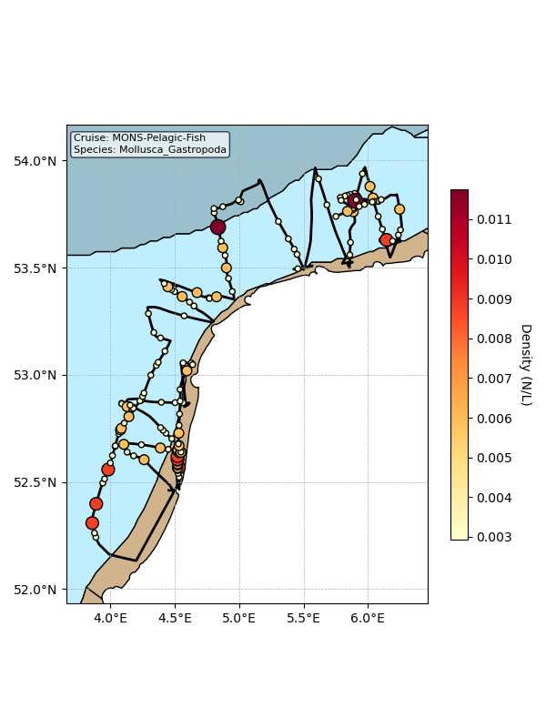

Map showing mean density estimates for Mollusca_Gastropoda along the cruise transect. OSPAR eutrophication areas are plotted in the background with different colours.

## Classification examples

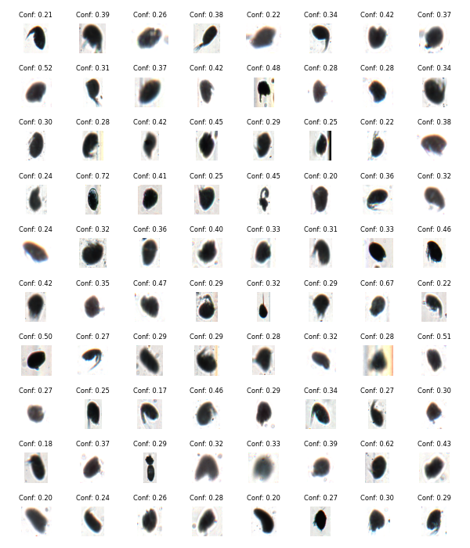

Figure showing several images classified as Mollusca_Gastropoda with model confidence.

# Class: Brachiopoda-larvae

## Statistics

|  |  |
| --- | --- |
| Metric | Value |
| Class ID | 2 |
| Class | Brachiopoda larvae |
| Number of predictions | 197 |
| Percentage of total images | 0.00 % |
| Min confidence | 0.18 % |
| Max confidence | 0.89 % |
| Average confidence | 0.47 % |
| Min density | 0.00 n/L |
| Max density | 0.01 n/L |
| Average density | 0.00 n/L |

## Model confidence

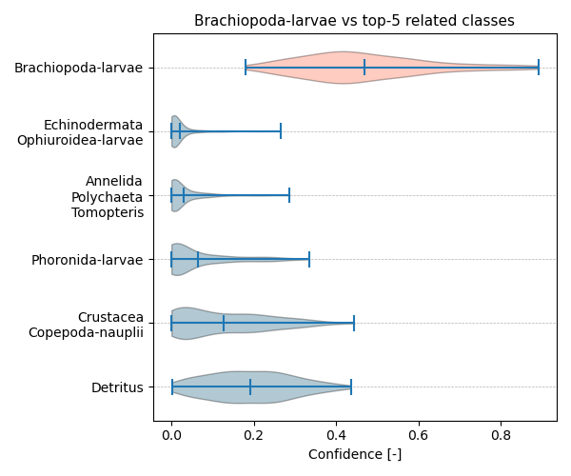

Figure showcasing the confidence distribution of the top-5 most related classes, which are determined by computing the mean confidence value of all non-target classes and selecting the five with the highest means, compared to Brachiopoda-larvae.

## Temporal density

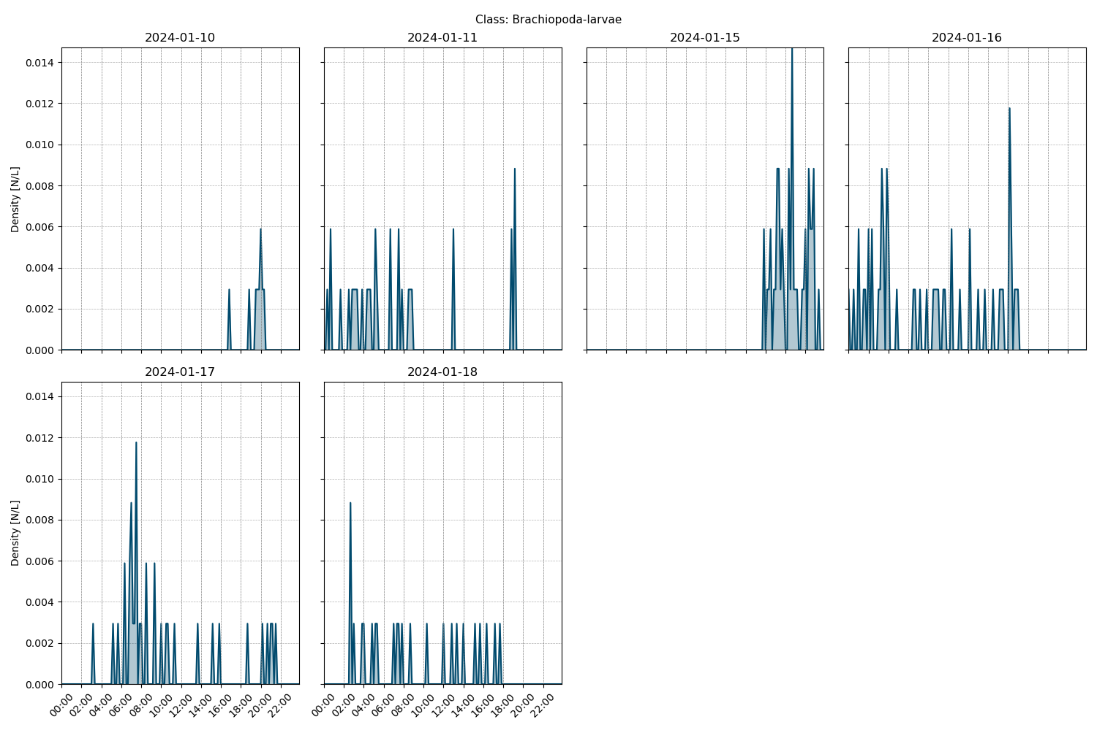

Figure showcasing the daily density estimates for Brachiopoda-larvae per 10 minutes.

## Spatio-temporal density

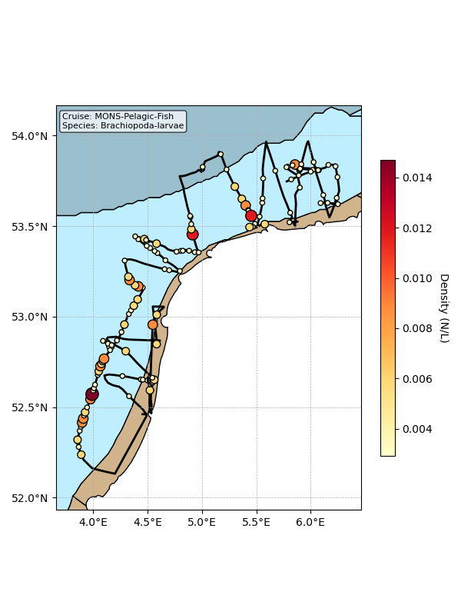

Map showing mean density estimates for Brachiopoda-larvae along the cruise transect. OSPAR eutrophication areas are plotted in the background with different colours.

## Classification examples

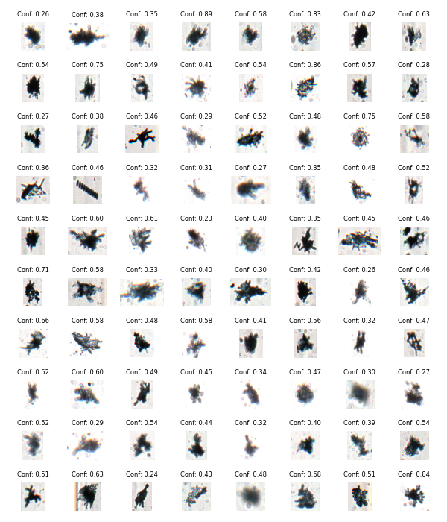

Figure showing several images classified as Brachiopoda-larvae with model confidence.

# Class: Crustacea_Cumacea

## Statistics

|  |  |
| --- | --- |
| Metric | Value |
| Class ID | 20 |
| Class | Crustacea Cumacea |
| Number of predictions | 73 |
| Percentage of total images | 0.00 % |
| Min confidence | 0.20 % |
| Max confidence | 1.00 % |
| Average confidence | 0.72 % |
| Min density | 0.00 n/L |
| Max density | 0.01 n/L |
| Average density | 0.00 n/L |

## Model confidence

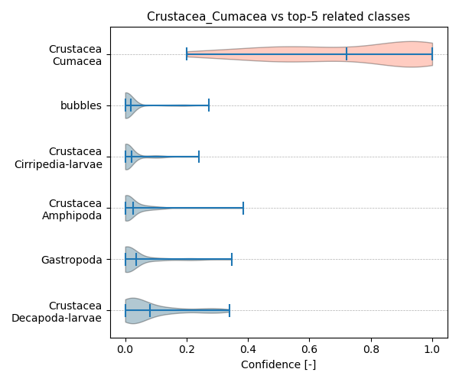

Figure showcasing the confidence distribution of the top-5 most related classes, which are determined by computing the mean confidence value of all non-target classes and selecting the five with the highest means, compared to Crustacea_Cumacea.

## Temporal density

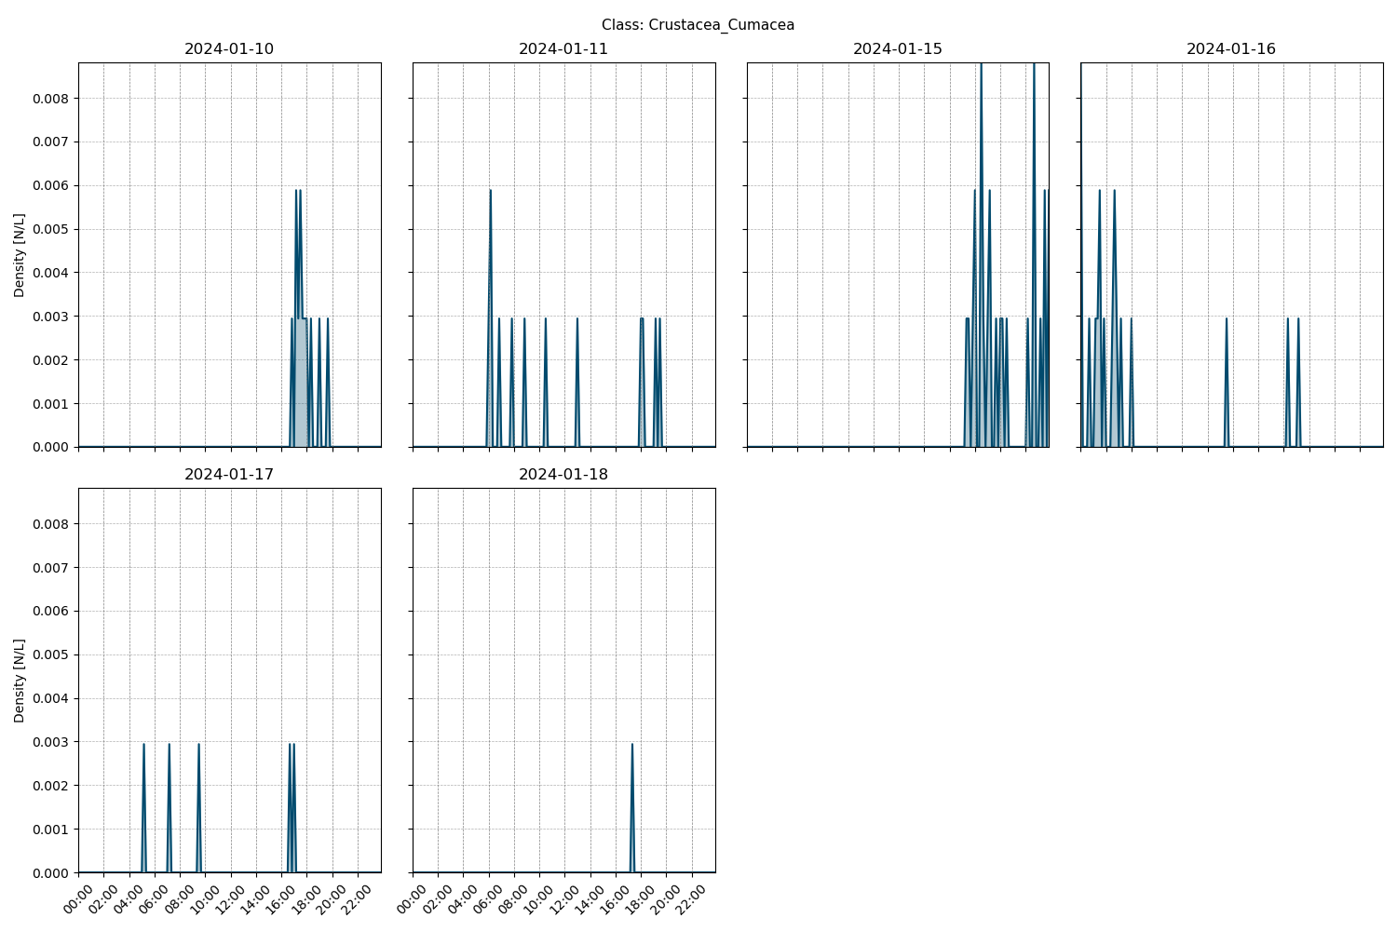

Figure showcasing the daily density estimates for Crustacea_Cumacea per 10 minutes.

## Spatio-temporal density

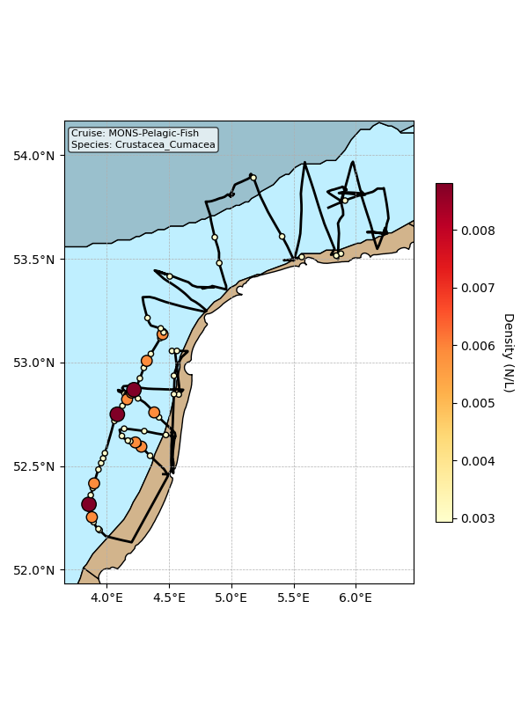

Map showing mean density estimates for Crustacea_Cumacea along the cruise transect. OSPAR eutrophication areas are plotted in the background with different colours.

## Classification examples

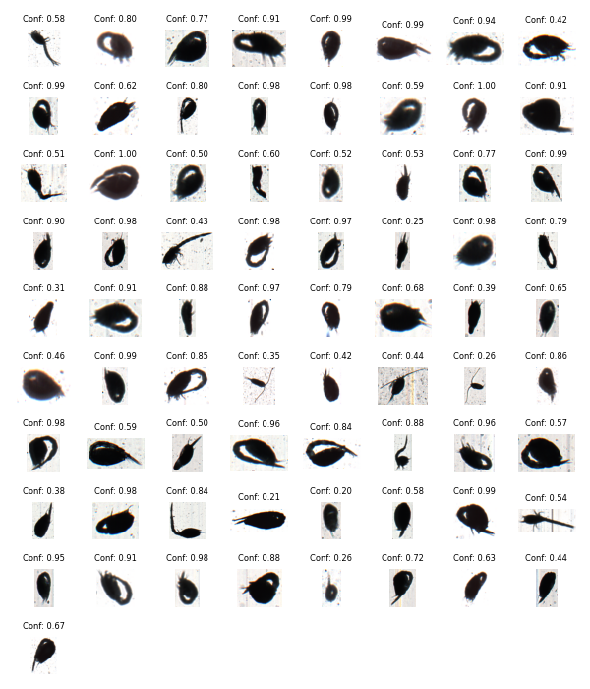

Figure showing several images classified as Crustacea_Cumacea with model confidence.

# Class: Cnidaria_Scyphozoa-ephyrae

## Statistics

|  |  |
| --- | --- |
| Metric | Value |
| Class ID | 10 |
| Class | Cnidaria Scyphozoa ephyrae |
| Number of predictions | 35 |
| Percentage of total images | 0.00 % |
| Min confidence | 0.24 % |
| Max confidence | 1.00 % |
| Average confidence | 0.87 % |
| Min density | 0.00 n/L |
| Max density | 0.01 n/L |
| Average density | 0.00 n/L |

## Model confidence

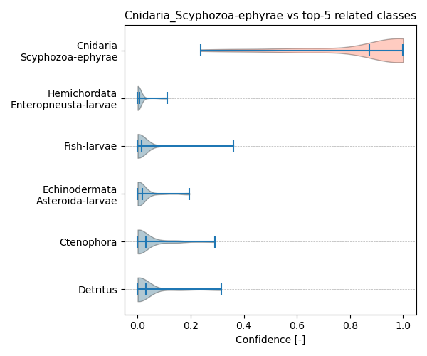

Figure showcasing the confidence distribution of the top-5 most related classes, which are determined by computing the mean confidence value of all non-target classes and selecting the five with the highest means, compared to Cnidaria_Scyphozoa-ephyrae.

## Temporal density

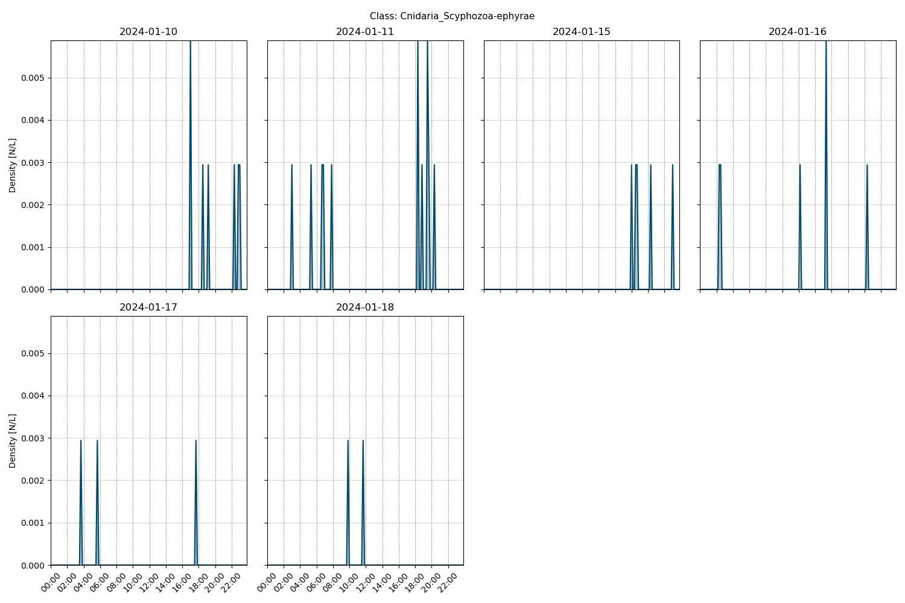

Figure showcasing the daily density estimates for Cnidaria_Scyphozoa-ephyrae per 10 minutes.

## Spatio-temporal density

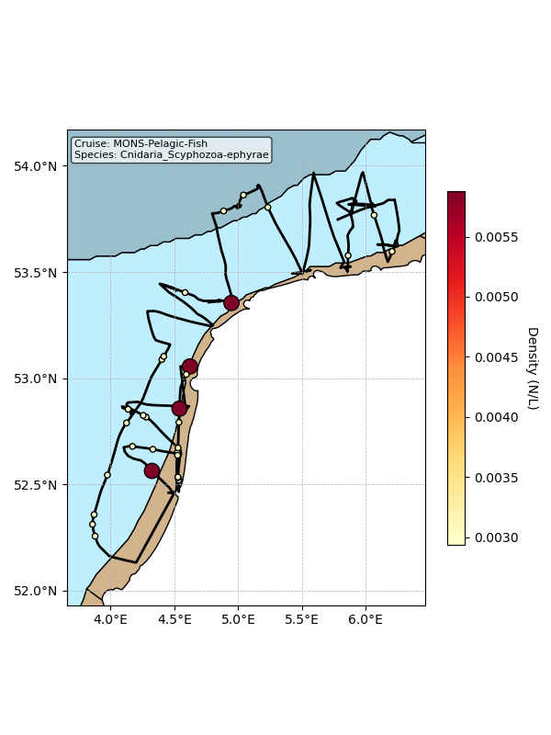

Map showing mean density estimates for Cnidaria_Scyphozoa-ephyrae along the cruise transect. OSPAR eutrophication areas are plotted in the background with different colours.

## Classification examples

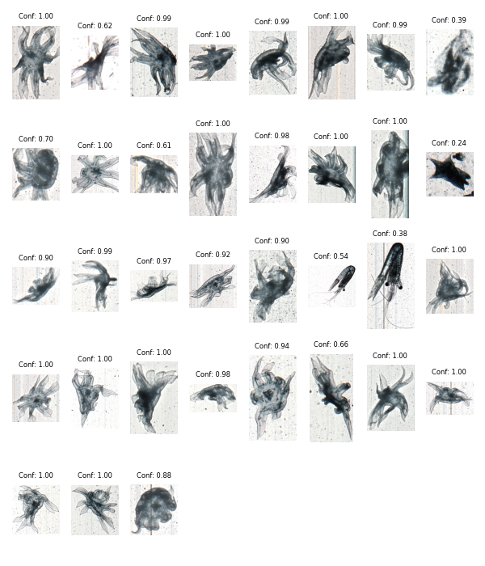

Figure showing several images classified as Cnidaria_Scyphozoa-ephyrae with model confidence.

# Class: Cyanobacteria

## Statistics

|  |  |
| --- | --- |
| Metric | Value |
| Class ID | 25 |
| Class | Cyanobacteria |
| Number of predictions | 12 |
| Percentage of total images | 0.00 % |
| Min confidence | 0.34 % |
| Max confidence | 0.97 % |
| Average confidence | 0.55 % |
| Min density | 0.00 n/L |
| Max density | 0.00 n/L |
| Average density | 0.00 n/L |

## Model confidence

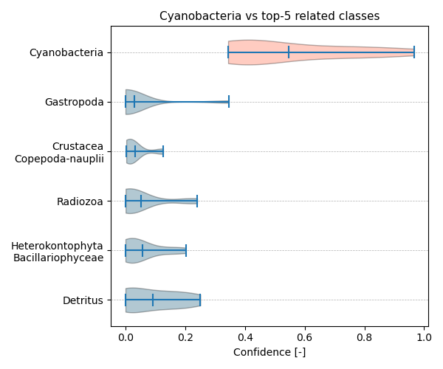

Figure showcasing the confidence distribution of the top-5 most related classes, which are determined by computing the mean confidence value of all non-target classes and selecting the five with the highest means, compared to Cyanobacteria.

## Temporal density

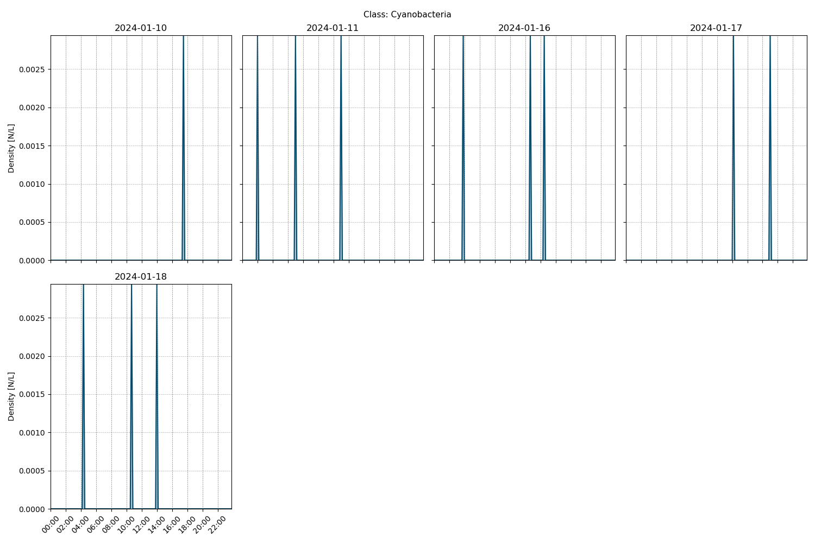

Figure showcasing the daily density estimates for Cyanobacteria per 10 minutes.

## Spatio-temporal density

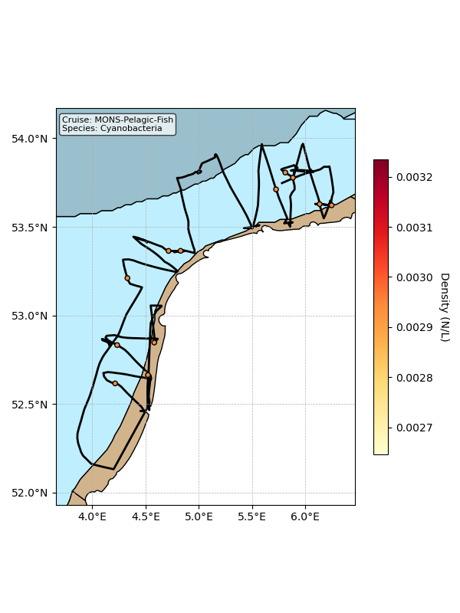

Map showing mean density estimates for Cyanobacteria along the cruise transect. OSPAR eutrophication areas are plotted in the background with different colours.

## Classification examples

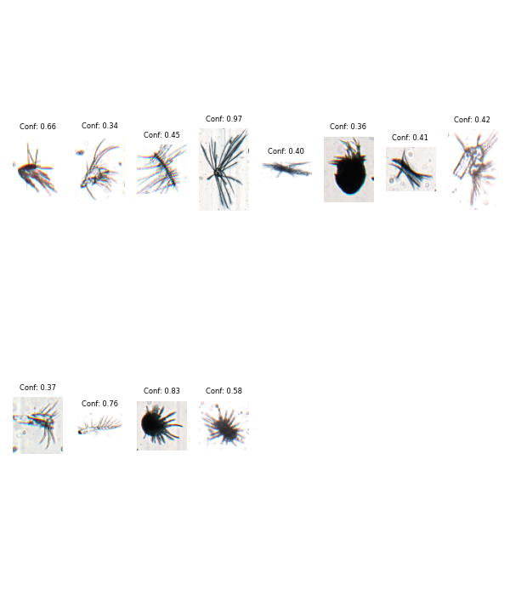

Figure showing several images classified as Cyanobacteria with model confidence.

# Class: Crustacea_Copepoda_Monstrilloidae

## Statistics

|  |  |
| --- | --- |
| Metric | Value |
| Class ID | 19 |
| Class | Crustacea Copepoda Monstrilloidae |
| Number of predictions | 6 |
| Percentage of total images | 0.00 % |
| Min confidence | 0.22 % |
| Max confidence | 0.63 % |
| Average confidence | 0.40 % |
| Min density | 0.00 n/L |
| Max density | 0.00 n/L |
| Average density | 0.00 n/L |

## Model confidence

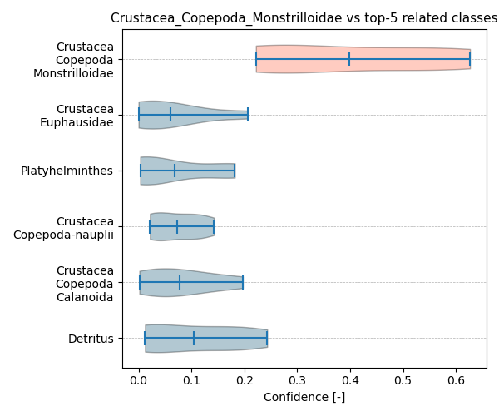

Figure showcasing the confidence distribution of the top-5 most related classes, which are determined by computing the mean confidence value of all non-target classes and selecting the five with the highest means, compared to Crustacea_Copepoda_Monstrilloidae.

## Temporal density

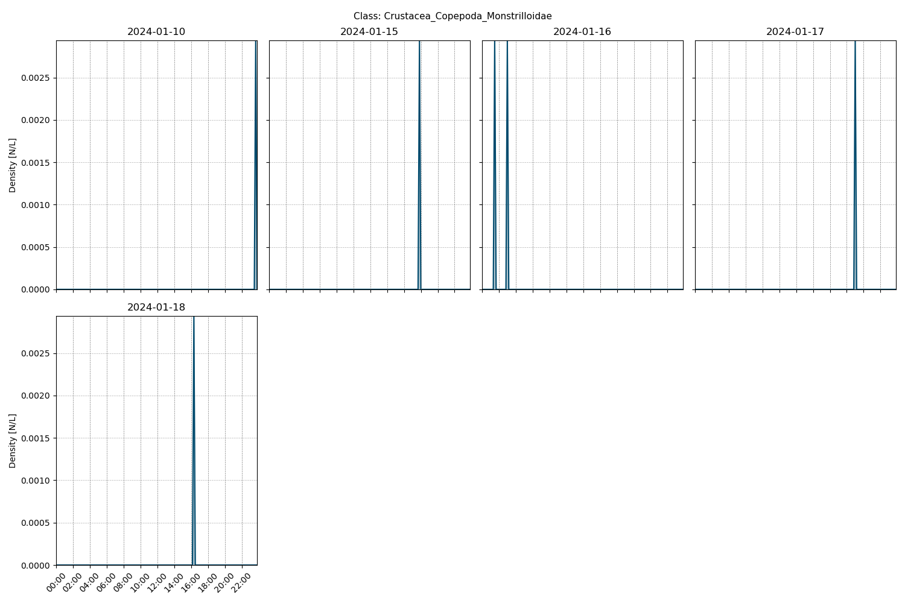

Figure showcasing the daily density estimates for Crustacea_Copepoda_Monstrilloidae per 10 minutes.

## Spatio-temporal density

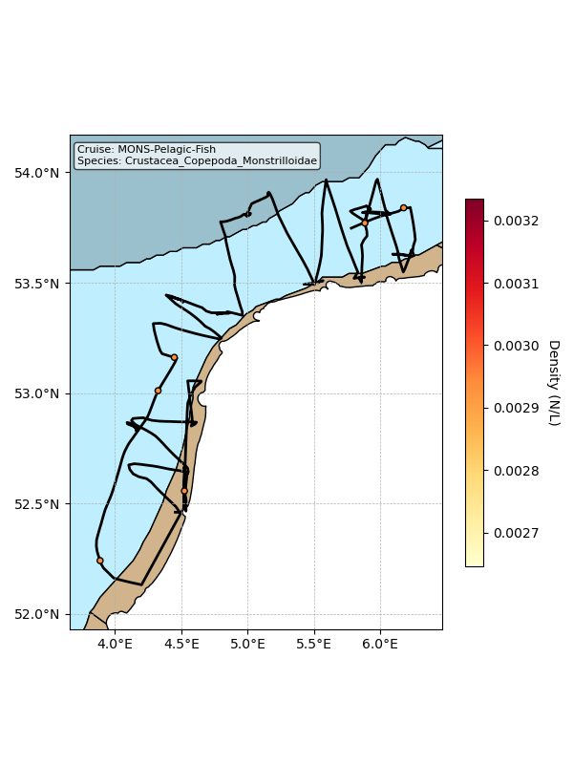

Map showing mean density estimates for Crustacea_Copepoda_Monstrilloidae along the cruise transect. OSPAR eutrophication areas are plotted in the background with different colours.

## Classification examples

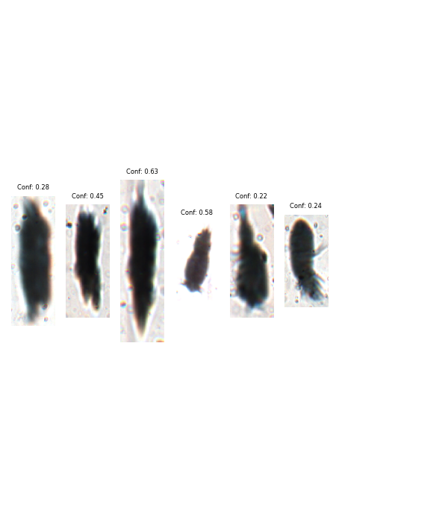

Figure showing several images classified as Crustacea_Copepoda_Monstrilloidae with model confidence.

# Class: Mollusca_Gastropoda-larvae

## Statistics

|  |  |
| --- | --- |
| Metric | Value |
| Class ID | 40 |
| Class | Mollusca Gastropoda larvae |
| Number of predictions | 4 |
| Percentage of total images | 0.00 % |
| Min confidence | 0.18 % |
| Max confidence | 0.31 % |
| Average confidence | 0.24 % |
| Min density | 0.00 n/L |
| Max density | 0.01 n/L |
| Average density | 0.00 n/L |

## Model confidence

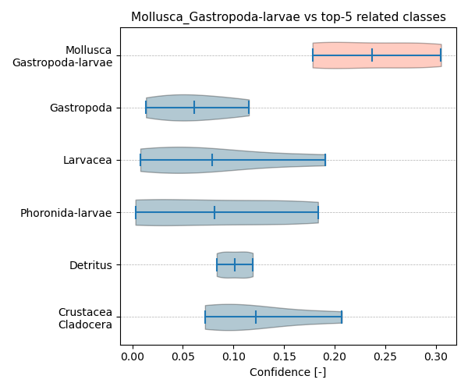

Figure showcasing the confidence distribution of the top-5 most related classes, which are determined by computing the mean confidence value of all non-target classes and selecting the five with the highest means, compared to Mollusca_Gastropoda-larvae.

## Temporal density

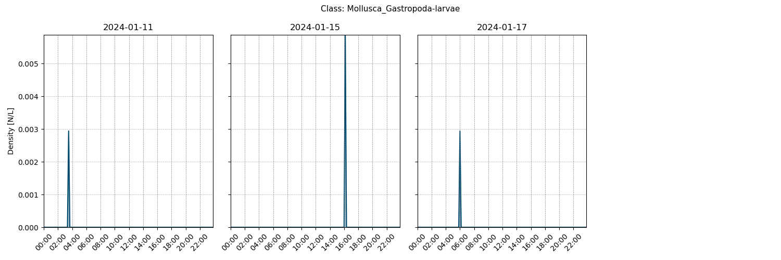

Figure showcasing the daily density estimates for Mollusca_Gastropoda-larvae per 10 minutes.

## Spatio-temporal density

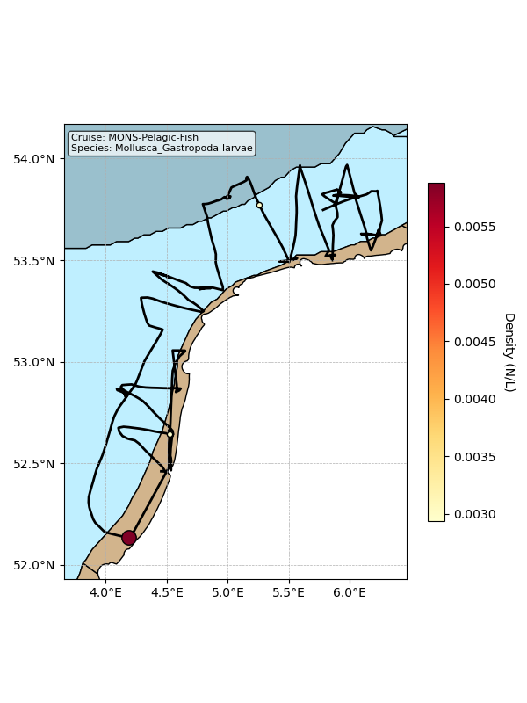

Map showing mean density estimates for Mollusca_Gastropoda-larvae along the cruise transect. OSPAR eutrophication areas are plotted in the background with different colours.

## Classification examples

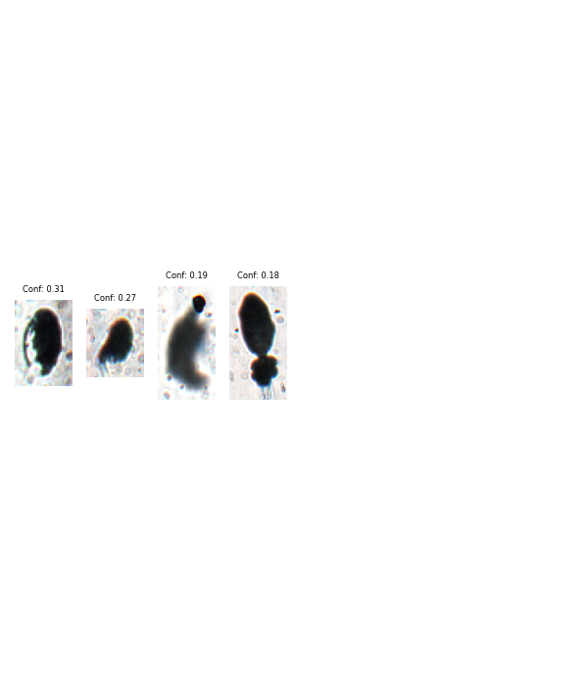

Figure showing several images classified as Mollusca_Gastropoda-larvae with model confidence.

# Class: Mollusca_Bivalvia-larvae

## Statistics

|  |  |
| --- | --- |
| Metric | Value |
| Class ID | 38 |
| Class | Mollusca Bivalvia larvae |
| Number of predictions | 2 |
| Percentage of total images | 0.00 % |
| Min confidence | 0.28 % |
| Max confidence | 0.48 % |
| Average confidence | 0.38 % |
| Min density | 0.00 n/L |
| Max density | 0.00 n/L |
| Average density | 0.00 n/L |

## Model confidence

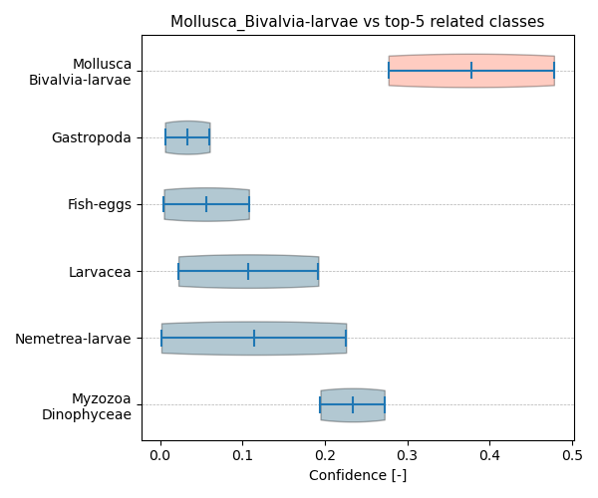

Figure showcasing the confidence distribution of the top-5 most related classes, which are determined by computing the mean confidence value of all non-target classes and selecting the five with the highest means, compared to Mollusca_Bivalvia-larvae.

## Temporal density

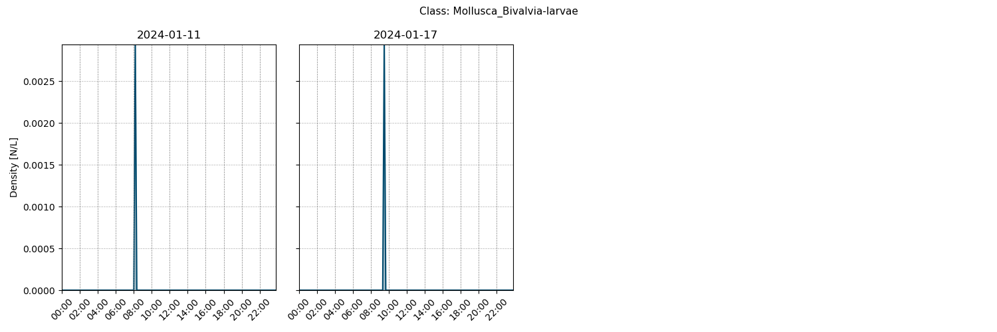

Figure showcasing the daily density estimates for Mollusca_Bivalvia-larvae per 10 minutes.

## Spatio-temporal density

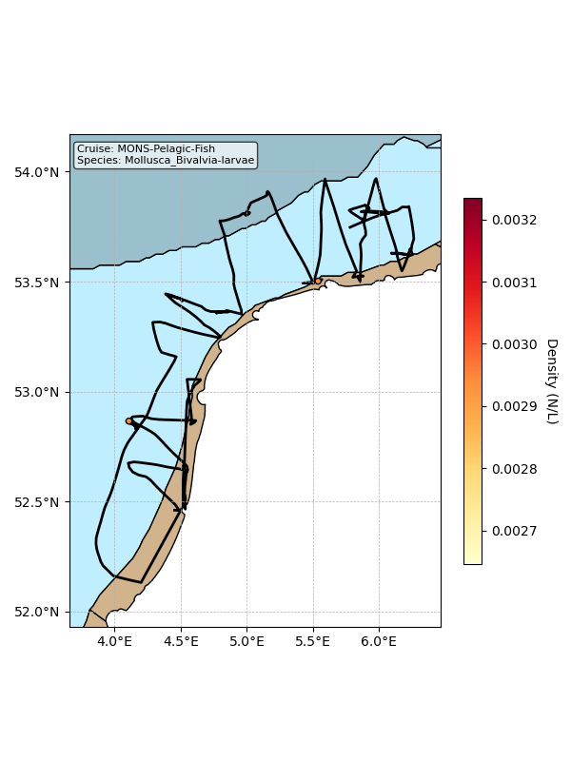

Map showing mean density estimates for Mollusca_Bivalvia-larvae along the cruise transect. OSPAR eutrophication areas are plotted in the background with different colours.

## Classification examples

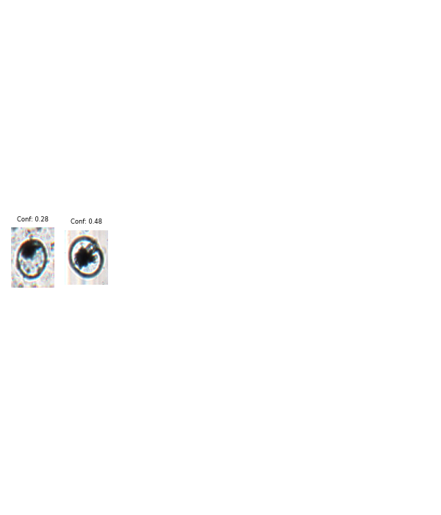

Figure showing several images classified as Mollusca_Bivalvia-larvae with model confidence.